Overlay Plot Room=1121, Grade=Unclassified, Frequency=Dynamic
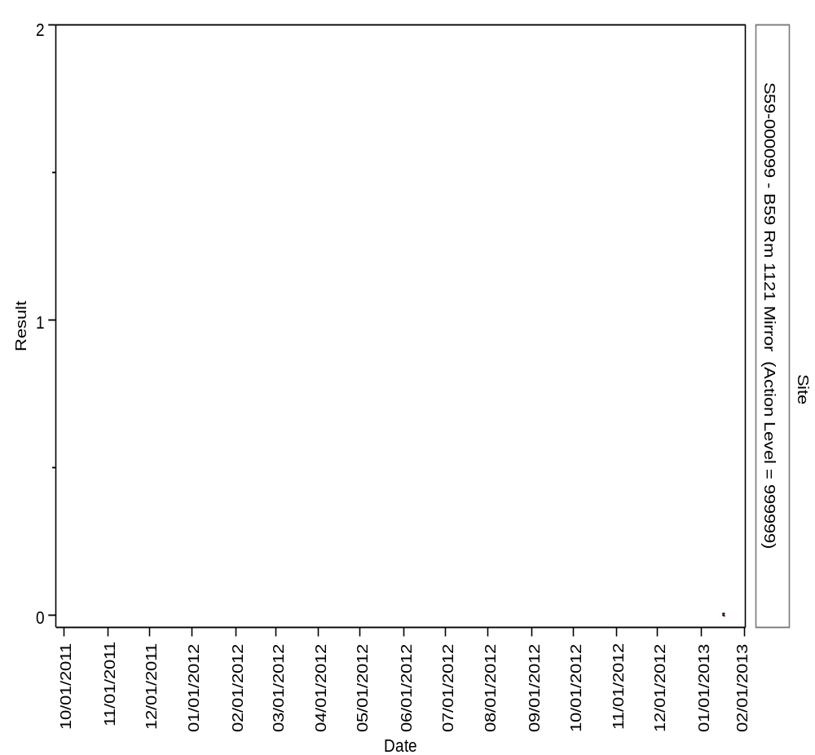

Overlay Plot Room=1200, Grade=Grade C, Frequency=Dynamic
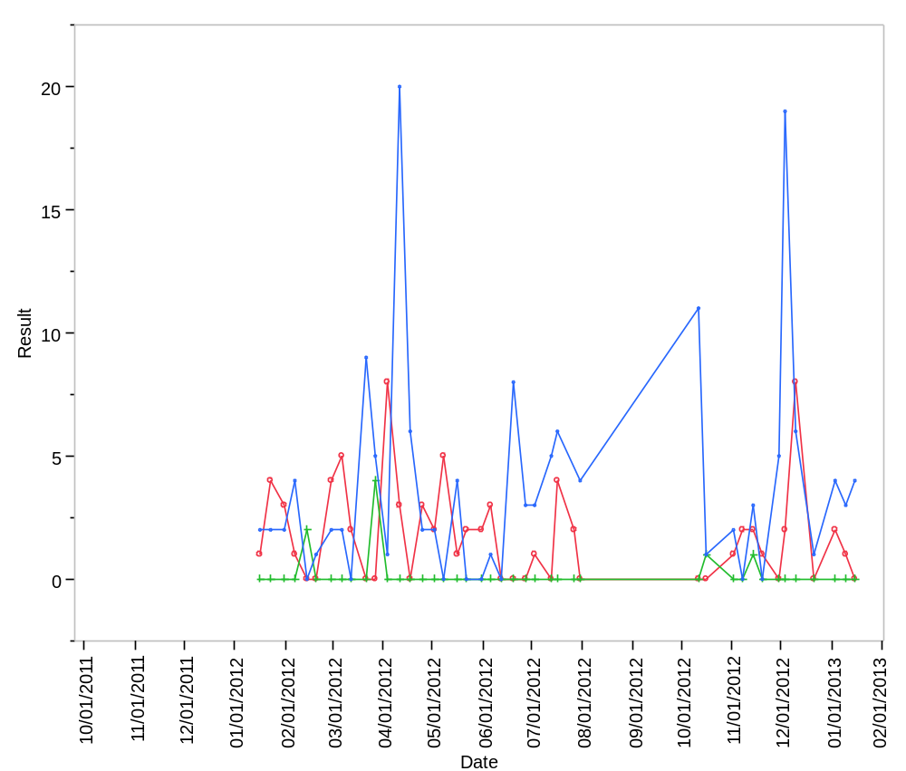

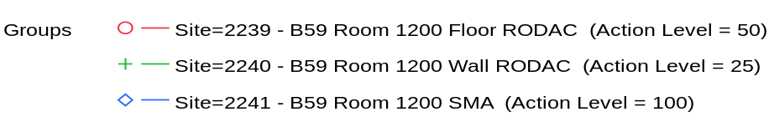

Overlay Plot Room=1200, Grade=Grade C, Frequency=Static
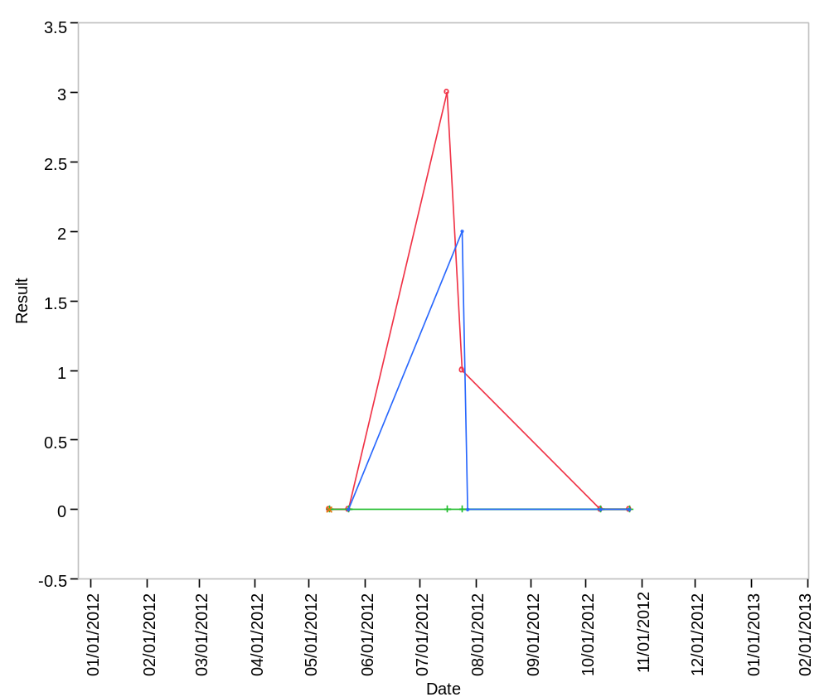

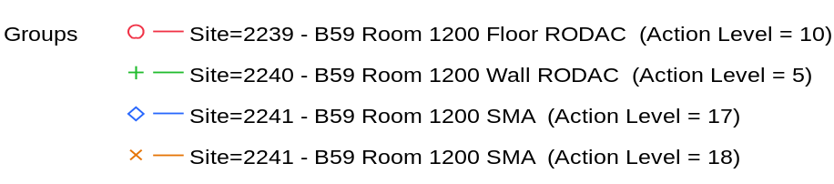

Overlay Plot Room=1201, Grade=Grade C, Frequency=Dynamic
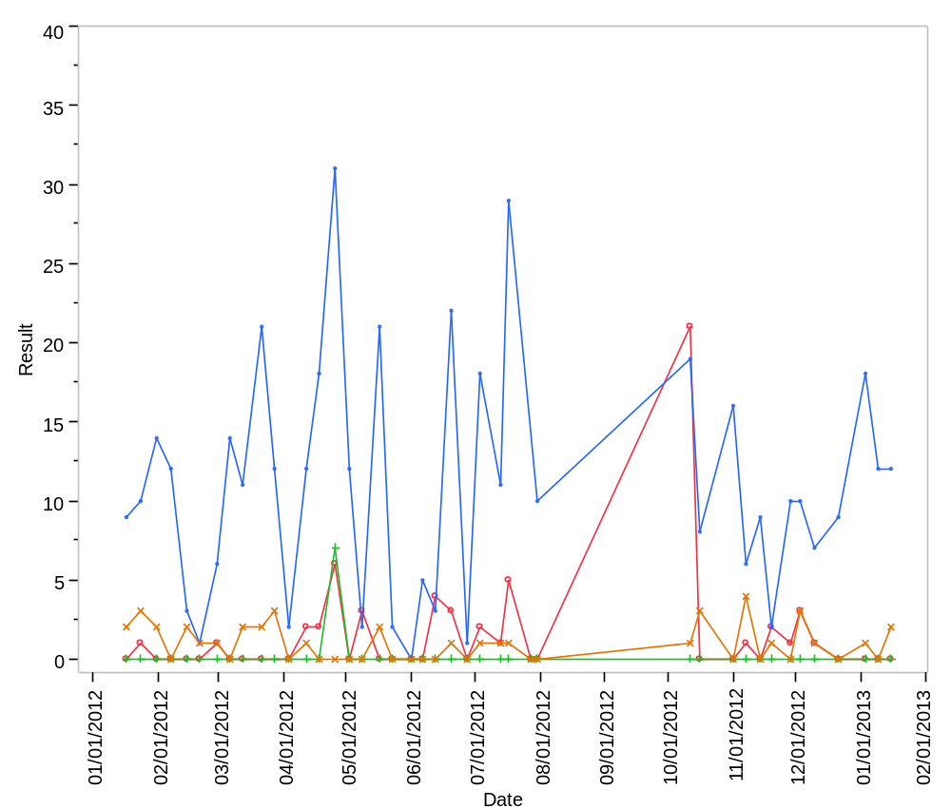

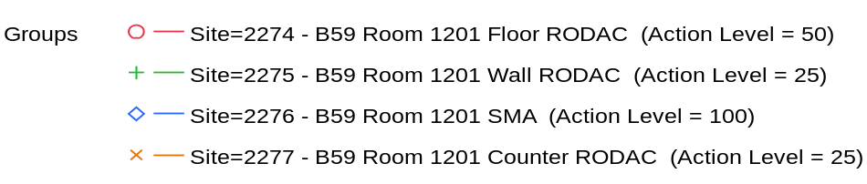

Overlay Plot Room=1201, Grade=Grade C, Frequency=Static
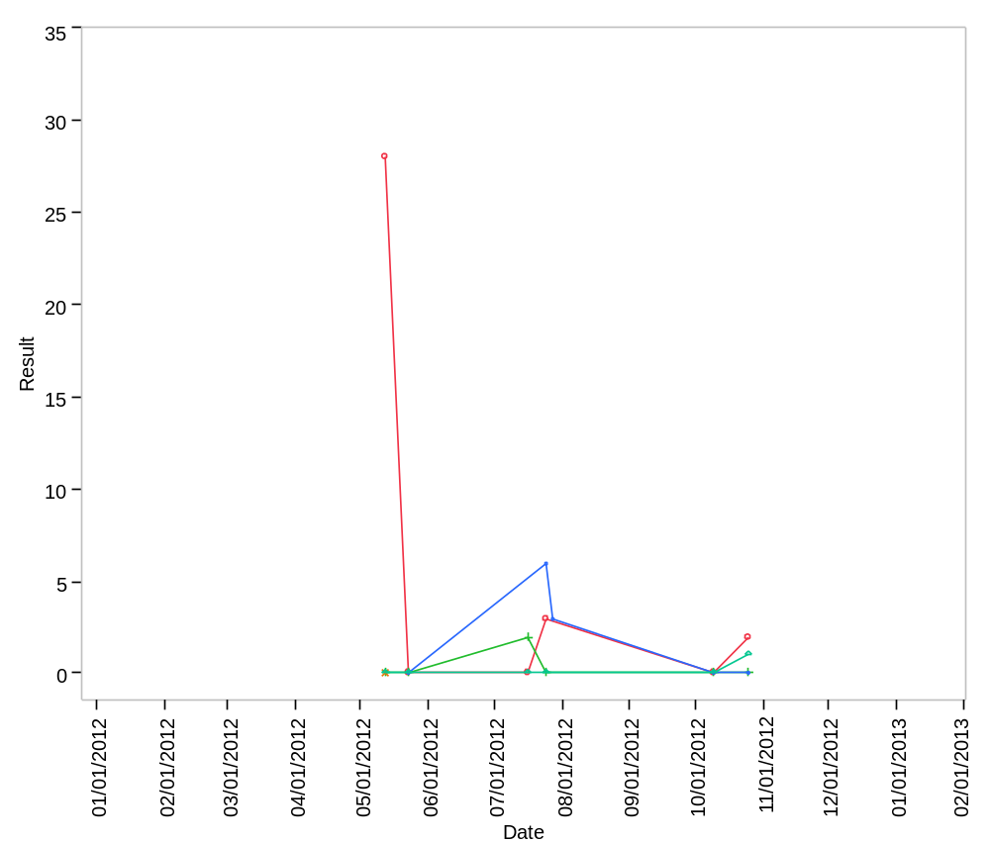

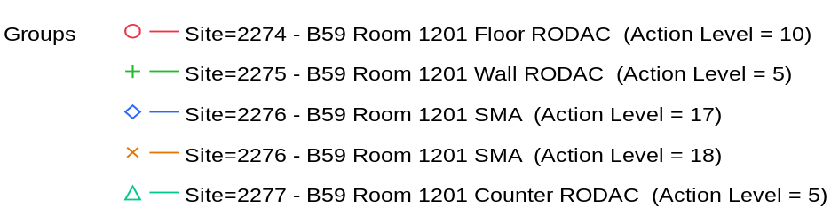

Overlay Plot Room=1202, Grade=Grade C, Frequency=Dynamic
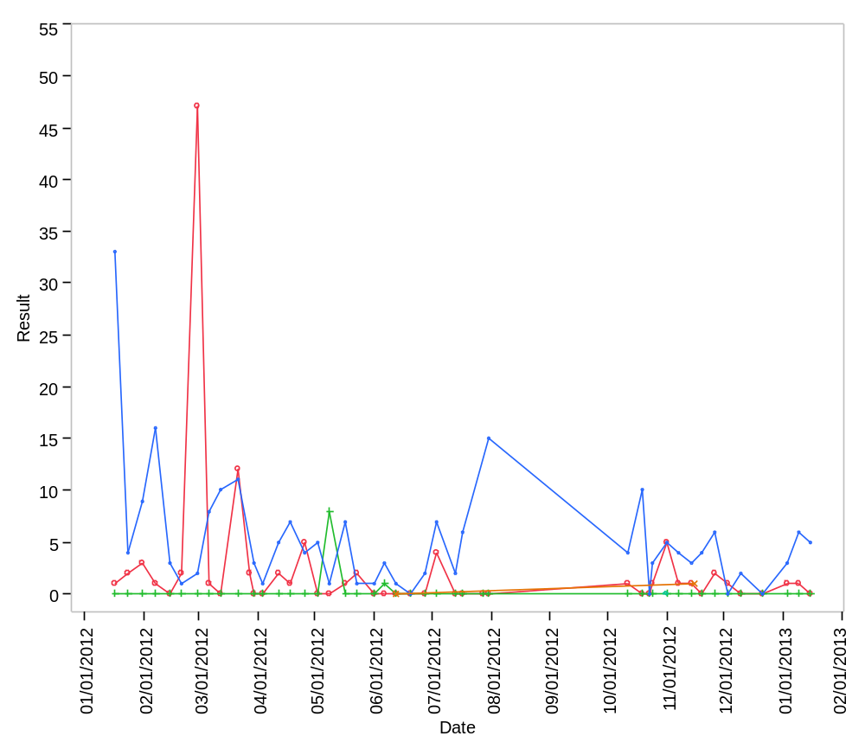

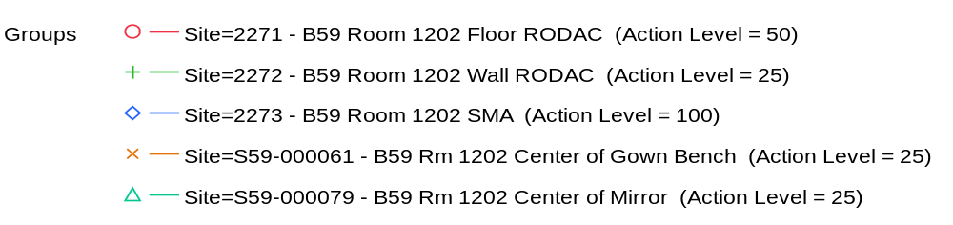

Overlay Plot Room=1202, Grade=Grade C, Frequency=Static
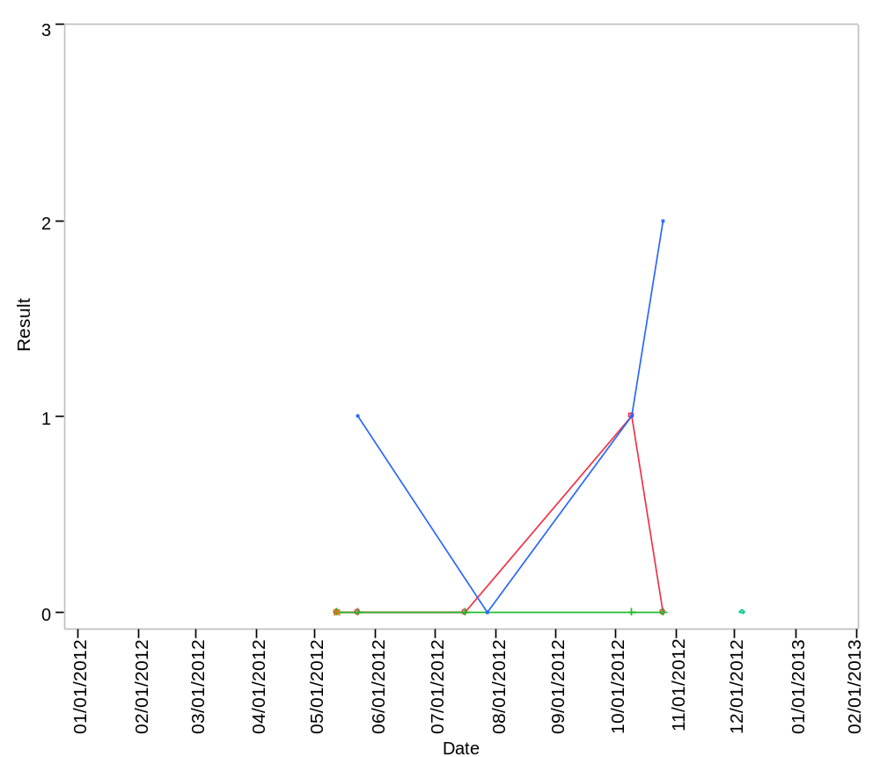

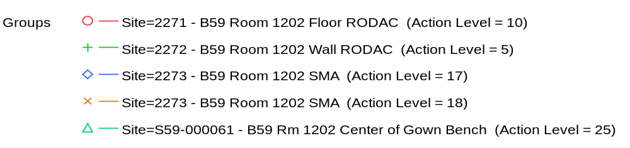

Overlay Plot Room=1203, Grade=Grade A, Frequency=Dynamic
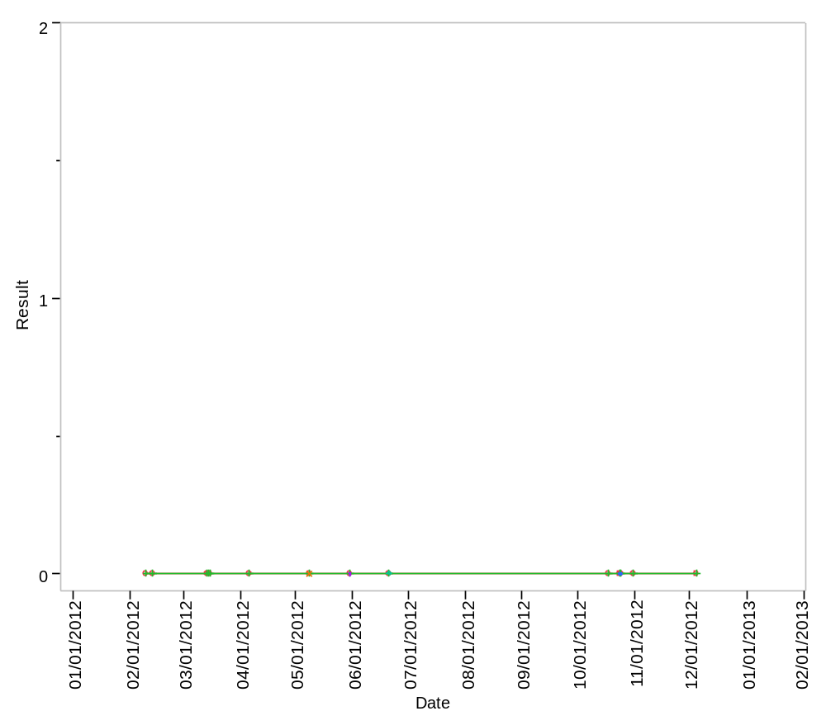

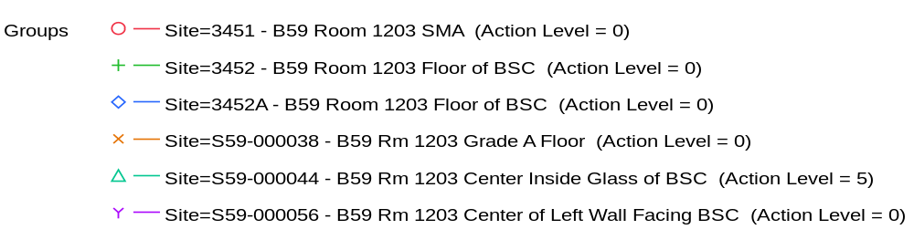

Overlay Plot Room=1203, Grade=Grade A, Frequency=Static
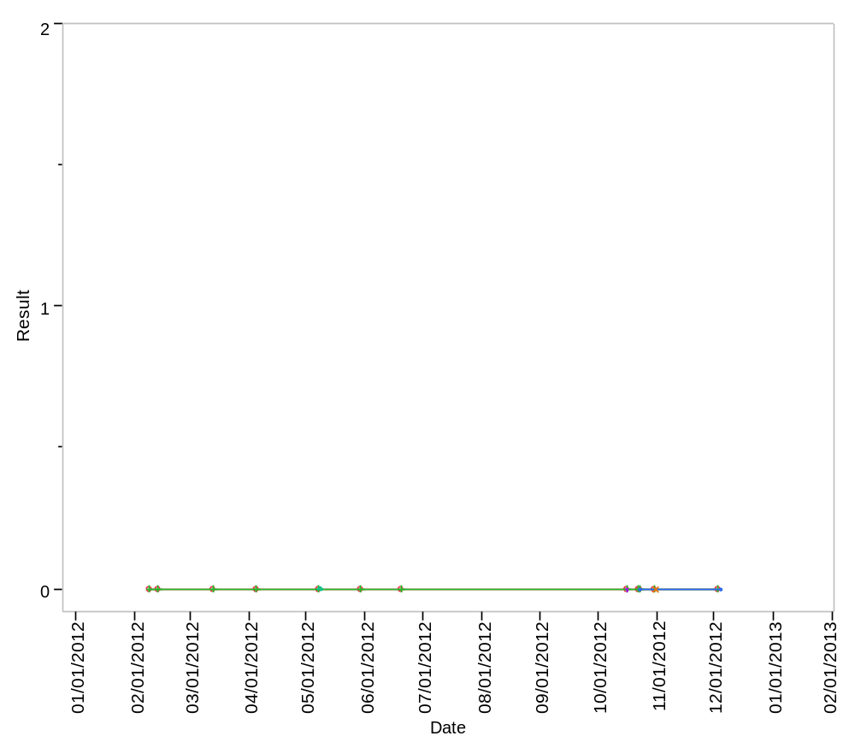

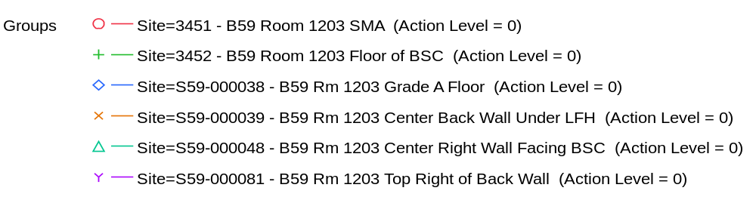

Overlay Plot Room=1203, Grade=Grade B, Frequency=Dynamic
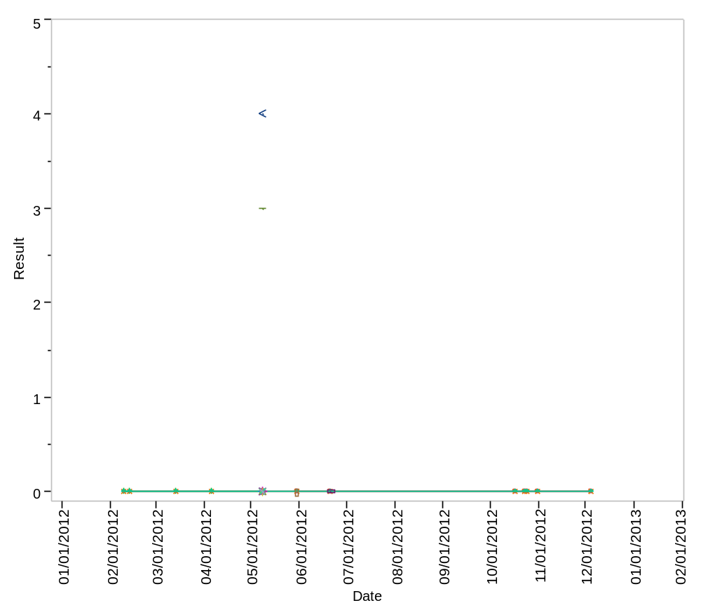

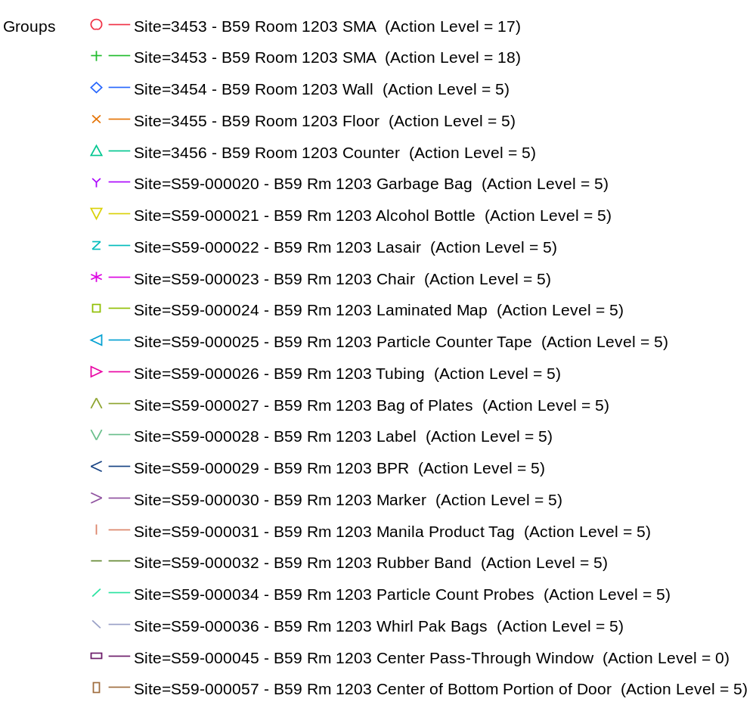

Overlay Plot Room=1203, Grade=Grade B, Frequency=Static
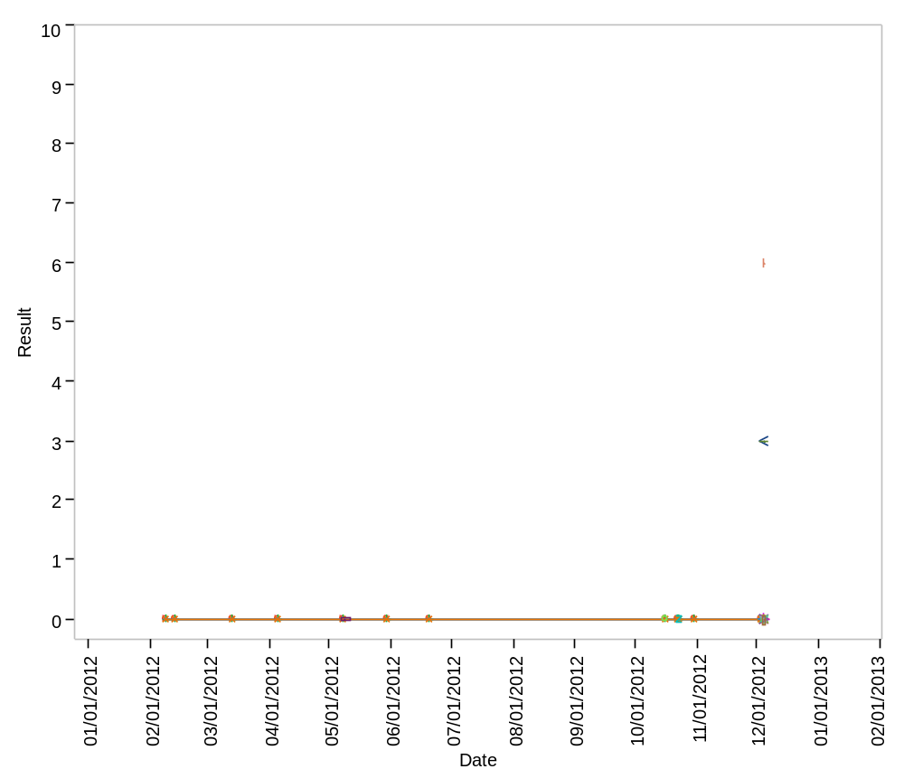

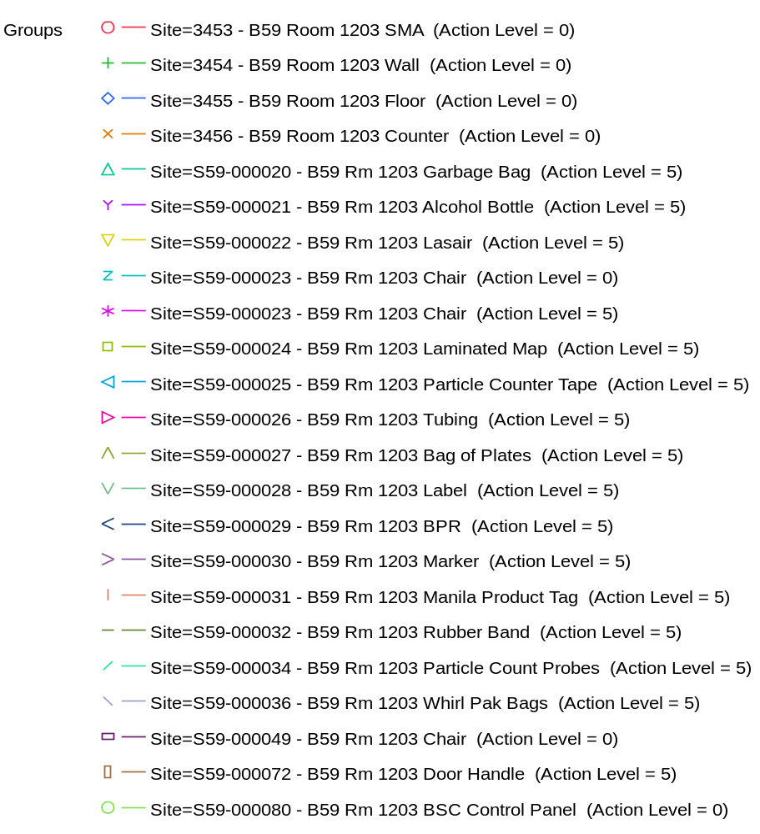

Overlay Plot Room=1203, Grade=Grade C, Frequency=Dynamic
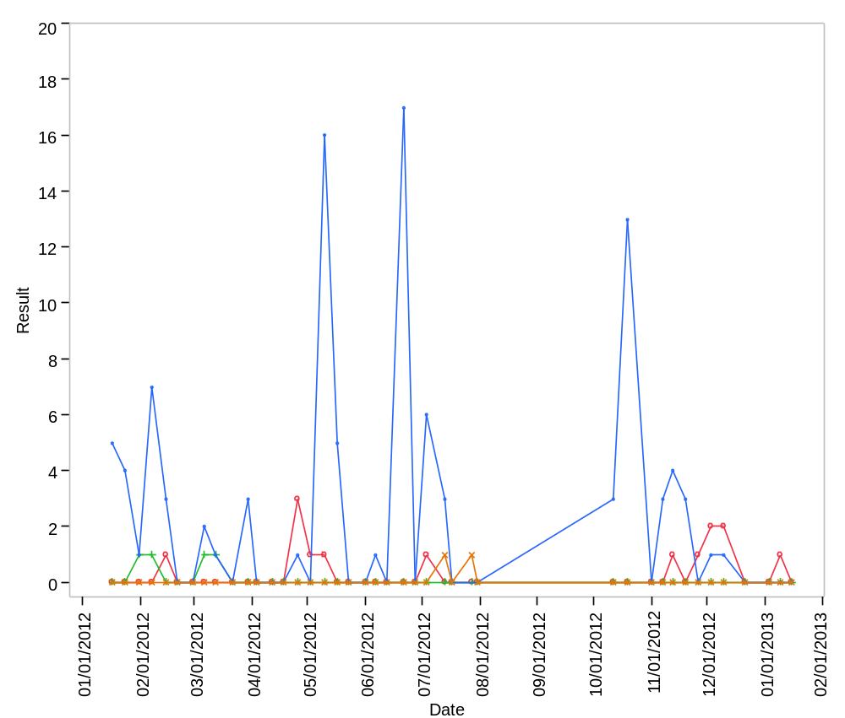

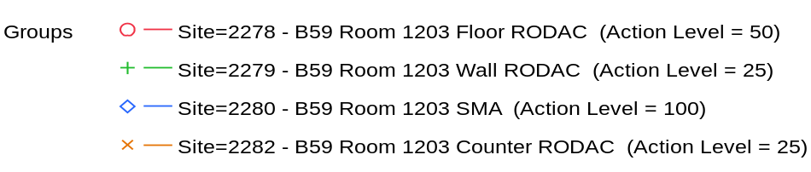

Overlay Plot Room=1203, Grade=Grade C, Frequency=Static
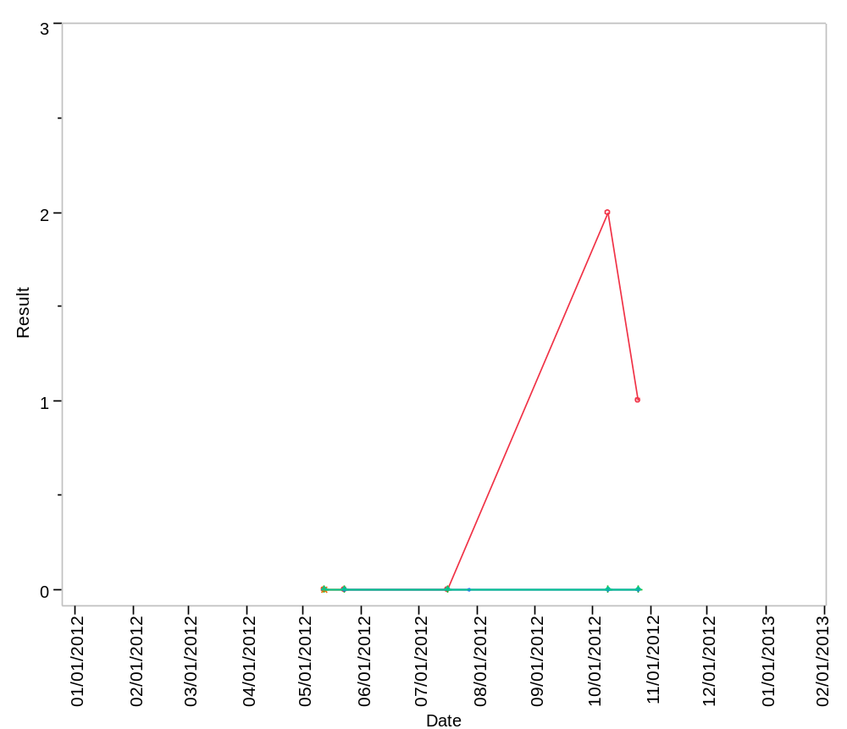

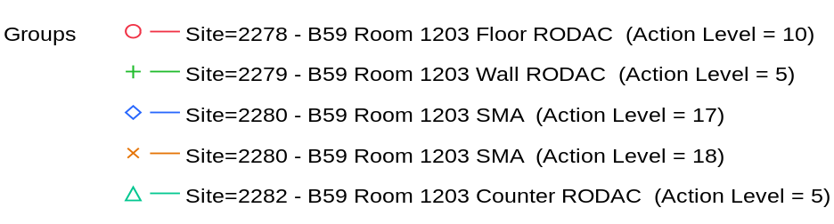

Overlay Plot Room=1203, Grade=Grade C - Laminar Flow, Frequency=Dynamic
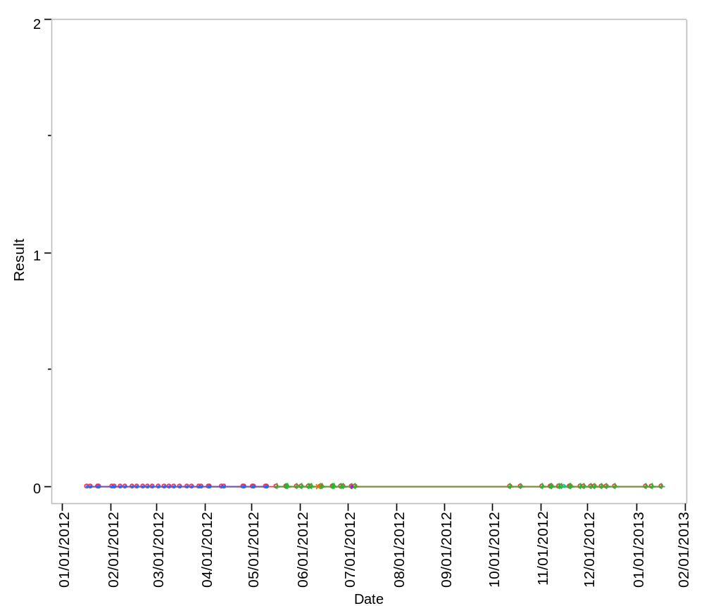

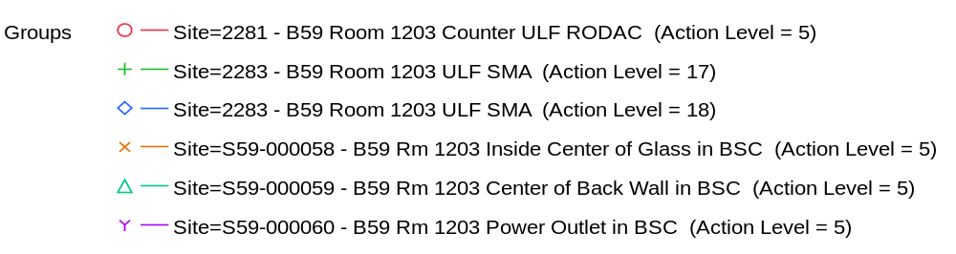

Overlay Plot Room=1203, Grade=Grade C - Laminar Flow, Frequency=Static
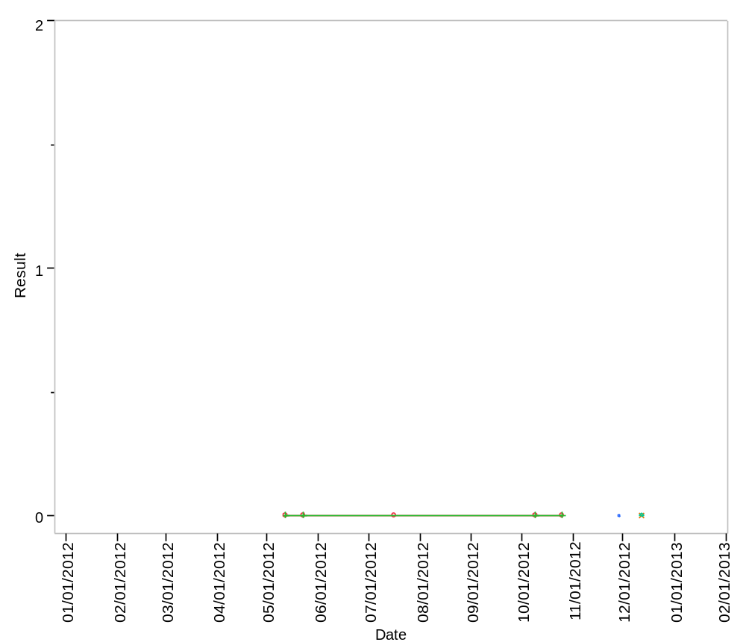

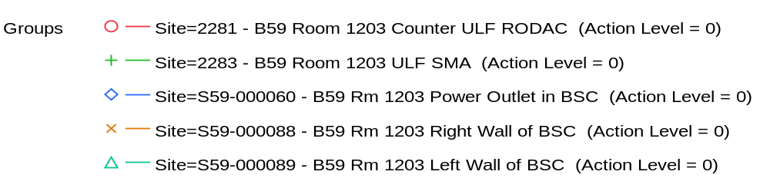

Overlay Plot Room=1204, Grade=Grade C, Frequency=Dynamic
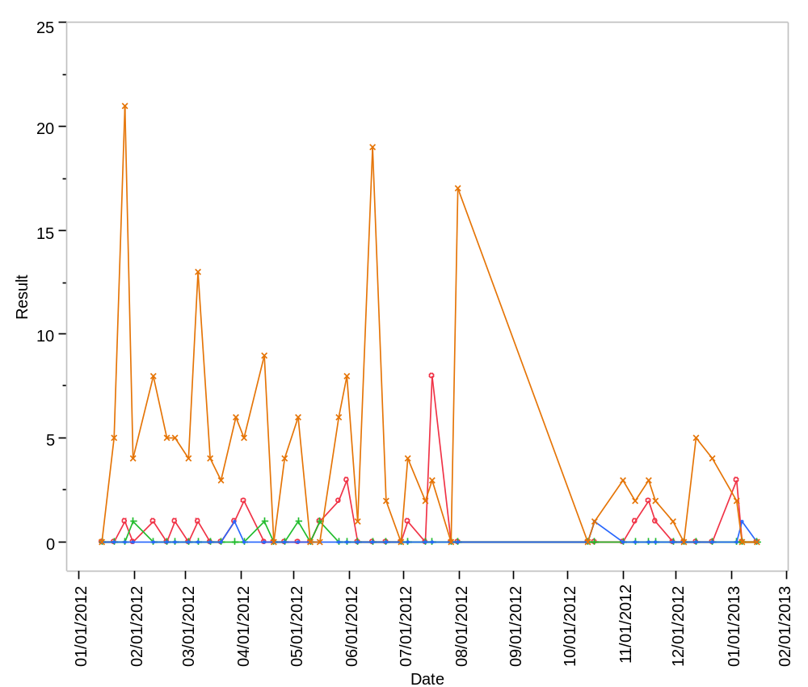

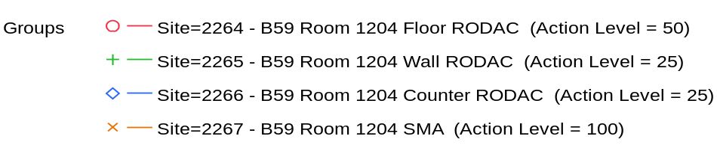

Overlay Plot Room=1204, Grade=Grade C, Frequency=Static
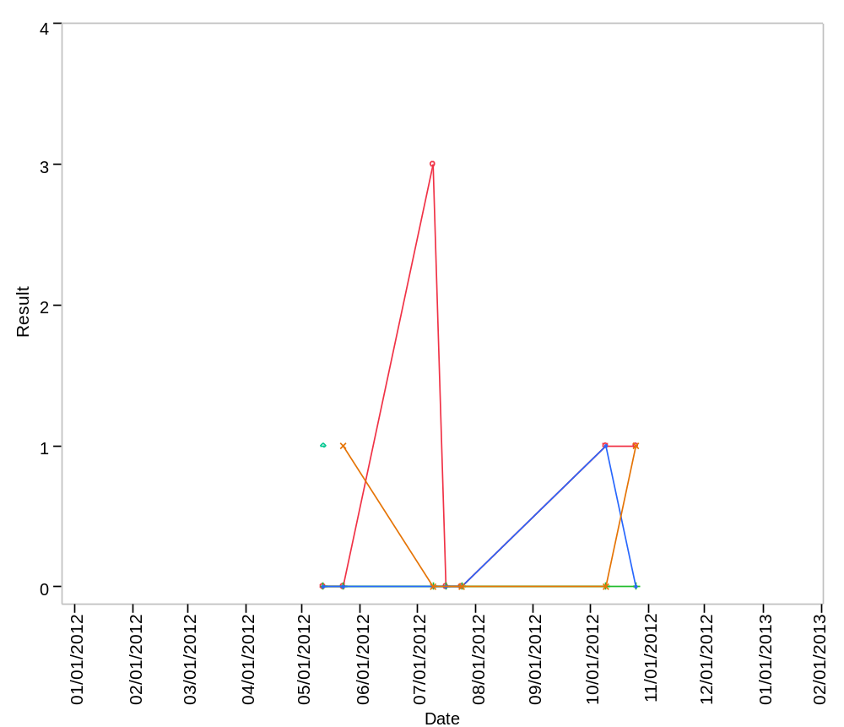

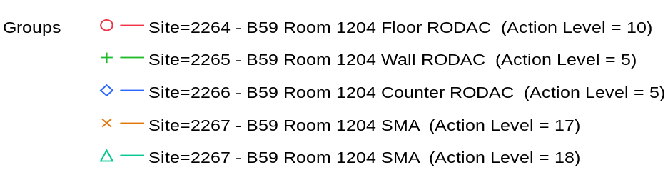

Overlay Plot Room=1204, Grade=Grade C - Laminar Flow, Frequency=Dynamic
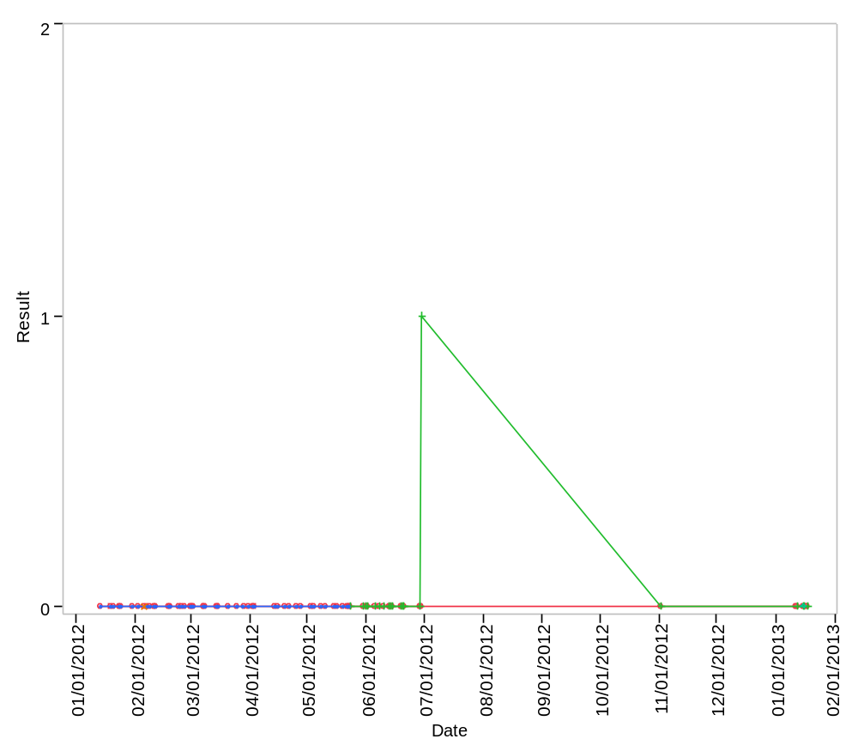

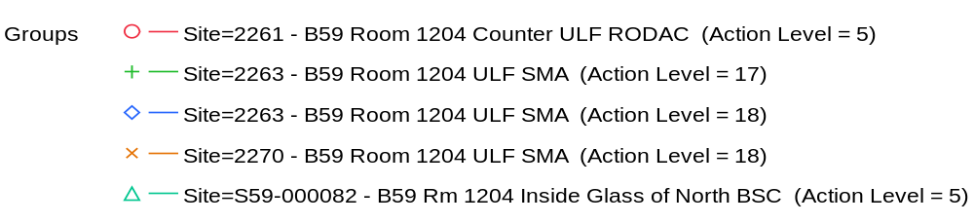

Overlay Plot Room=1204, Grade=Grade C - Laminar Flow, Frequency=Static
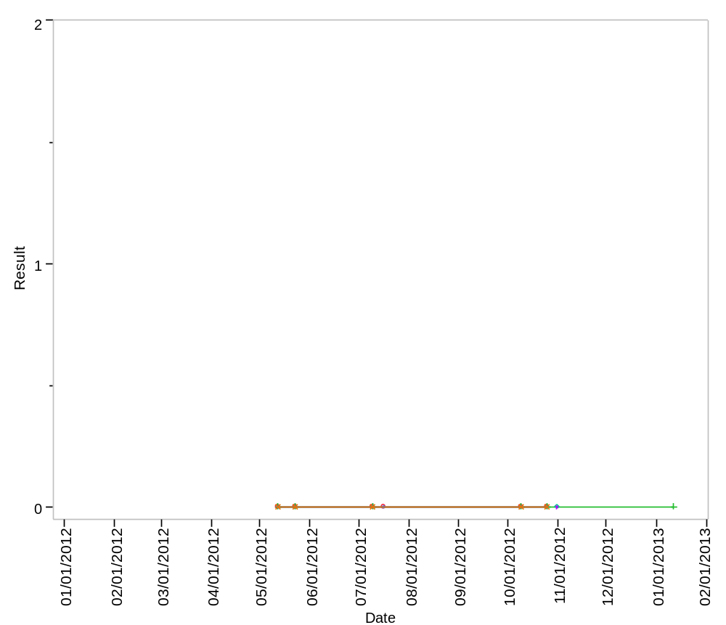

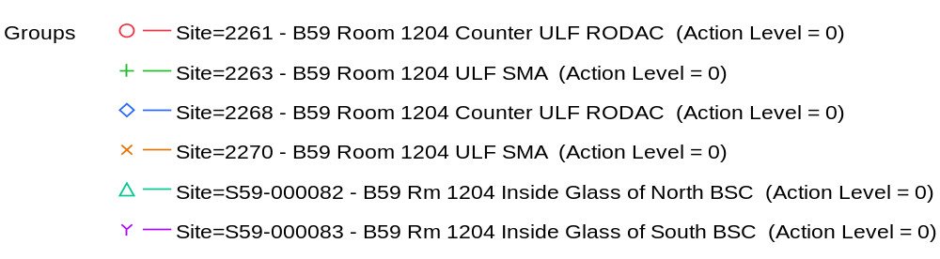

Overlay Plot Room=1205, Grade=Grade D, Frequency=Dynamic
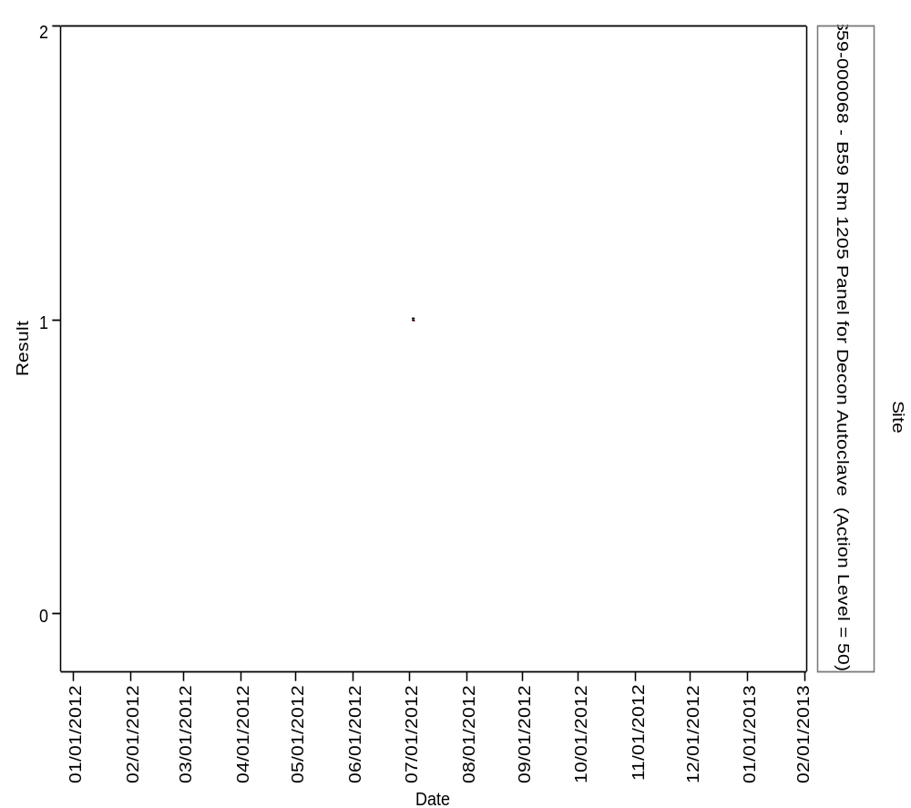

Overlay Plot Room=1205, Grade=Grade D, Frequency=Static
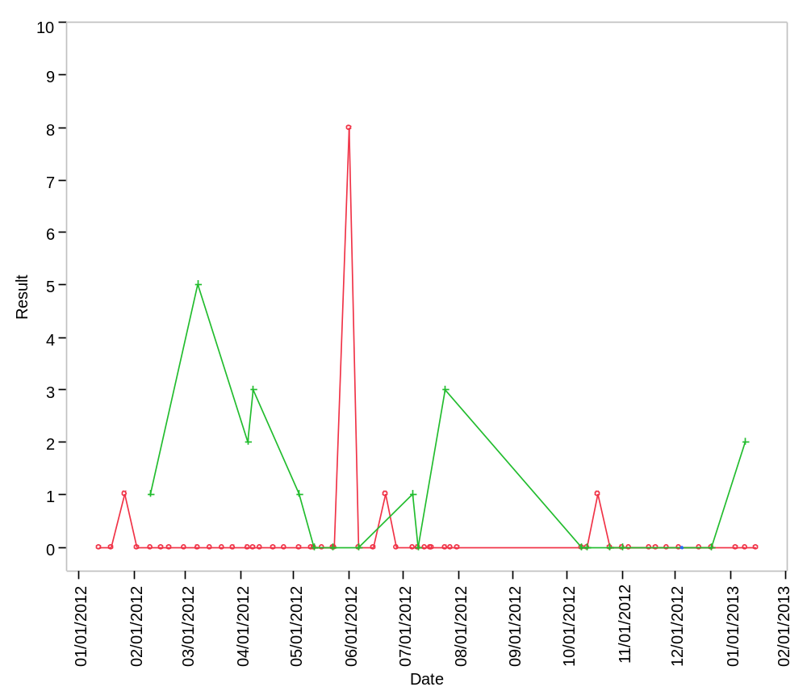

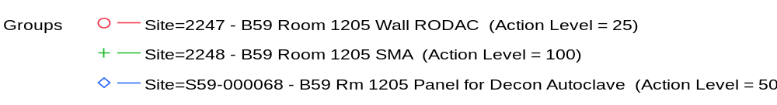

Overlay Plot Room=1208, Grade=Grade D, Frequency=Static
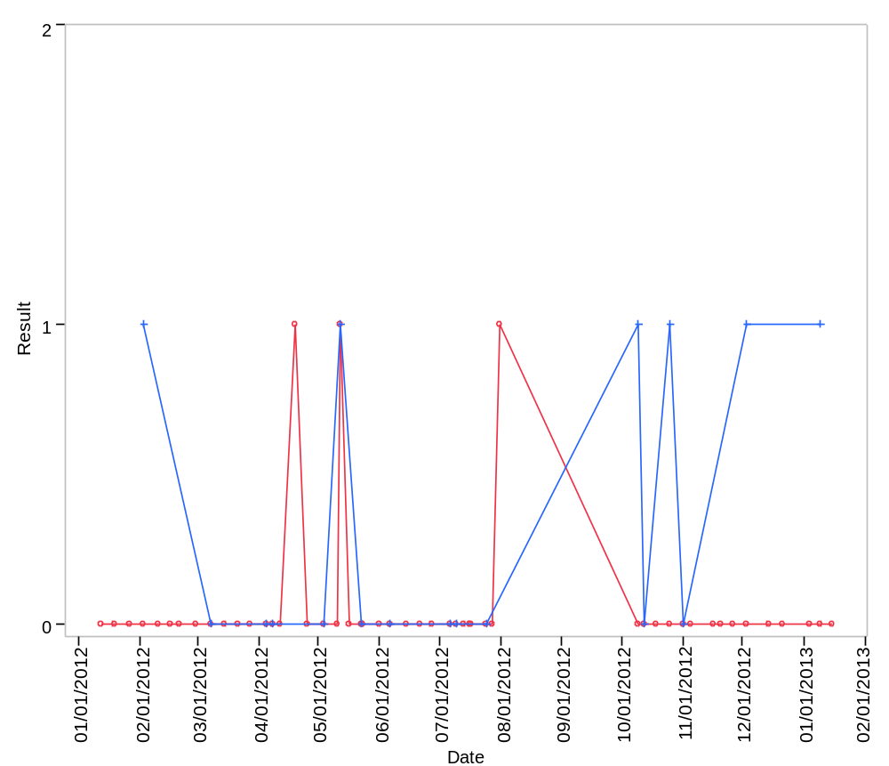

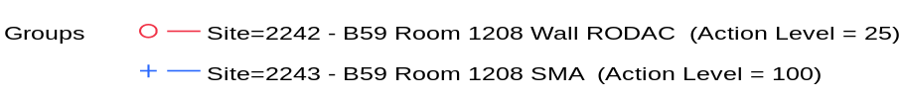

Overlay Plot Room=1209, Grade=Grade C, Frequency=Dynamic
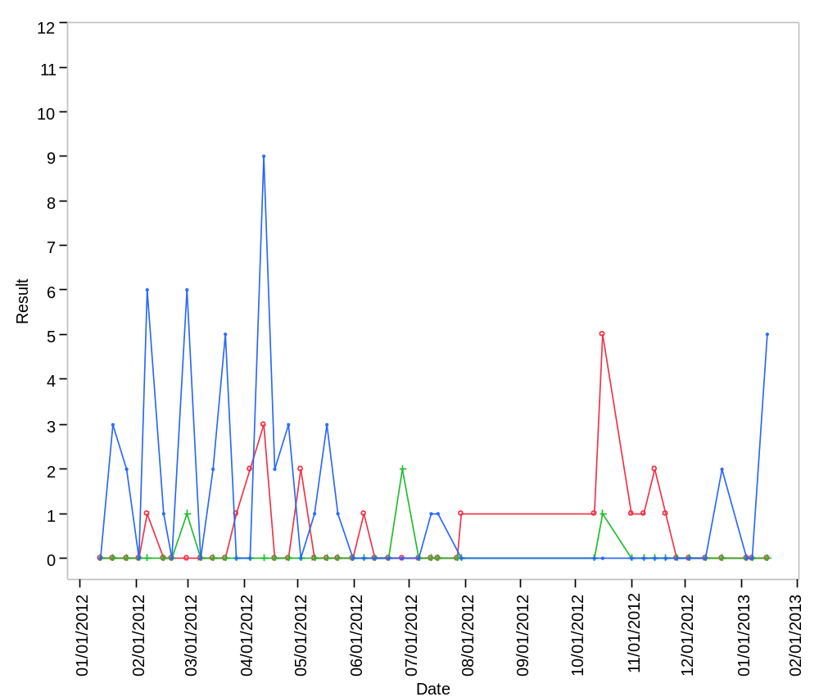

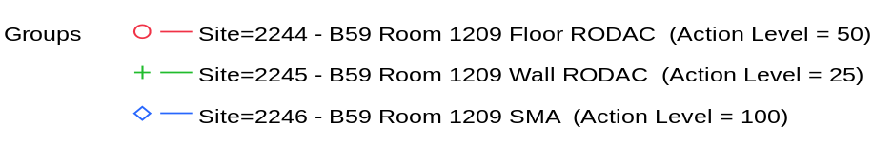

Overlay Plot Room=1209, Grade=Grade C, Frequency=Static
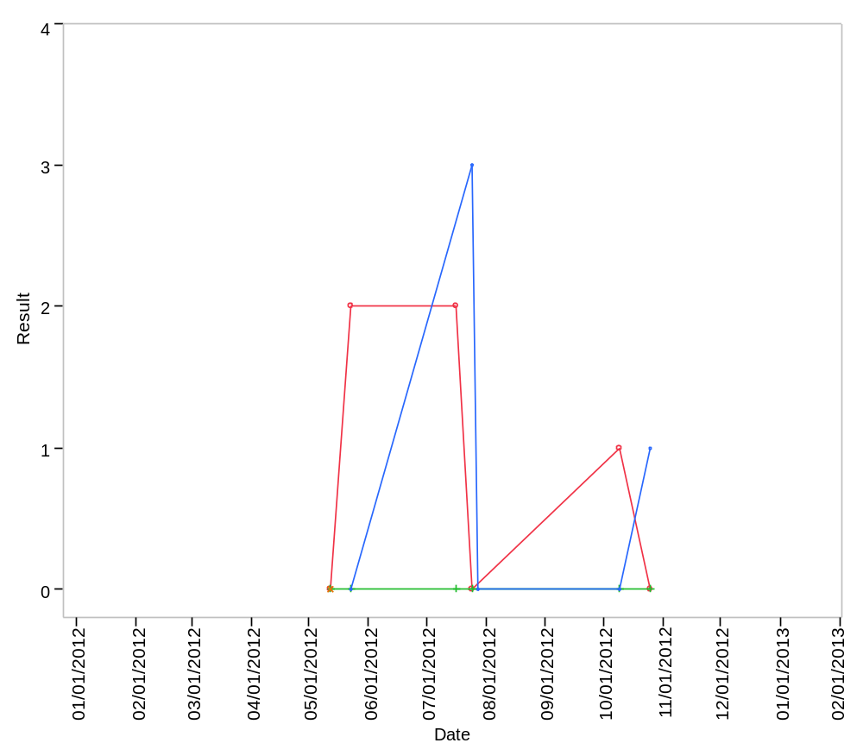

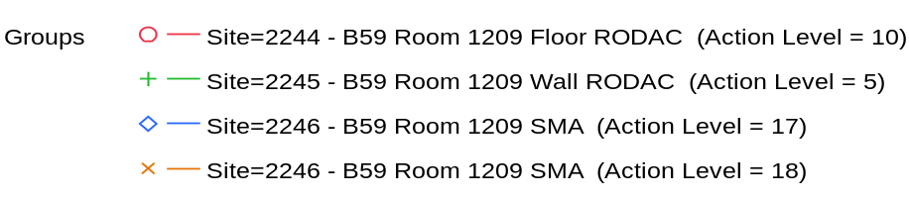

Overlay Plot Room=1210, Grade=Grade C, Frequency=Dynamic
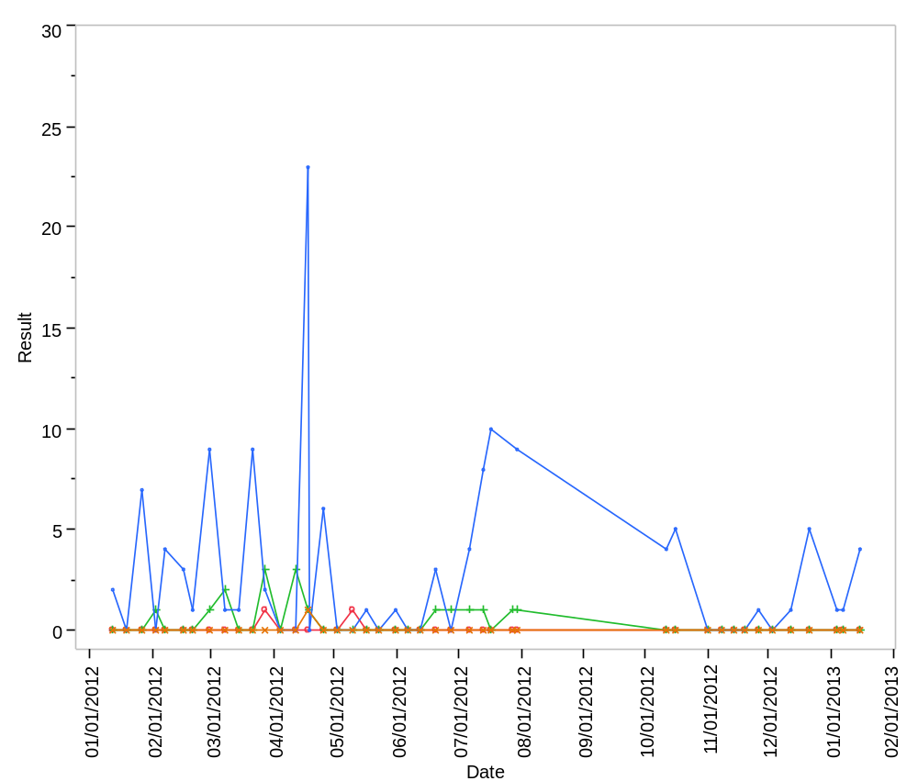

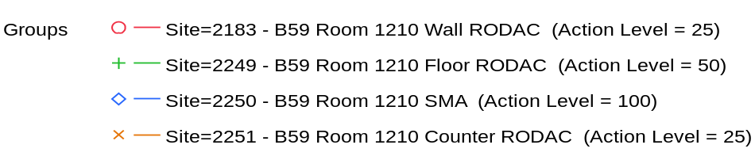

Overlay Plot Room=1210, Grade=Grade C, Frequency=Static
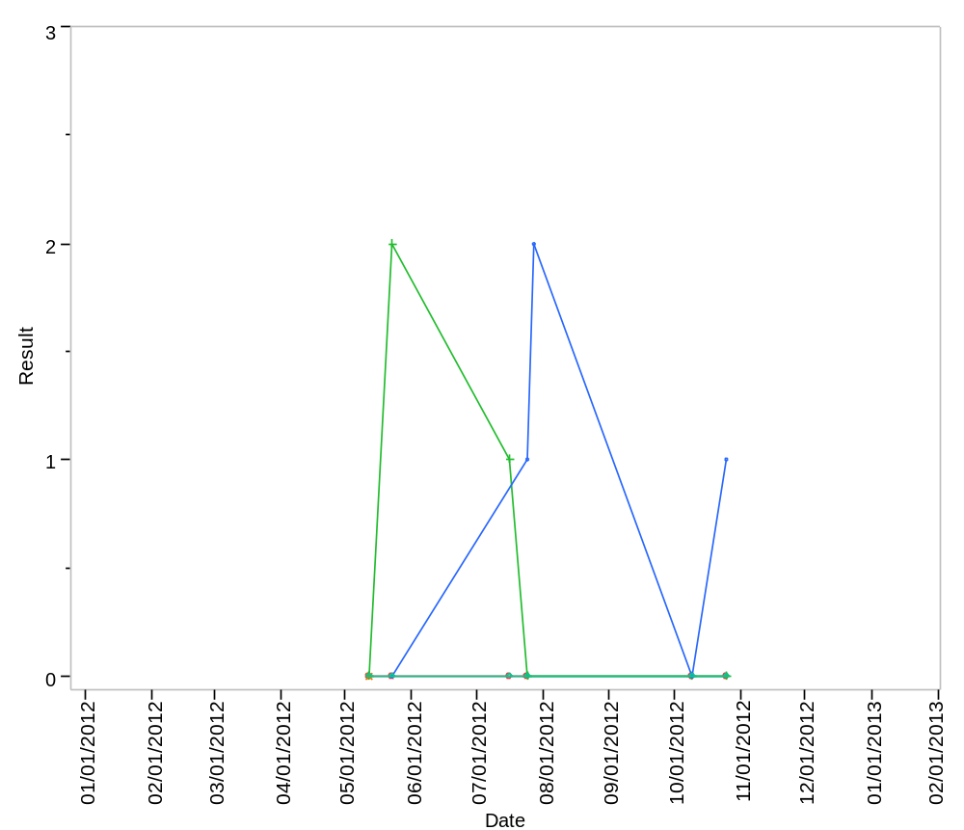

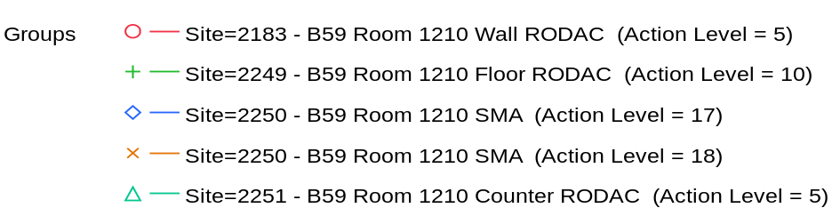

Overlay Plot Room=1211, Grade=Grade C, Frequency=Dynamic
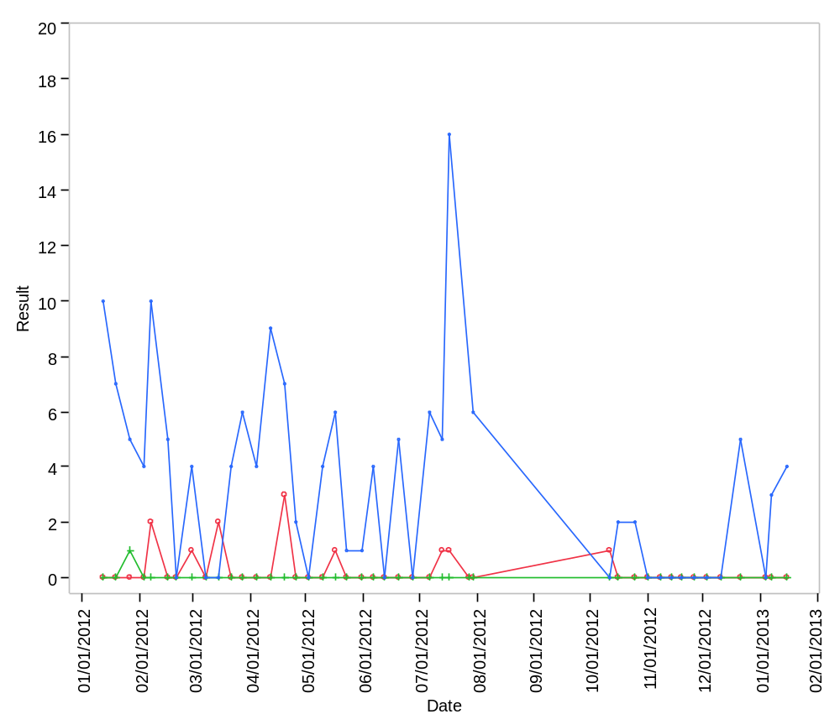

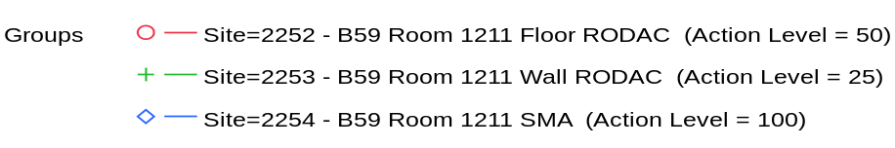

Overlay Plot Room=1211, Grade=Grade C, Frequency=Static
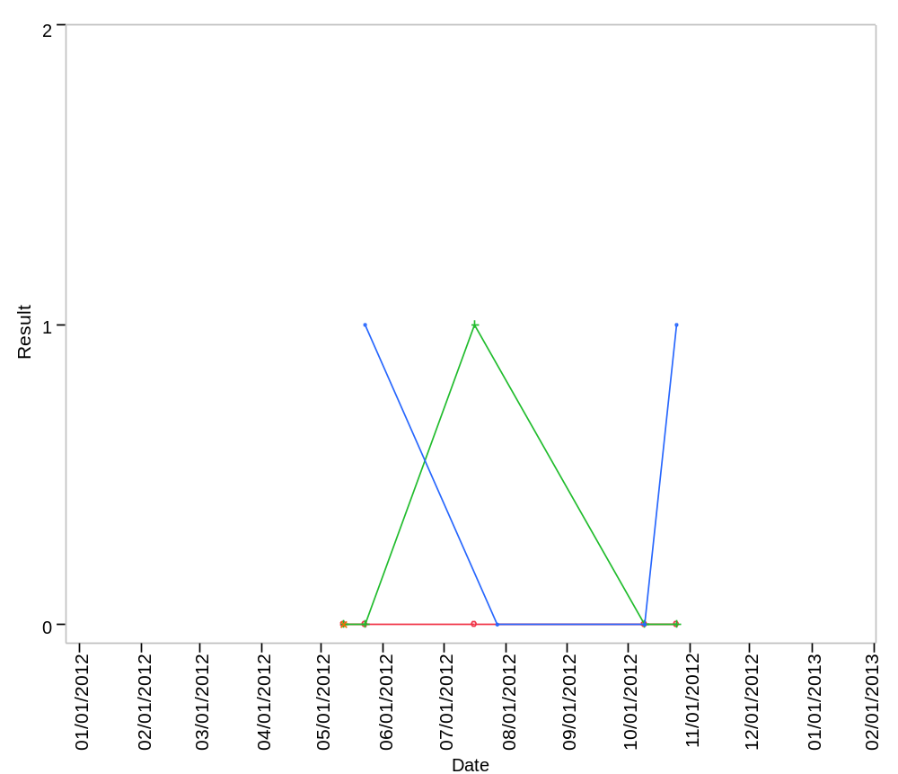

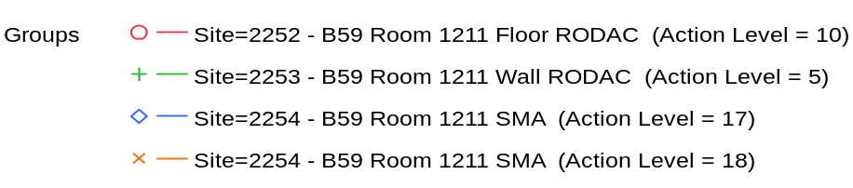

Overlay Plot Room=1212, Grade=Grade A, Frequency=Dynamic
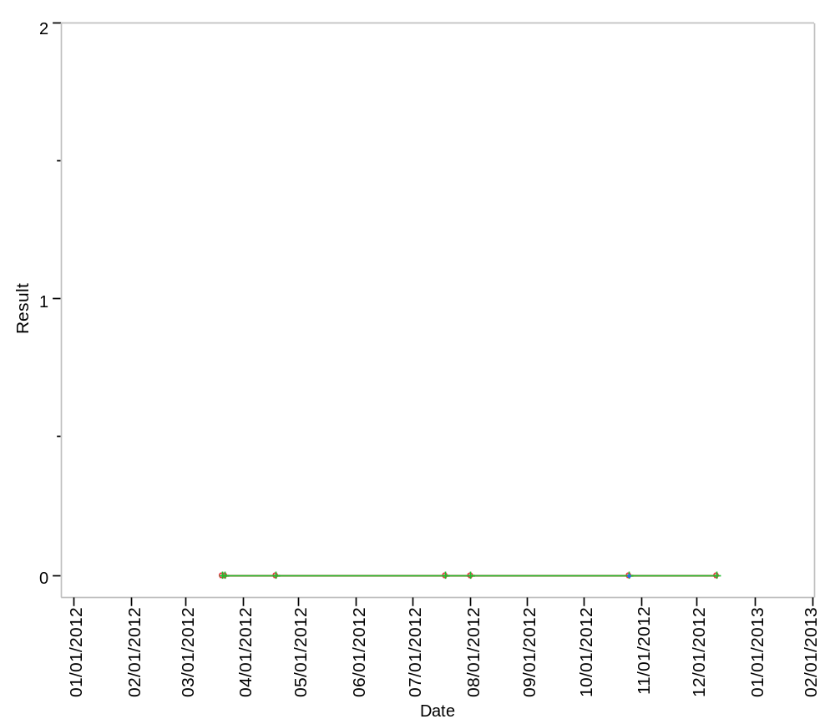

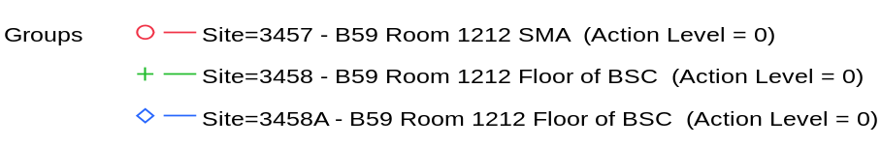

Overlay Plot Room=1212, Grade=Grade A, Frequency=Static
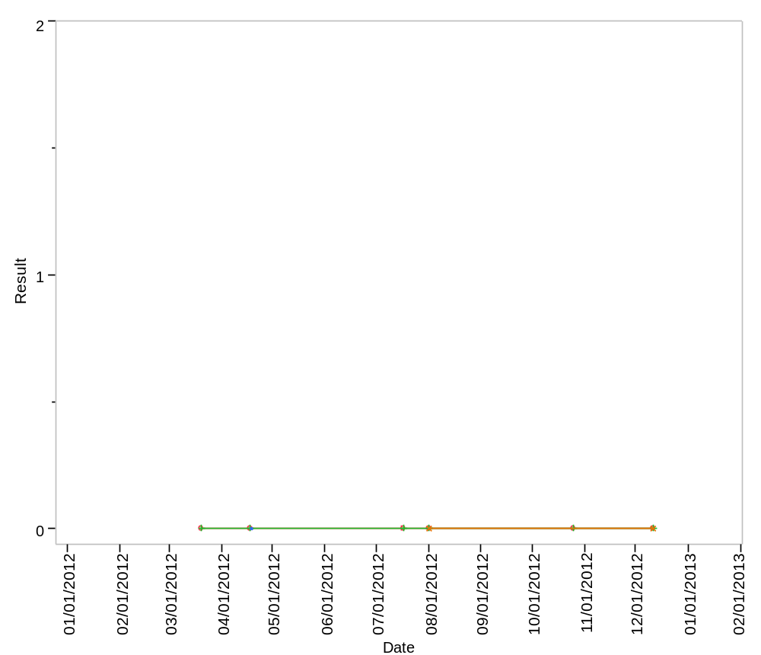

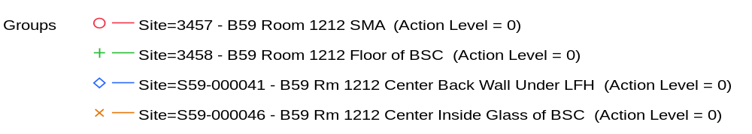

Overlay Plot Room=1212, Grade=Grade B, Frequency=Dynamic
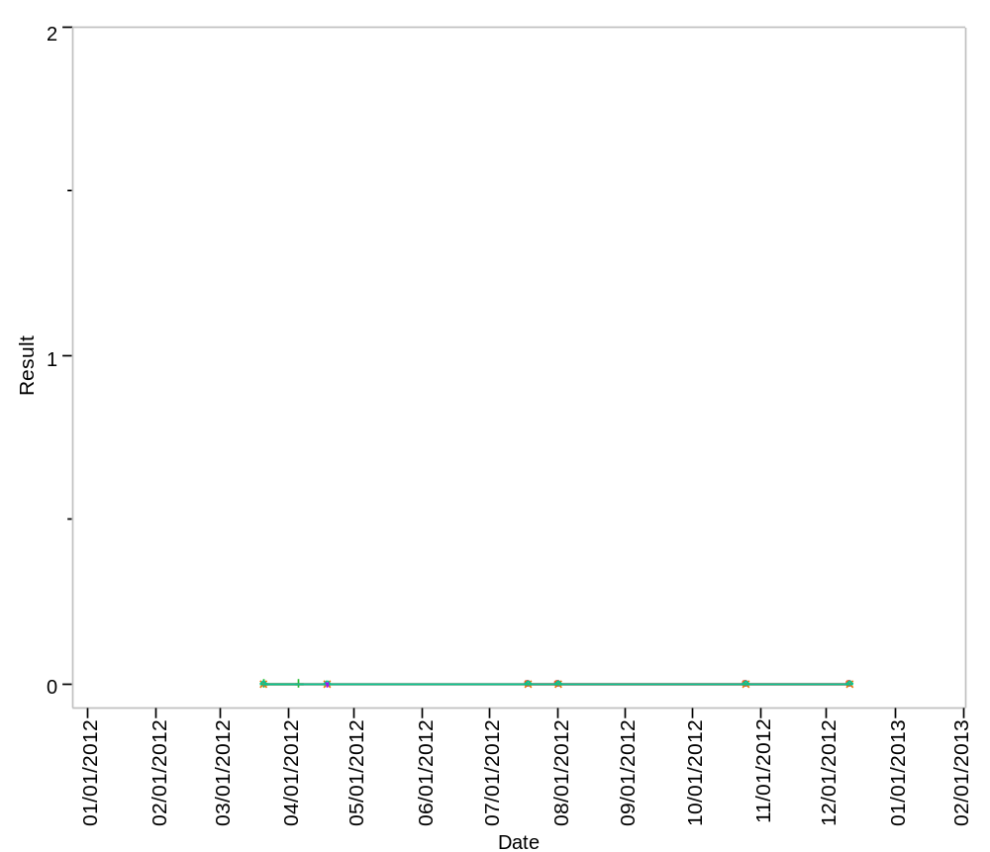

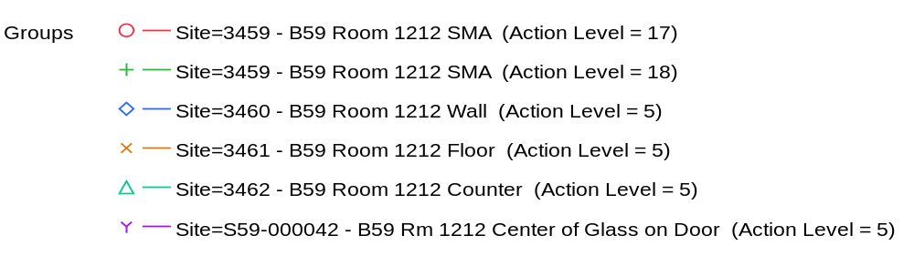

Overlay Plot Room=1212, Grade=Grade B, Frequency=Static
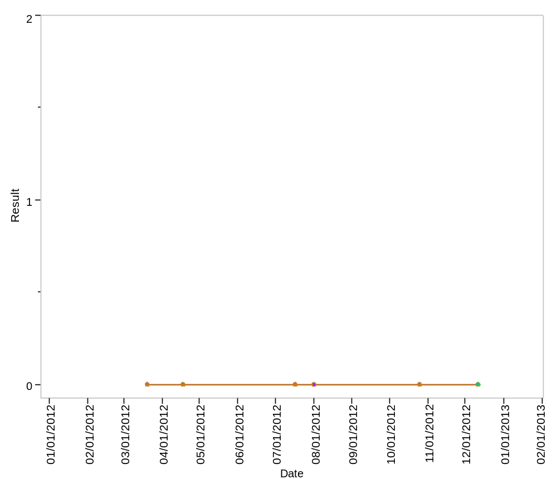

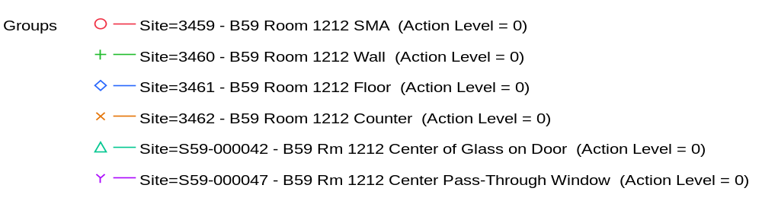

Overlay Plot Room=1212, Grade=Grade C, Frequency=Dynamic
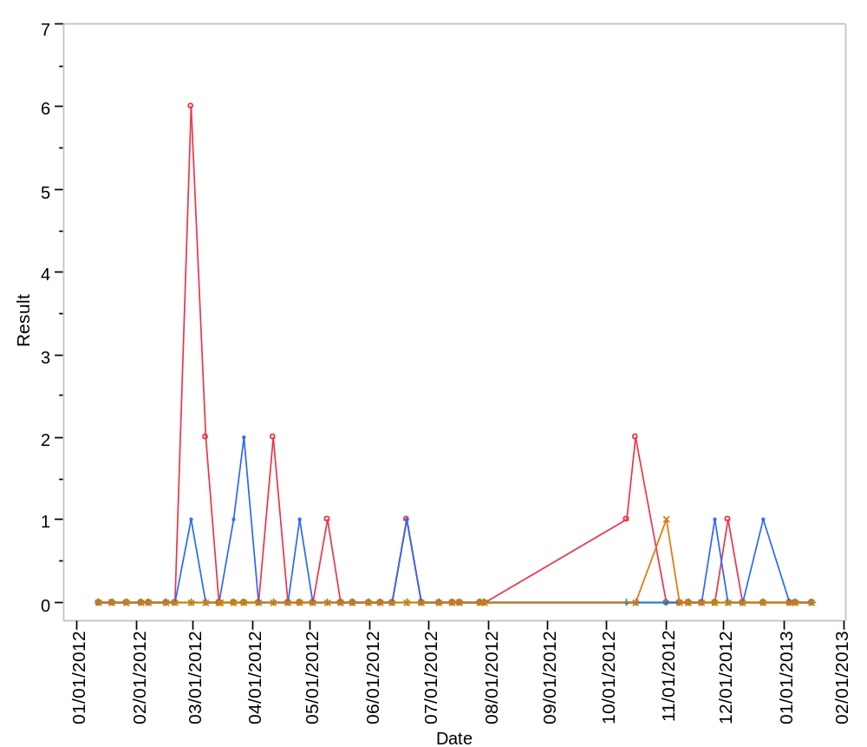

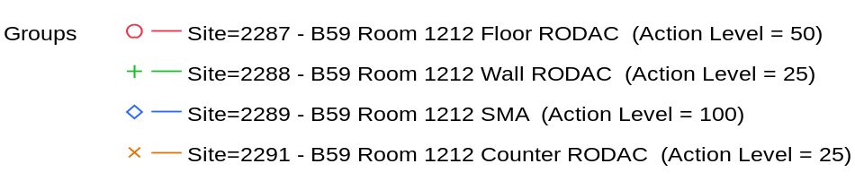

Overlay Plot Room=1212, Grade=Grade C, Frequency=Static
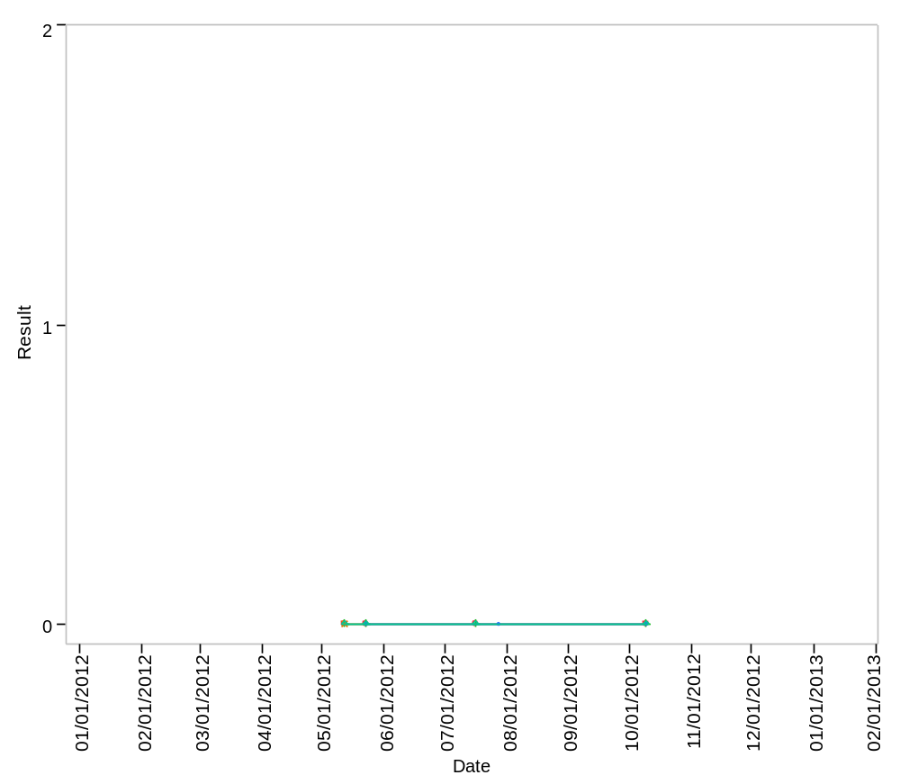

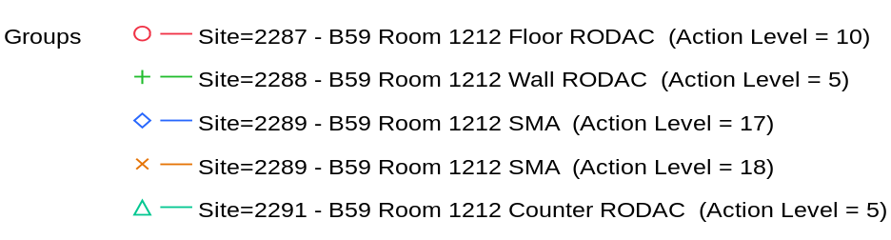

Overlay Plot Room=1212, Grade=Grade C - Laminar Flow, Frequency=Dynamic
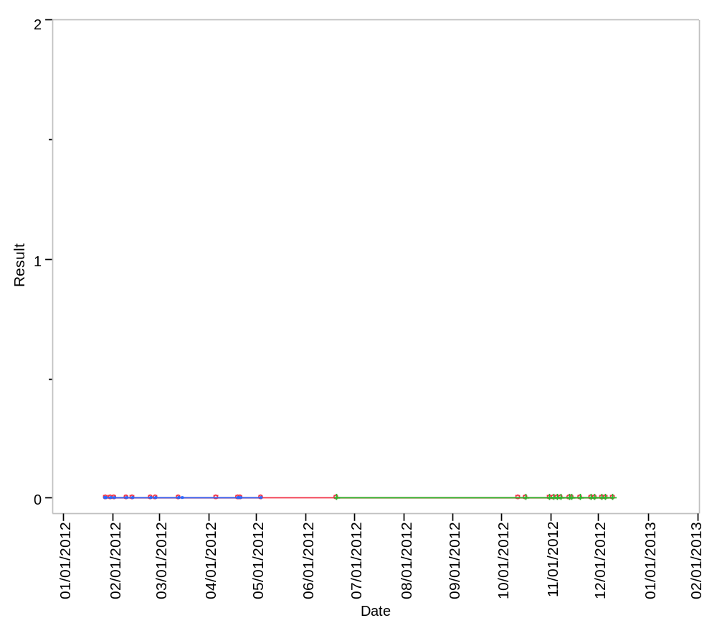

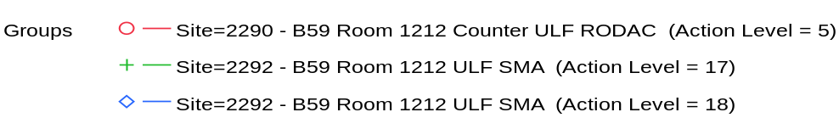

Overlay Plot Room=1212, Grade=Grade C - Laminar Flow, Frequency=Static
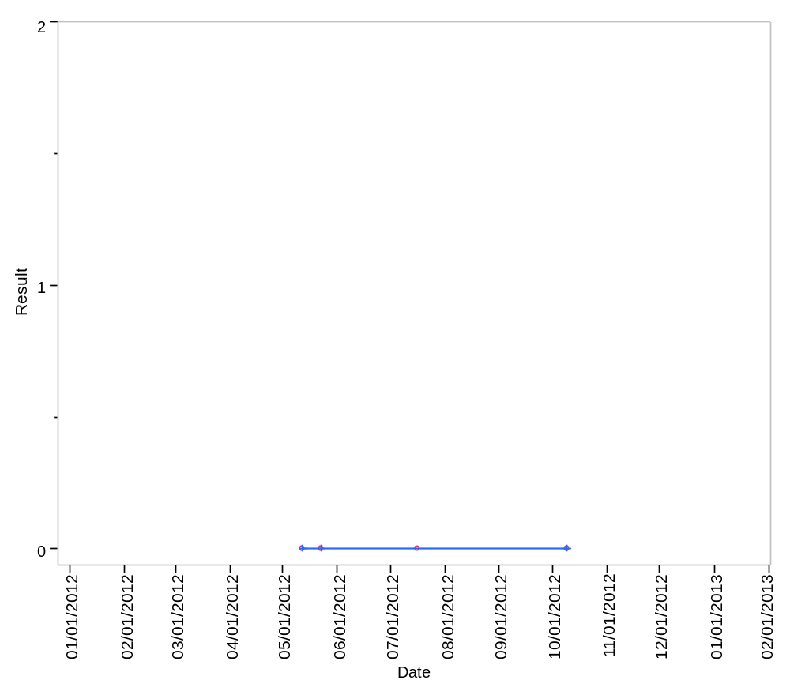

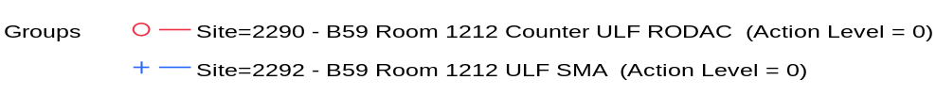

Overlay Plot Room=1213, Grade=Grade C, Frequency=Dynamic
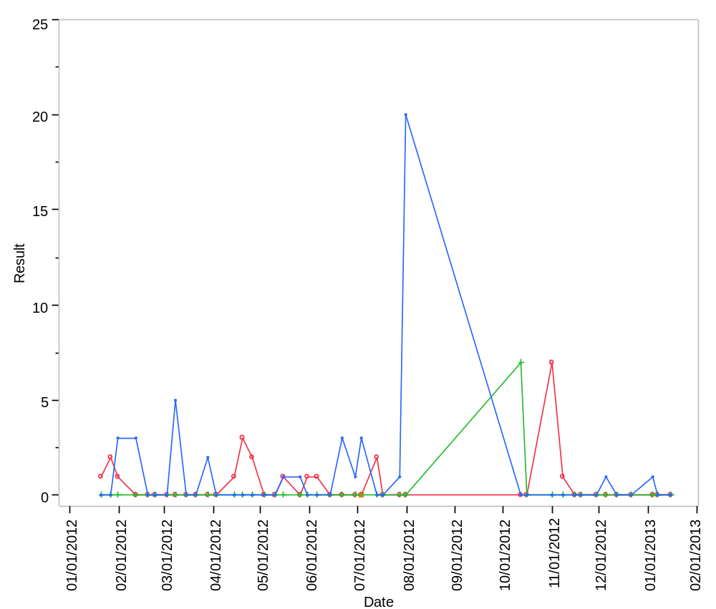

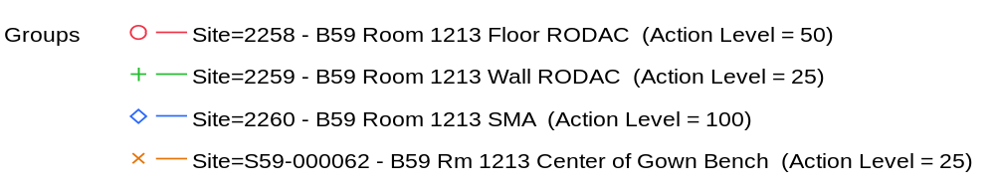

Overlay Plot Room=1213, Grade=Grade C, Frequency=Static
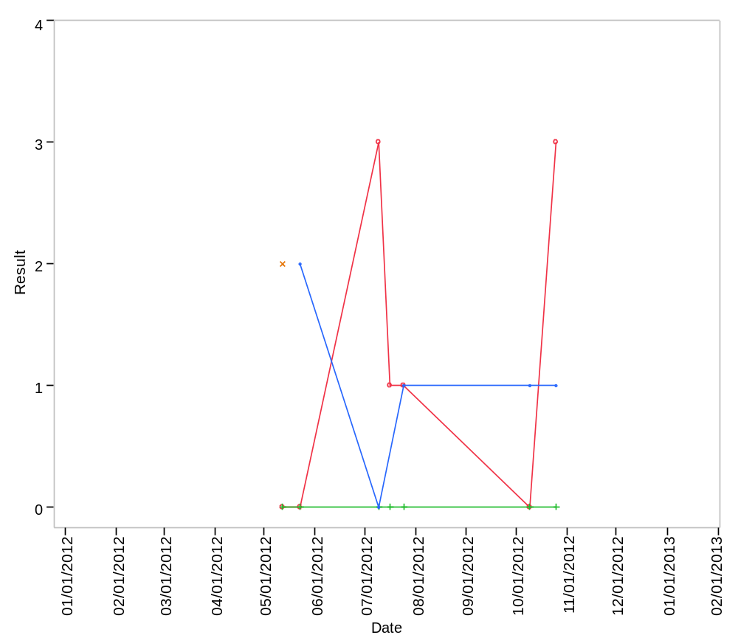

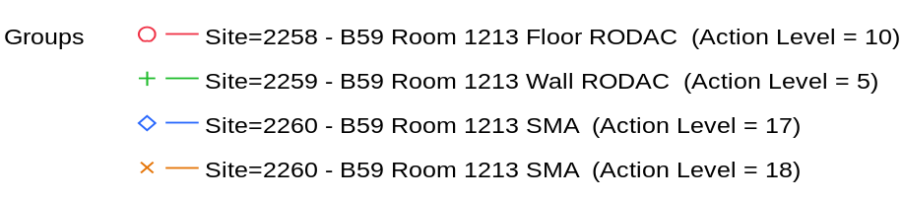

Overlay Plot Room=1307, Grade=Grade C, Frequency=Dynamic
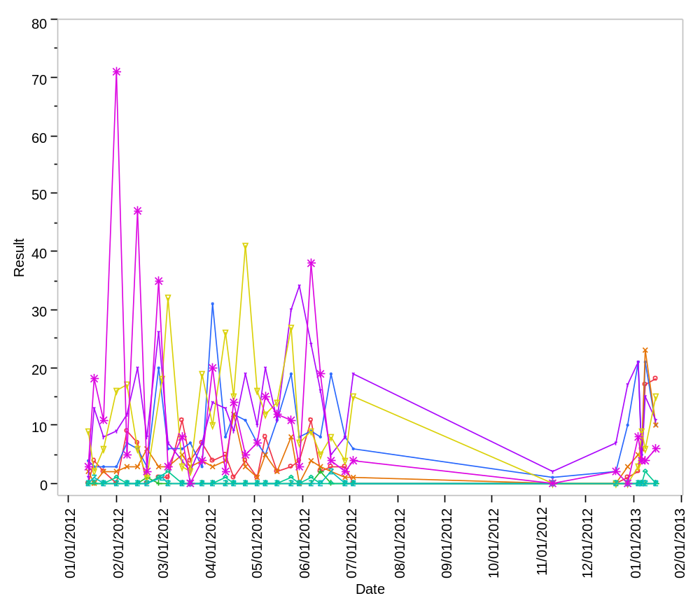

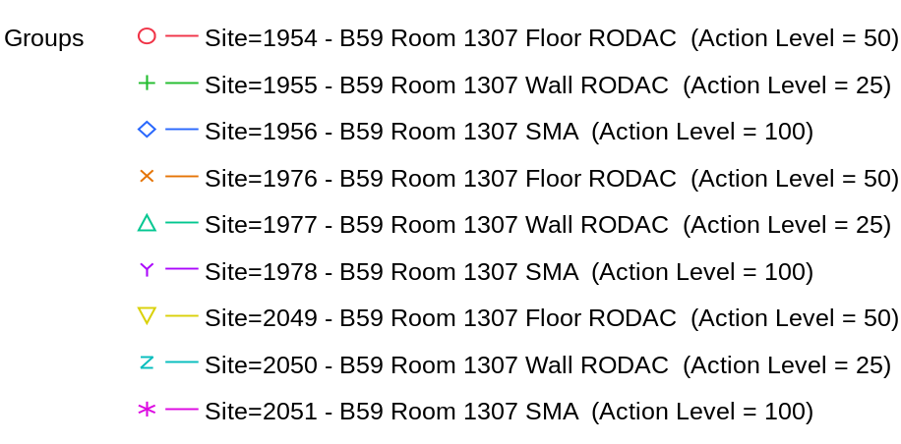

Overlay Plot Room=1307, Grade=Grade C, Frequency=Static
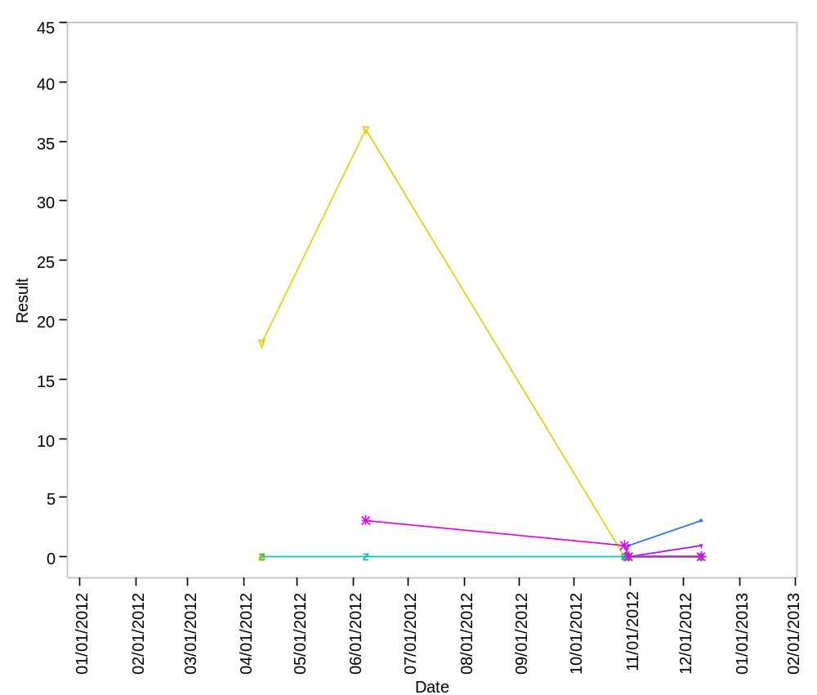

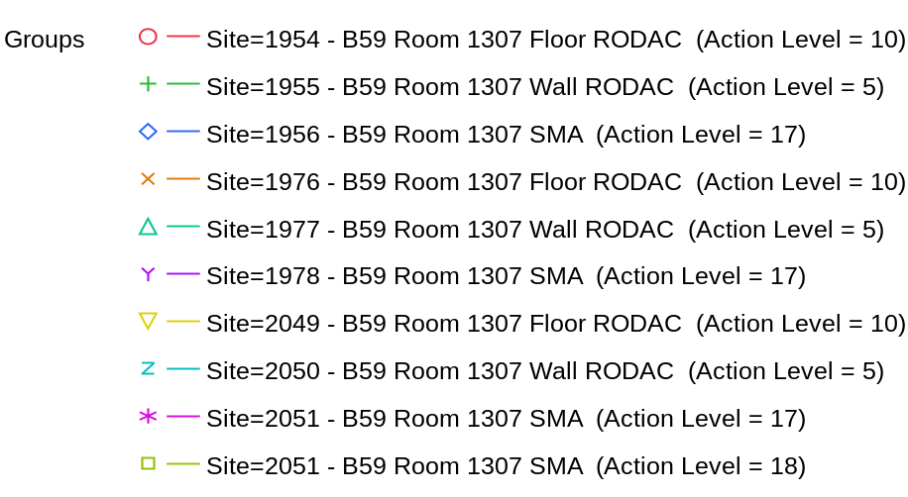

Overlay Plot Room=1407, Grade=Grade C, Frequency=Dynamic
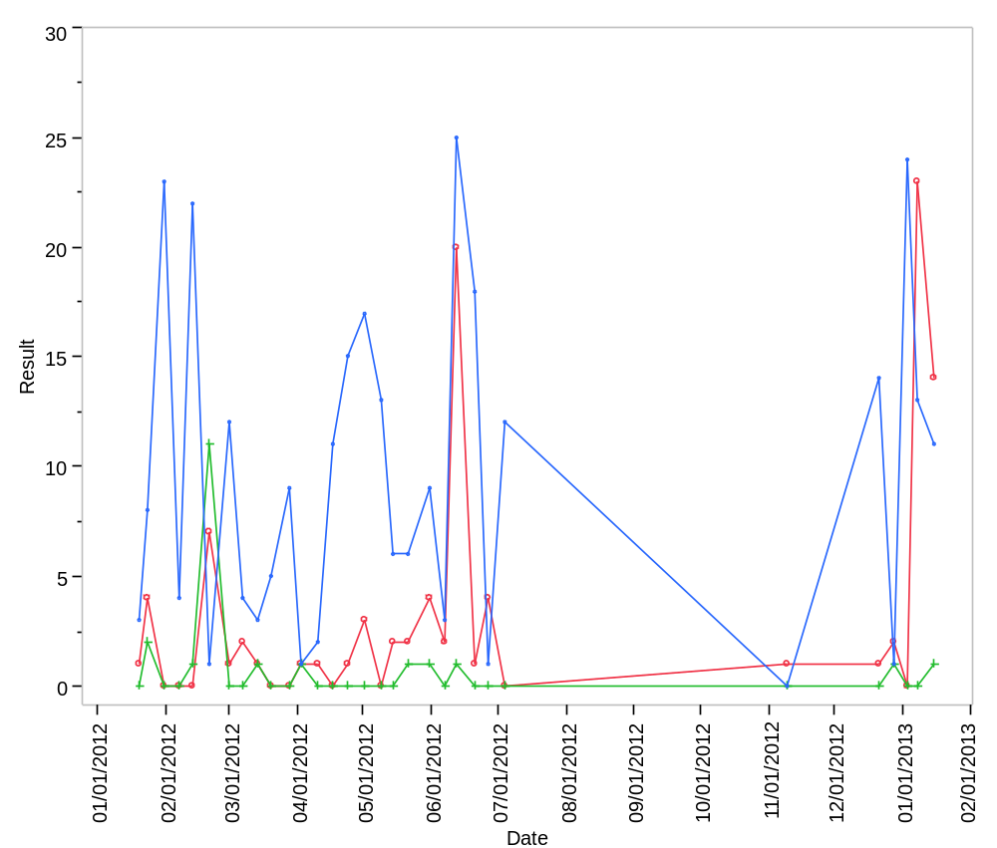

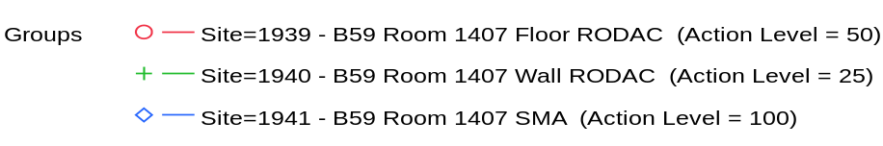

Overlay Plot Room=1407, Grade=Grade C, Frequency=Static
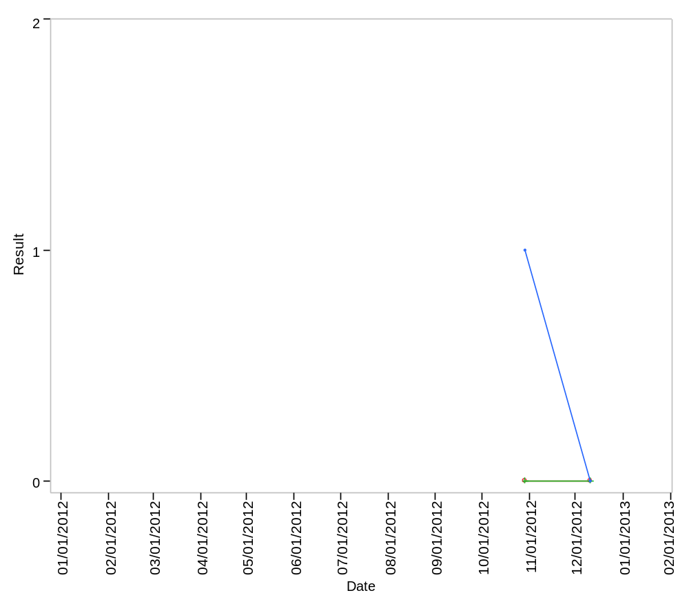

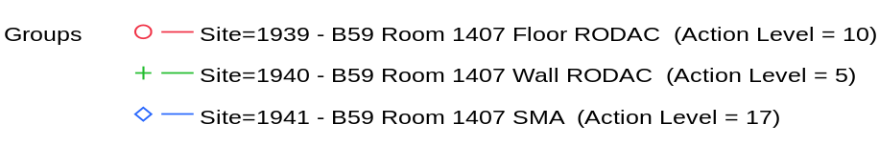

Overlay Plot Room=1408, Grade=Grade D, Frequency=Static
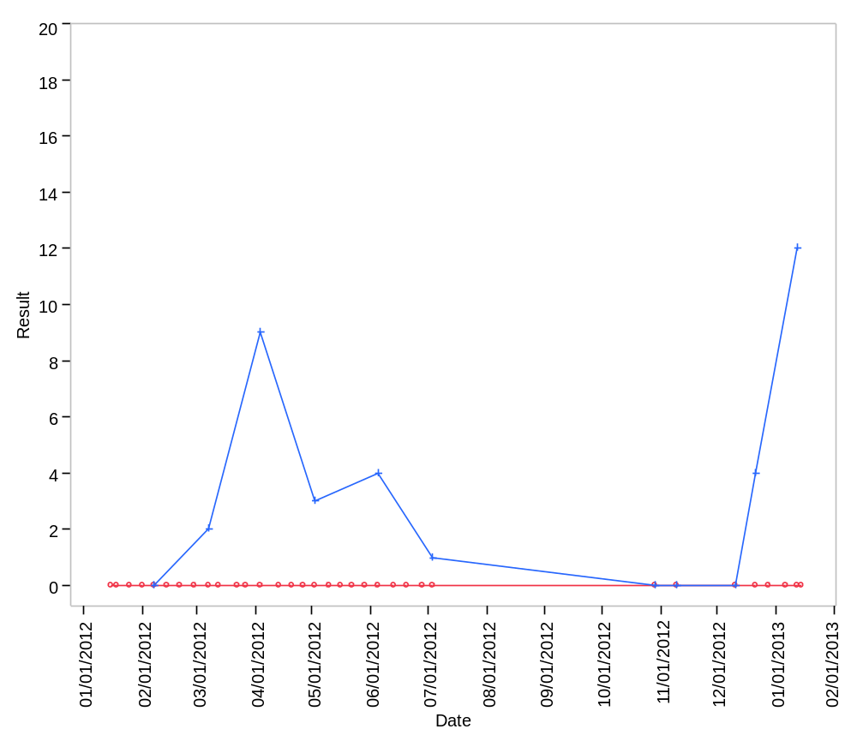

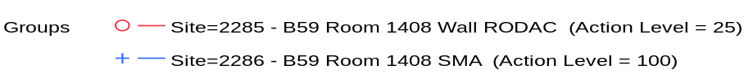

Overlay Plot Room=1409, Grade=Grade C, Frequency=Dynamic
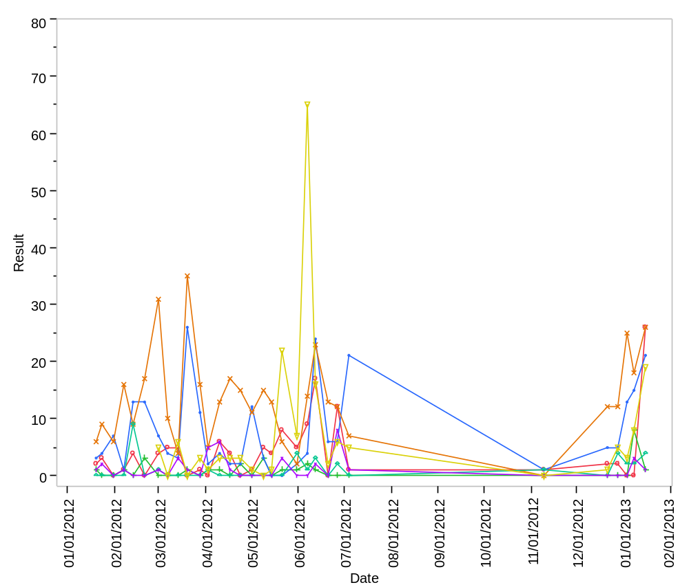

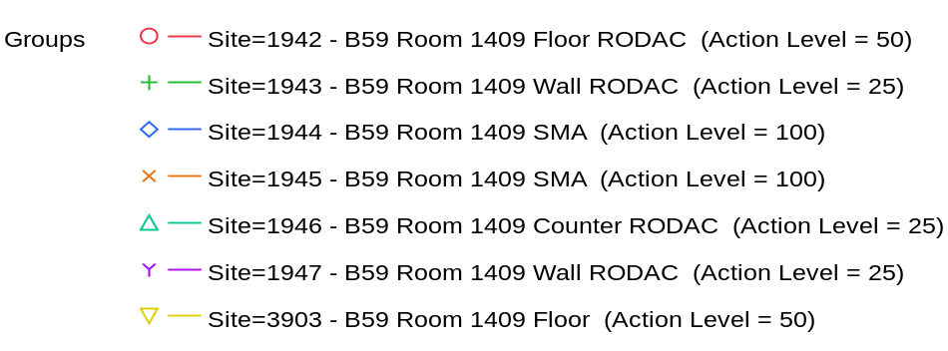

Overlay Plot Room=1409, Grade=Grade C, Frequency=Static
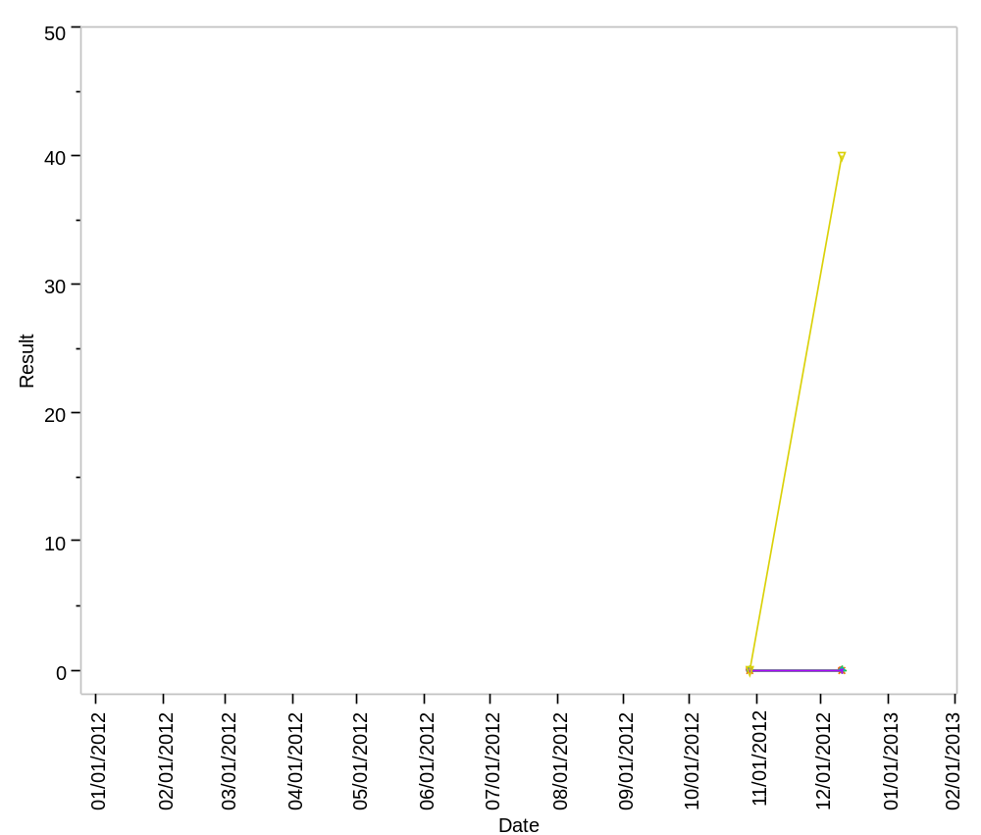

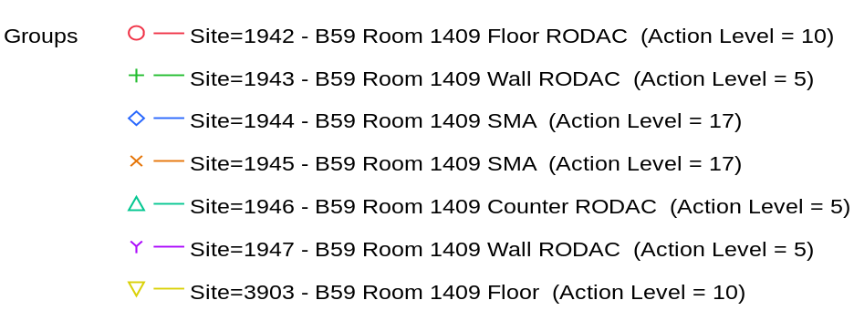

Overlay Plot Room=1411, Grade=Grade C - Laminar Flow, Frequency=Dynamic
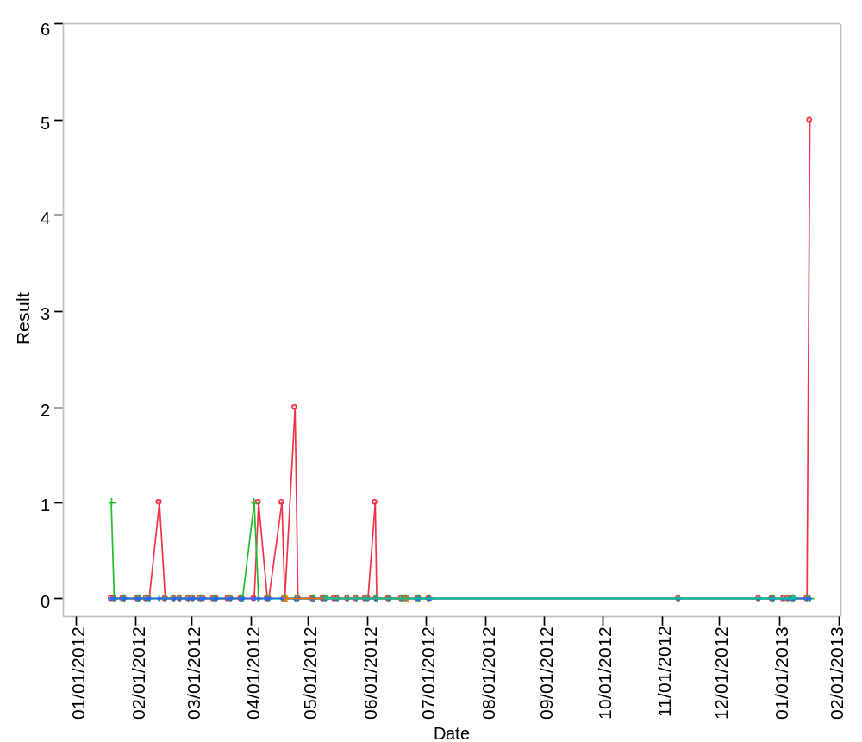

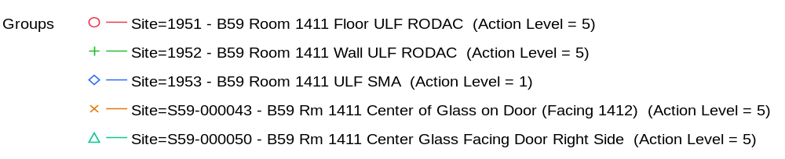

Overlay Plot Room=1411, Grade=Grade C - Laminar Flow, Frequency=Static
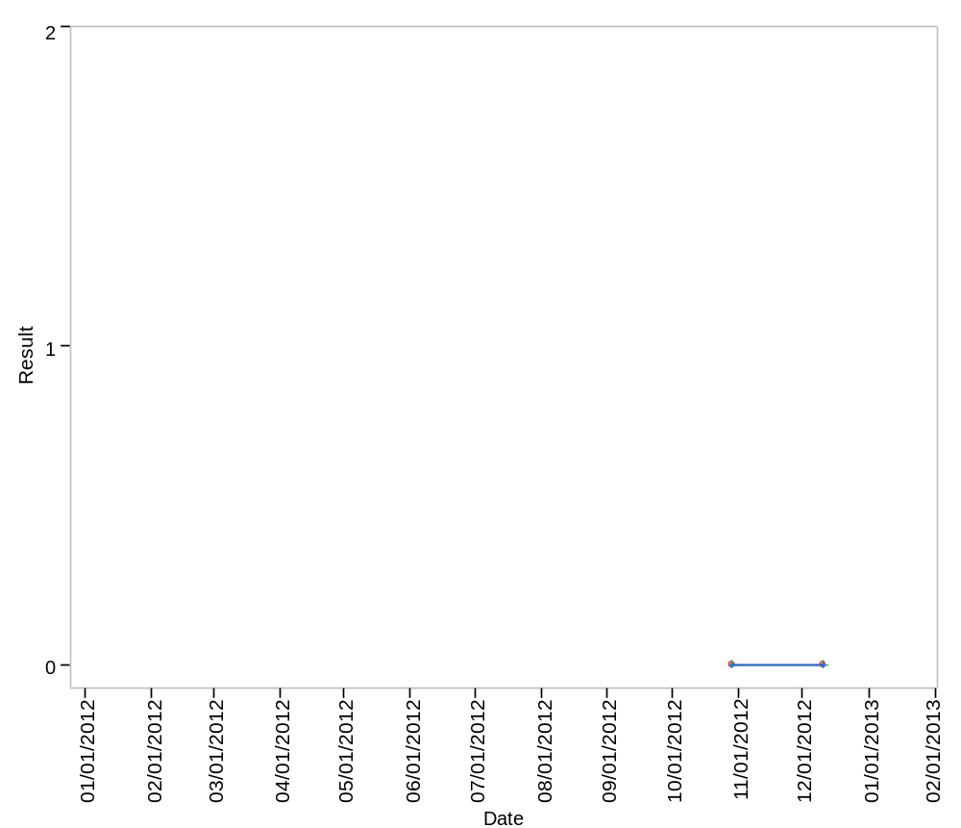

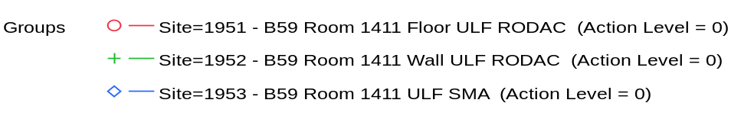

Overlay Plot Room=1412, Grade=Grade C, Frequency=Dynamic
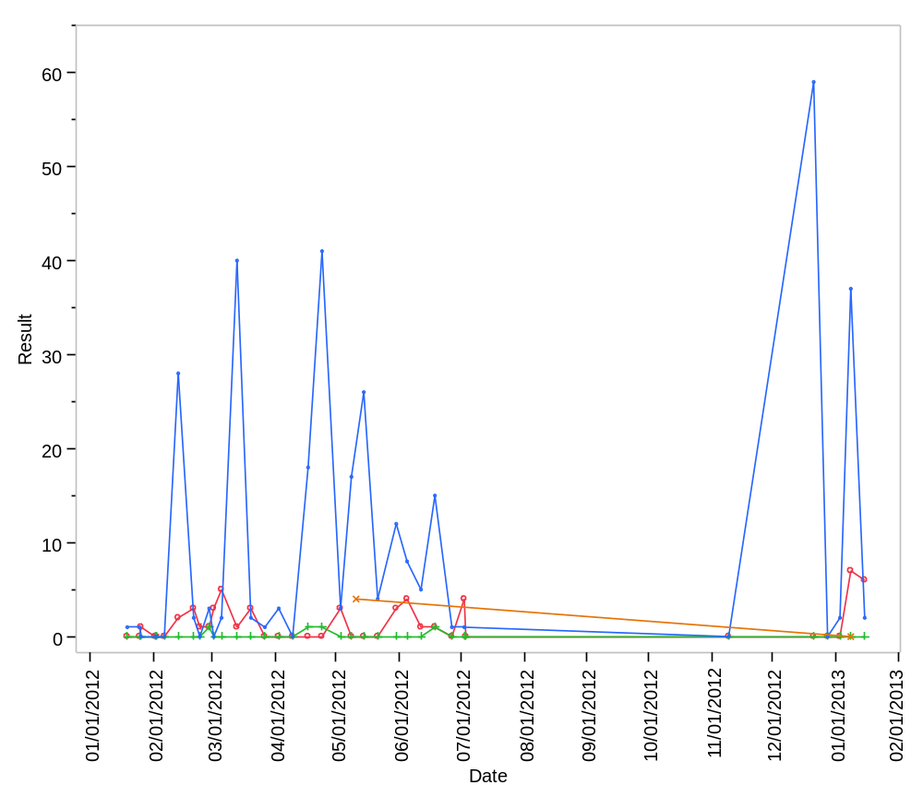

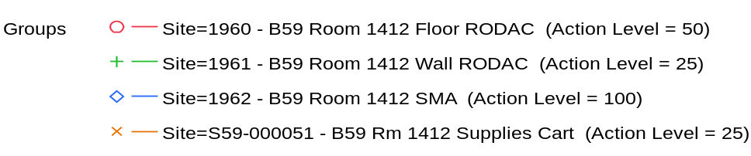

Overlay Plot Room=1412, Grade=Grade C, Frequency=Static
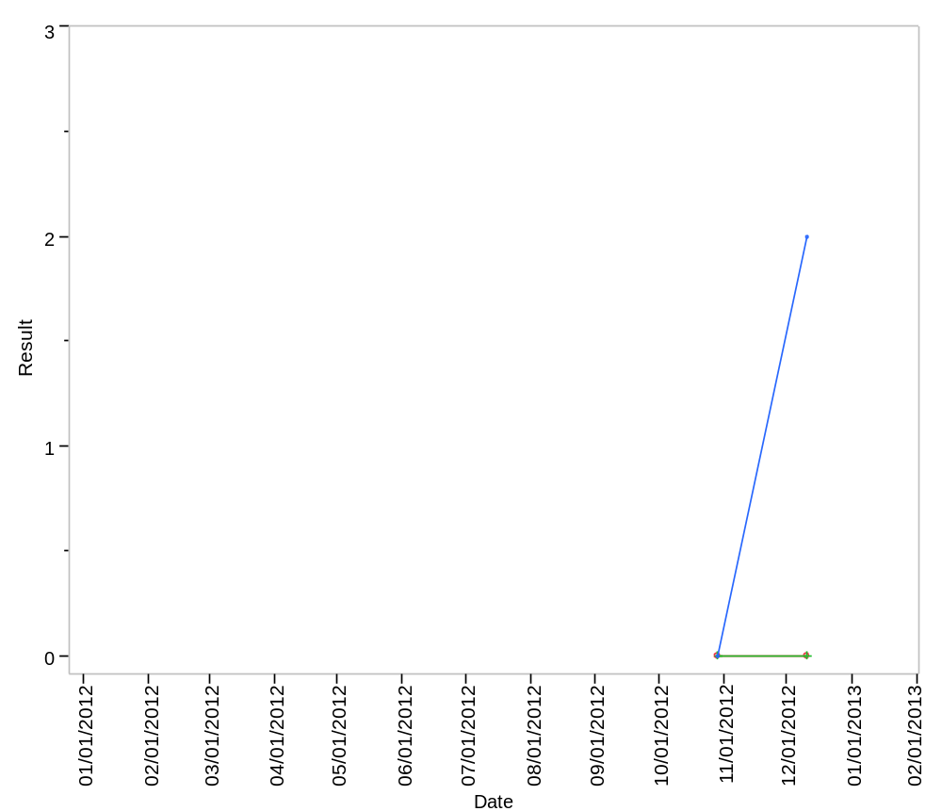

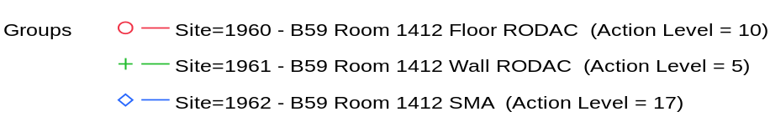

Overlay Plot Room=1413, Grade=Grade D, Frequency=Static
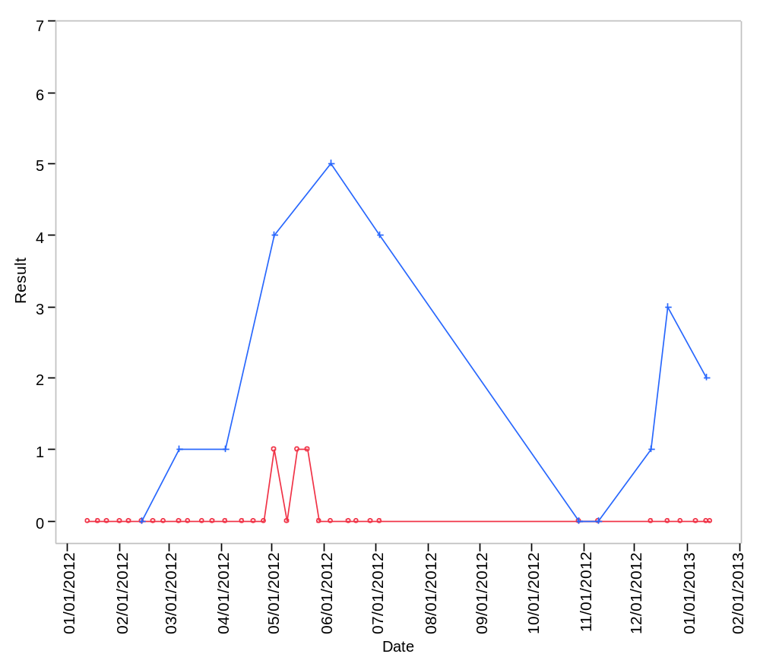

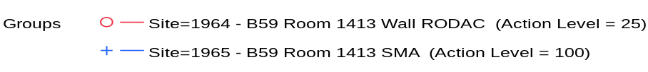

Overlay Plot Room=1416, Grade=Grade C, Frequency=Dynamic
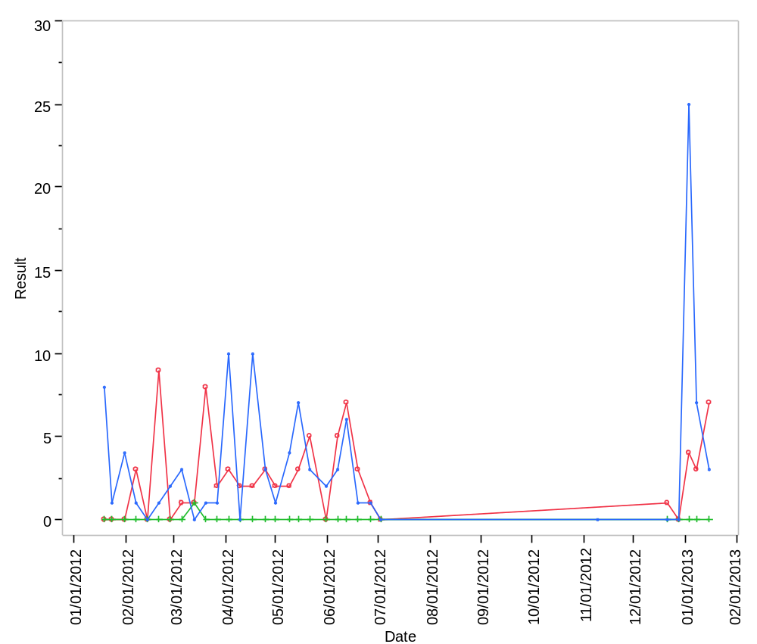

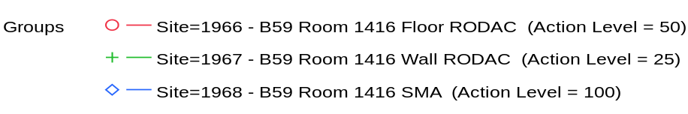

Overlay Plot Room=1416, Grade=Grade C, Frequency=Static
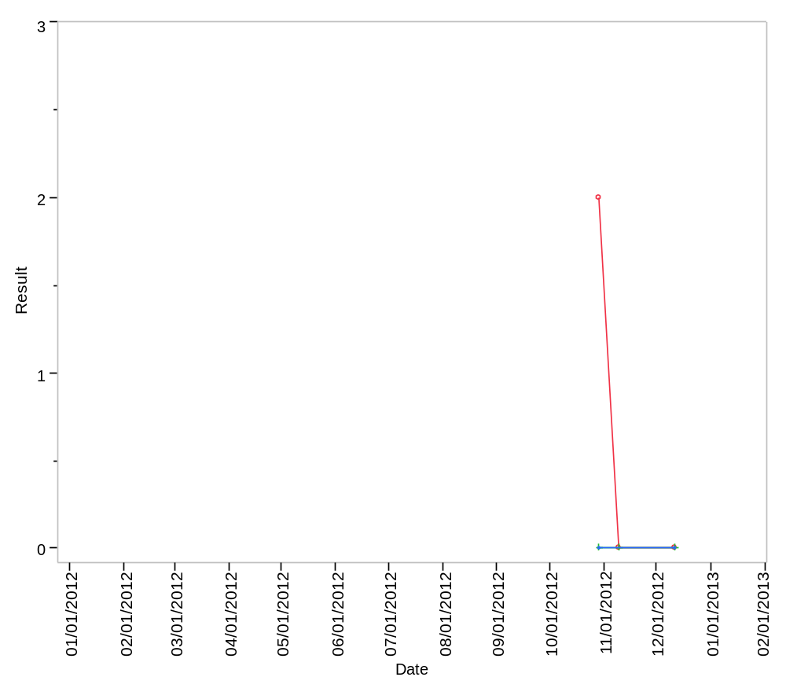

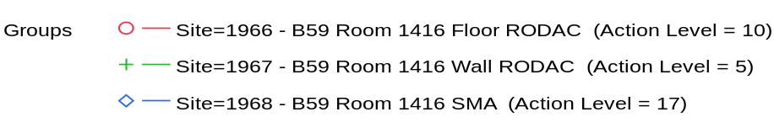

Overlay Plot Room=1418, Grade=Grade C, Frequency=Dynamic
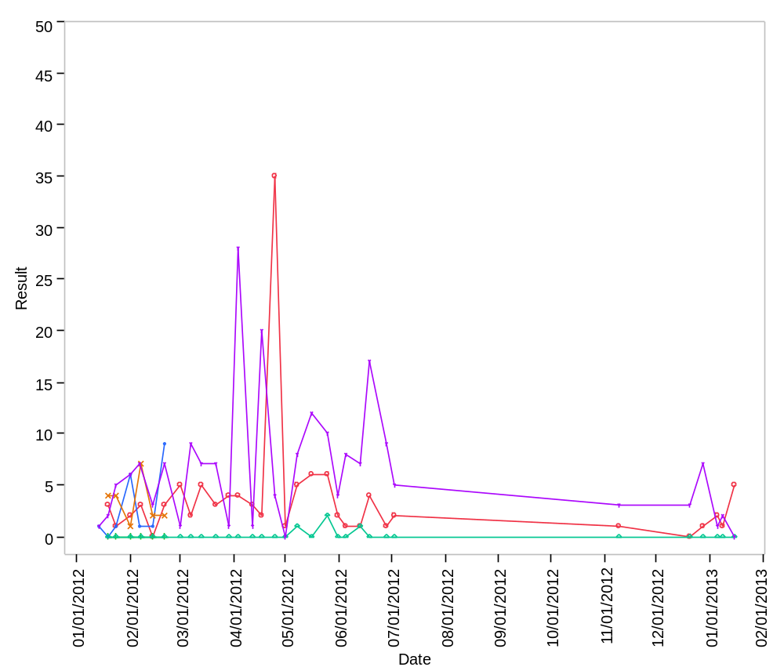

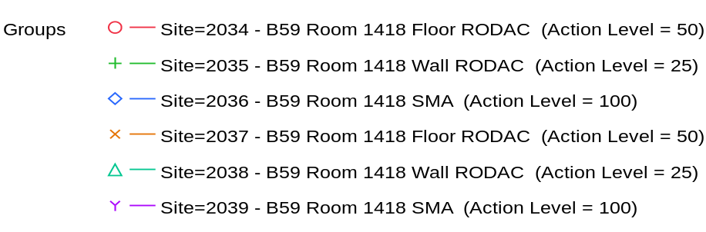

Overlay Plot Room=1418, Grade=Grade C, Frequency=Static
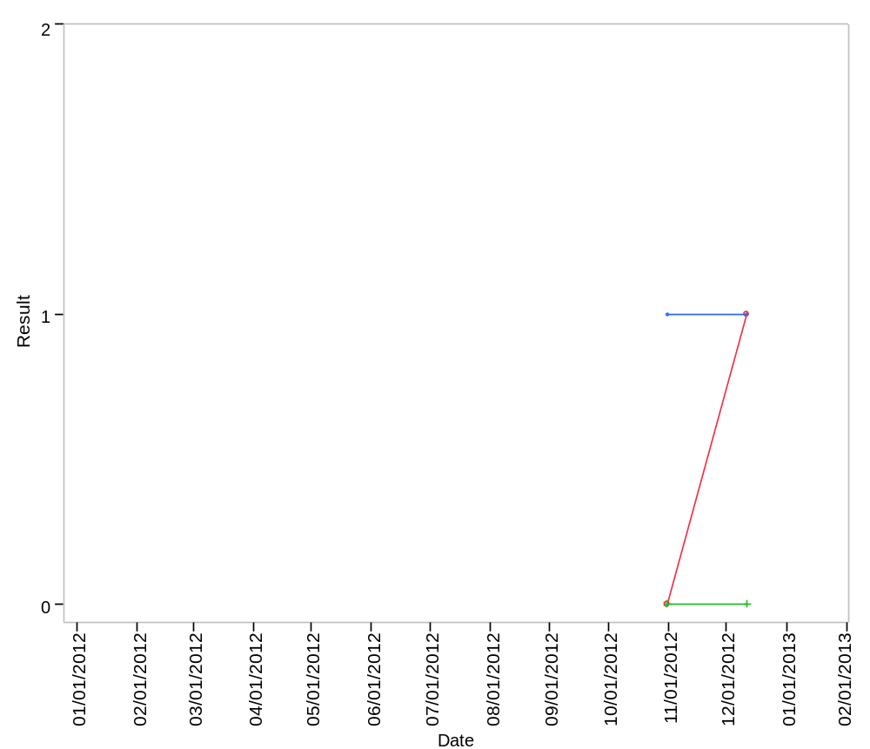

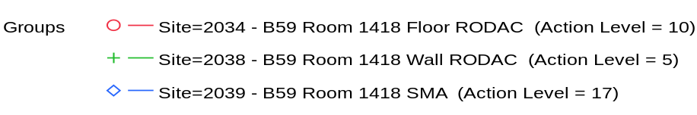

Overlay Plot Room=1421, Grade=Grade C, Frequency=Dynamic
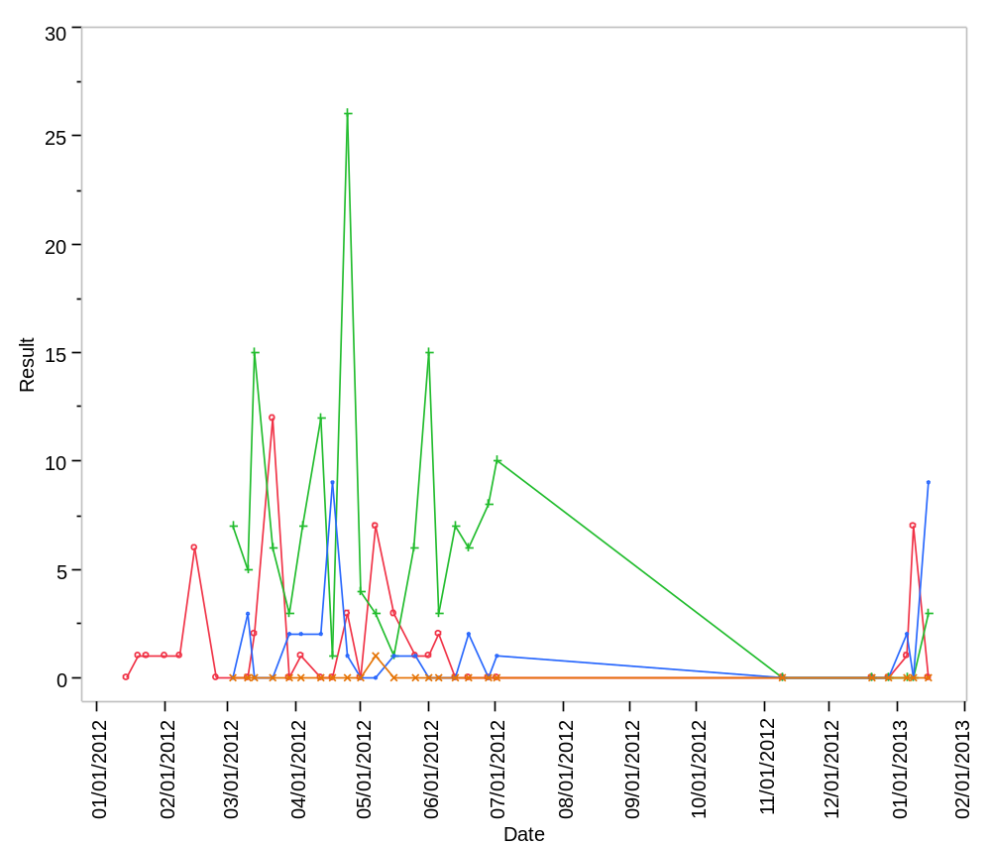

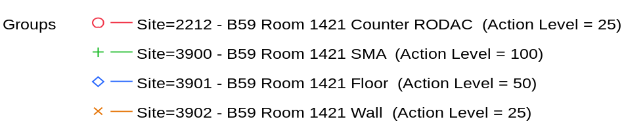

Overlay Plot Room=1421, Grade=Grade C, Frequency=Static
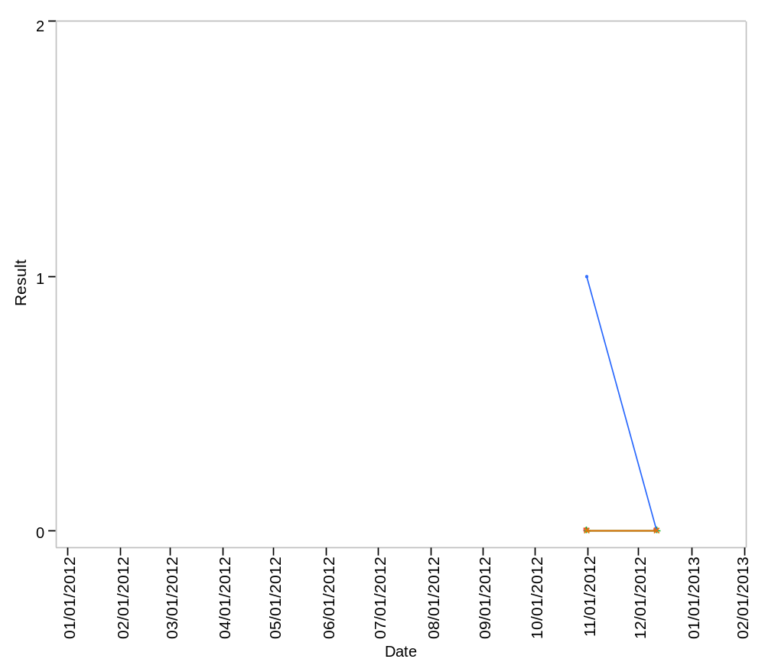

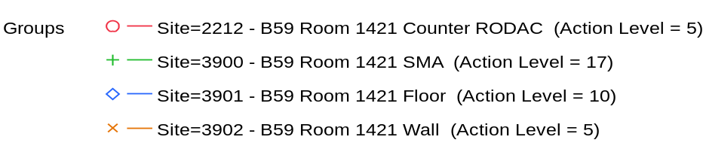

Overlay Plot Room=1422, Grade=Grade C, Frequency=Dynamic
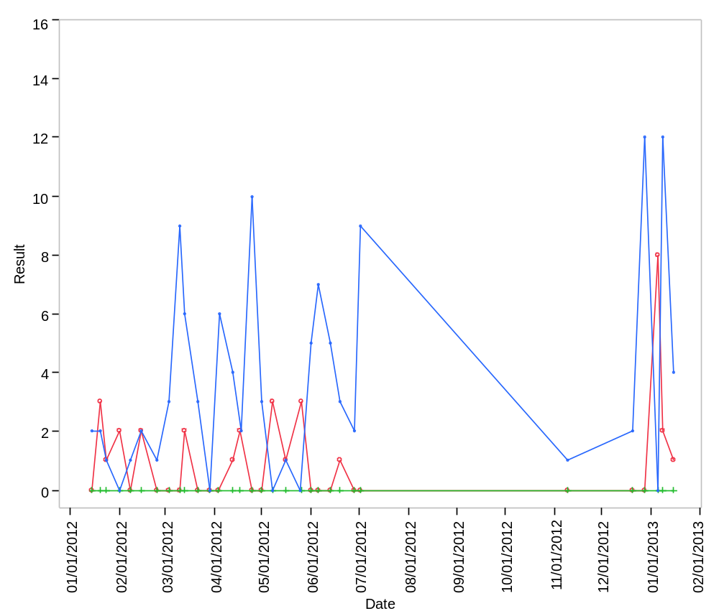

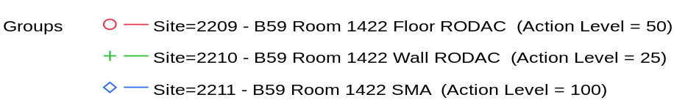

Overlay Plot Room=1422, Grade=Grade C, Frequency=Static
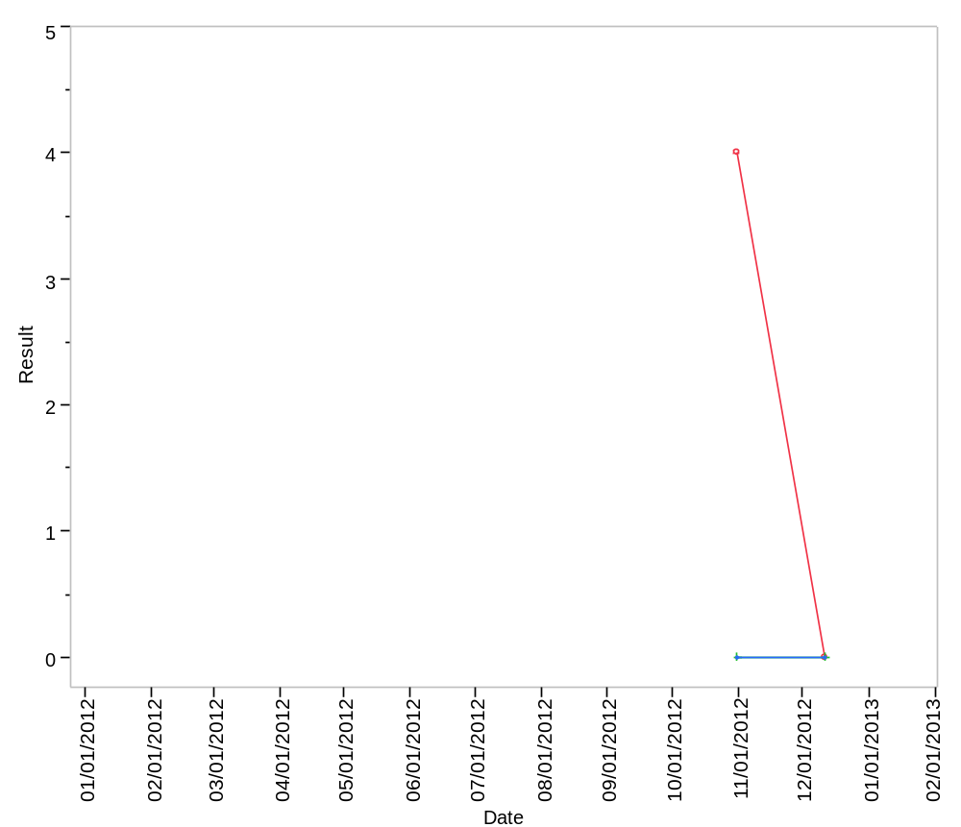

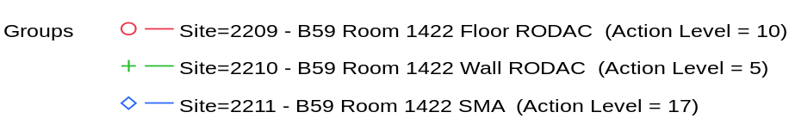

Overlay Plot Room=1423, Grade=Grade D, Frequency=Static
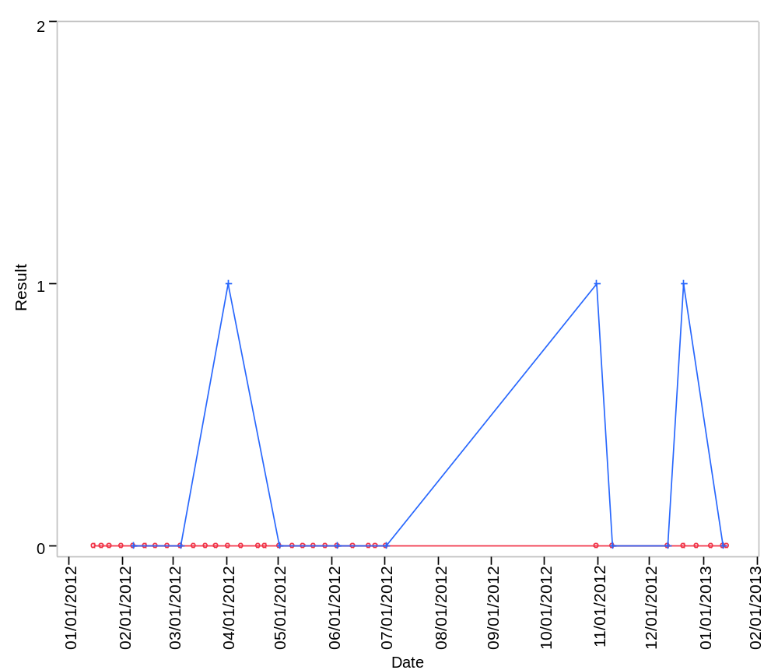

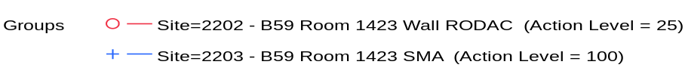

Overlay Plot Room=1425, Grade=Grade D, Frequency=Static
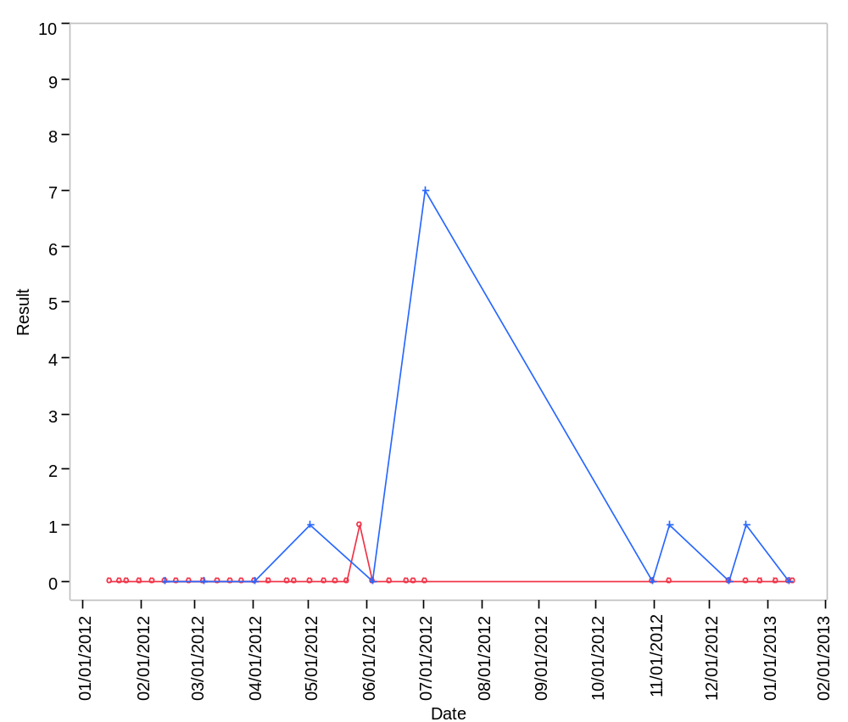

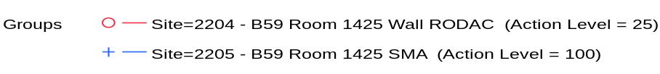

Overlay Plot Room=1426, Grade=Grade C, Frequency=Dynamic
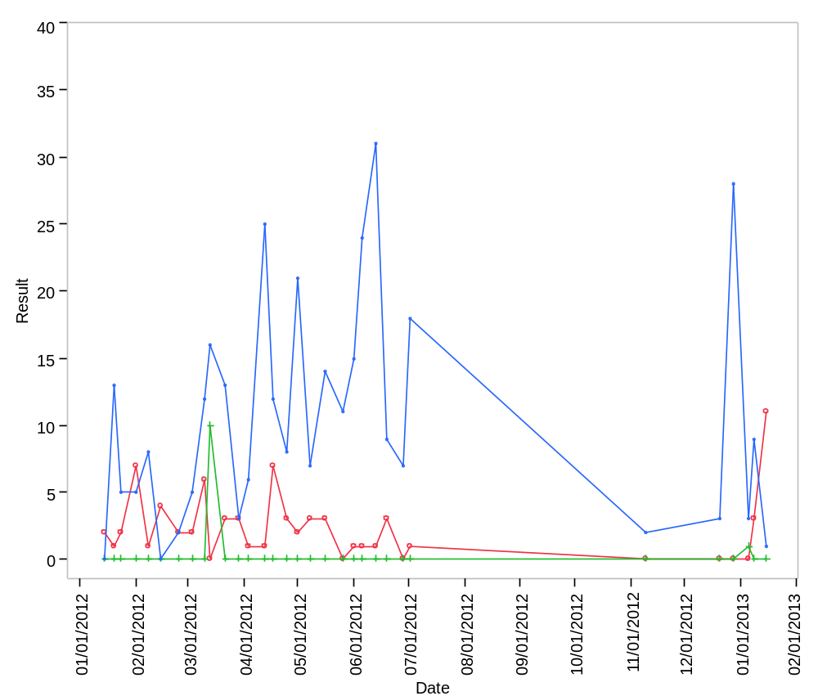

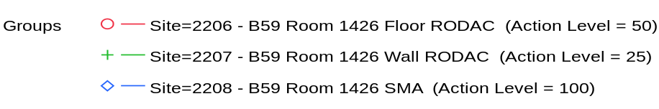

Overlay Plot Room=1426, Grade=Grade C, Frequency=Static
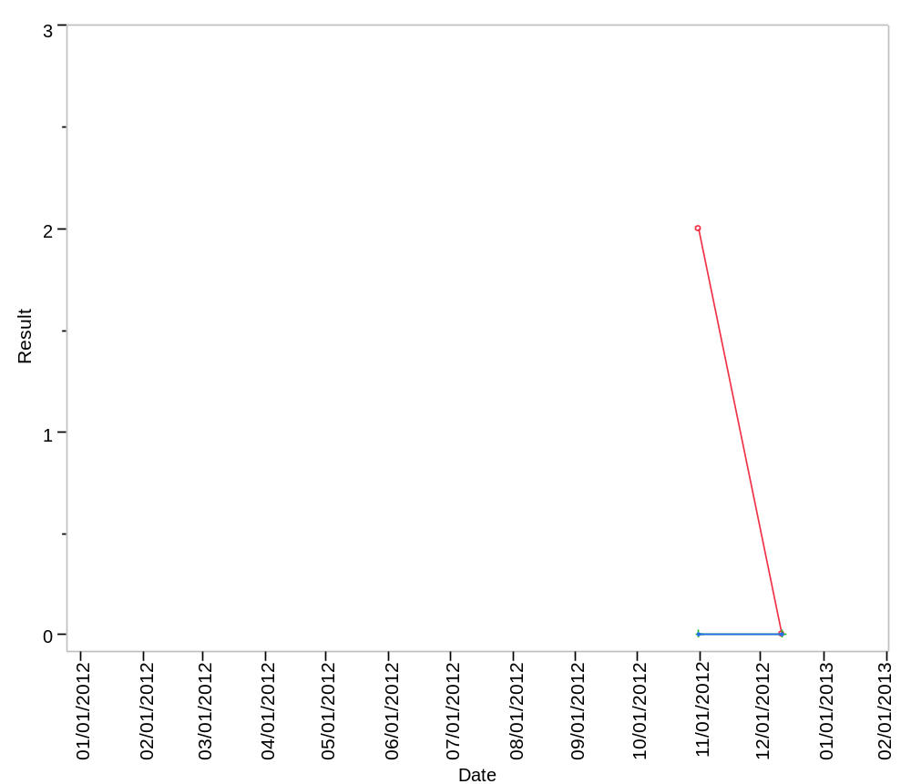

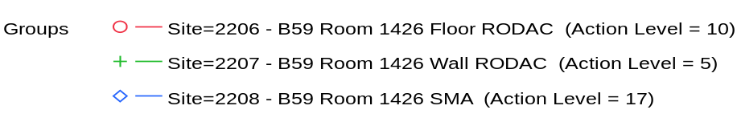

Overlay Plot Room=1427, Grade=Grade C, Frequency=Dynamic
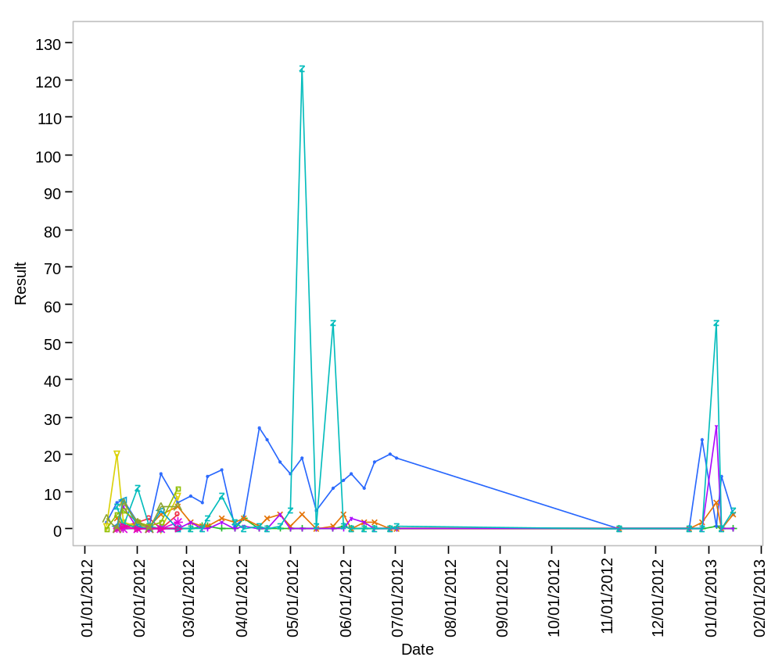

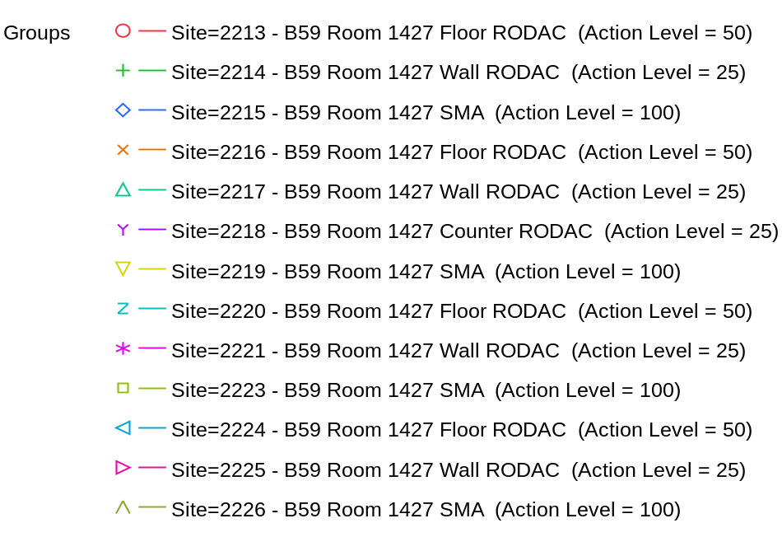

Overlay Plot Room=1427, Grade=Grade C, Frequency=Static
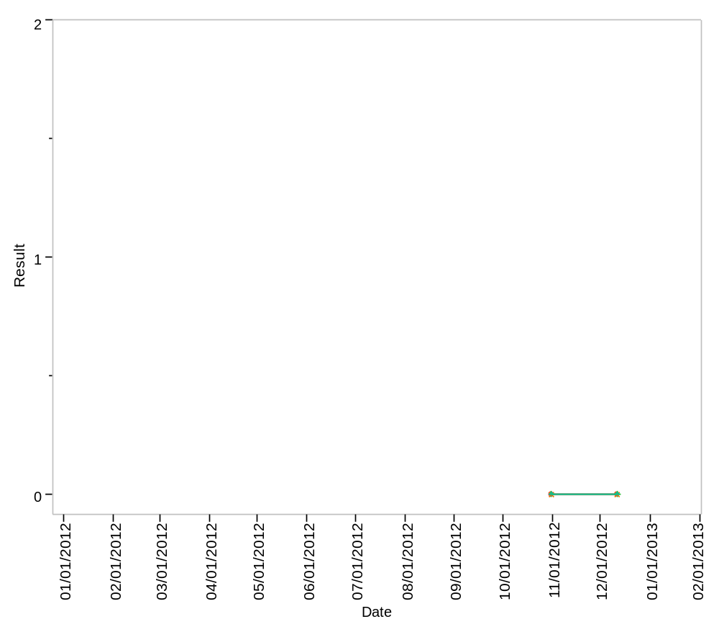

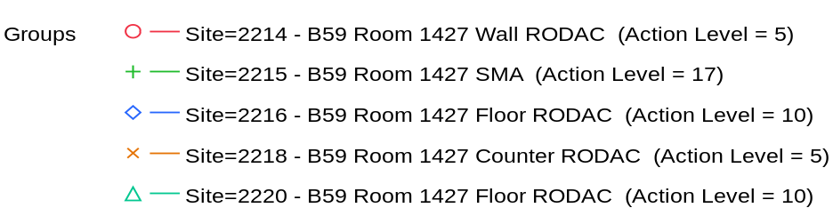

Overlay Plot Room=1428, Grade=Grade D, Frequency=Static
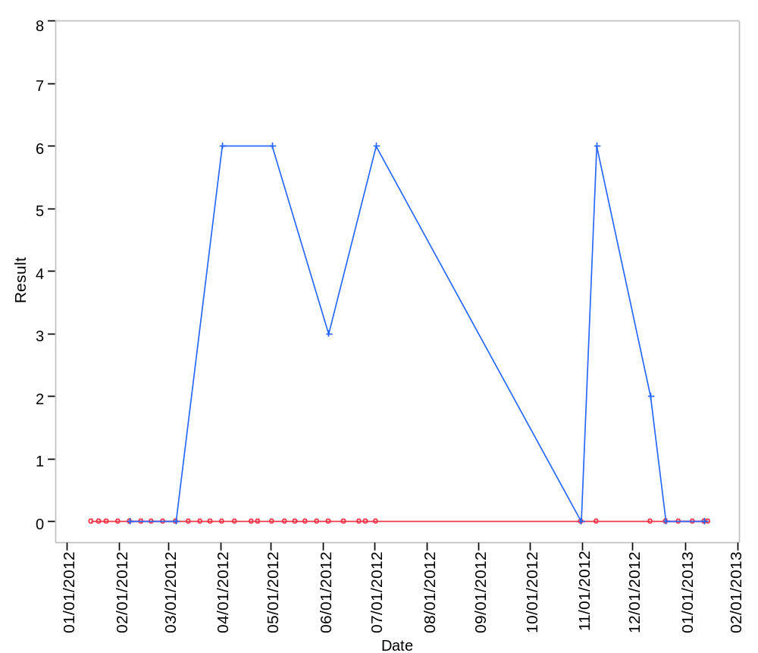

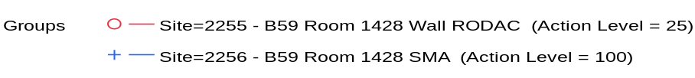

Overlay Plot Room=1431, Grade=Grade D, Frequency=Dynamic
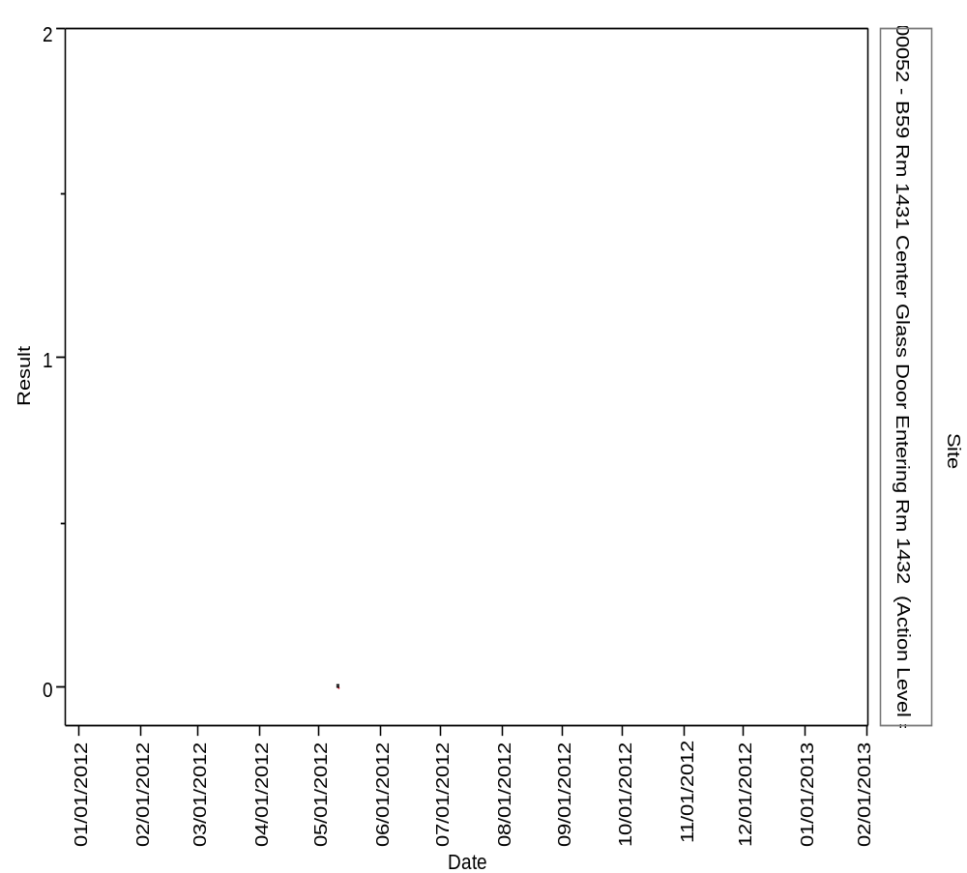

Overlay Plot Room=1431, Grade=Grade D, Frequency=Static
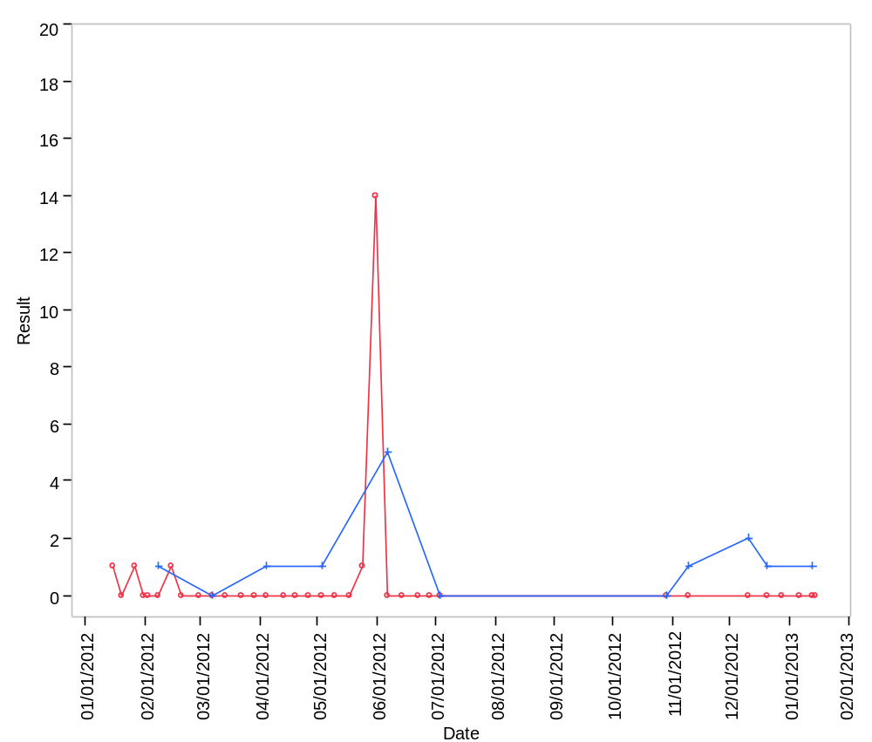

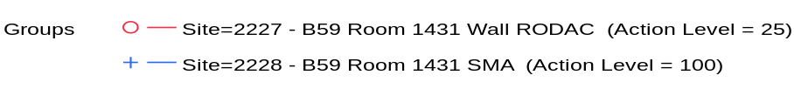

Overlay Plot Room=1432, Grade=Grade C, Frequency=Dynamic
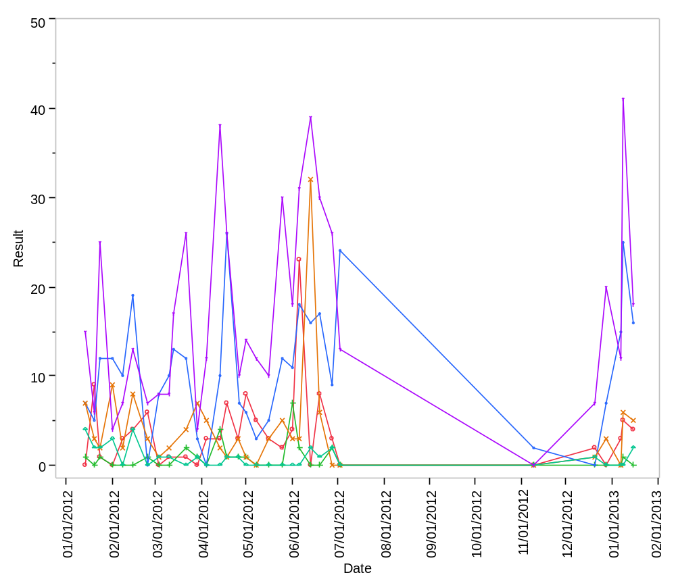

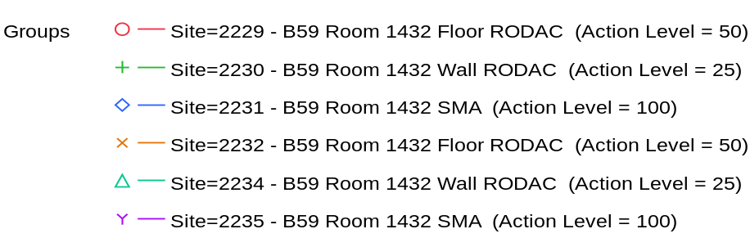

Overlay Plot Room=1432, Grade=Grade C, Frequency=Static
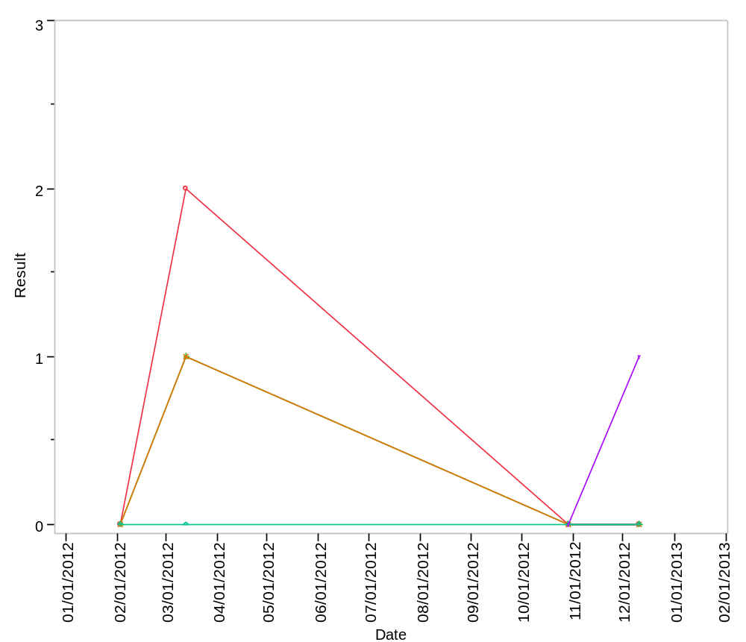

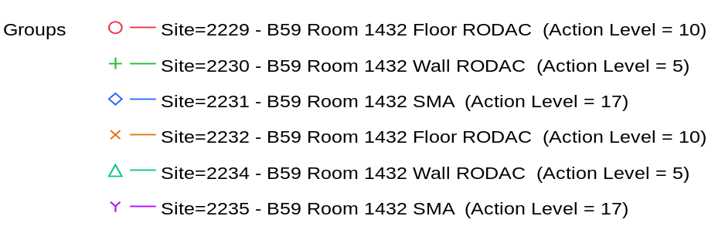

Overlay Plot Room=1433, Grade=Grade C, Frequency=Dynamic
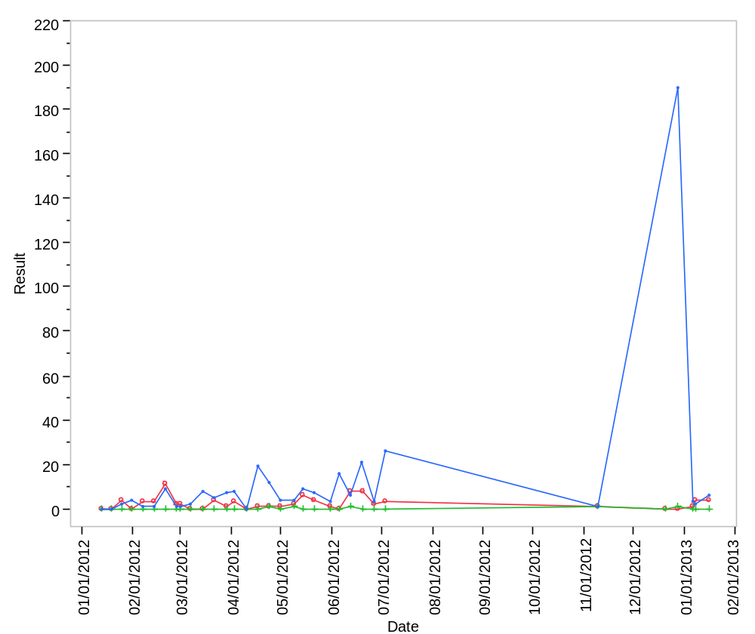

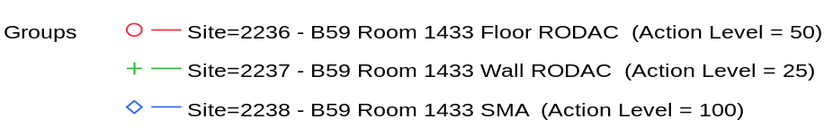

Overlay Plot Room=1433, Grade=Grade C, Frequency=Static
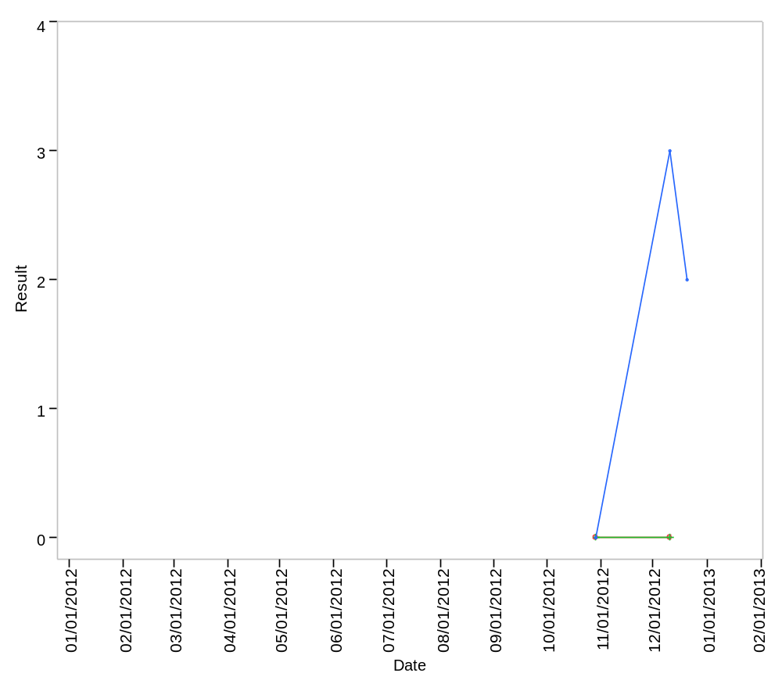

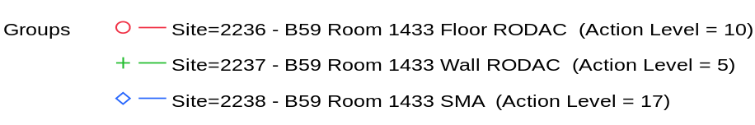

Overlay Plot Room=1440, Grade=Grade D, Frequency=Static
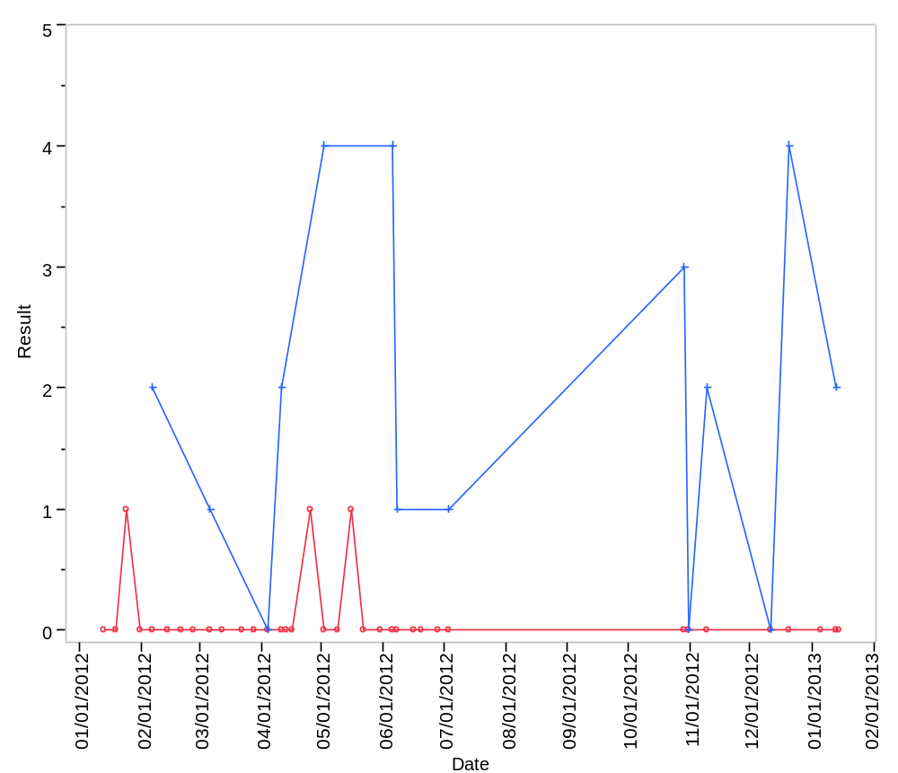

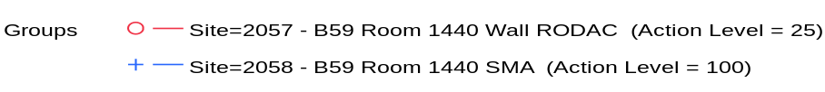

Overlay Plot Room=1441, Grade=Grade D, Frequency=Static
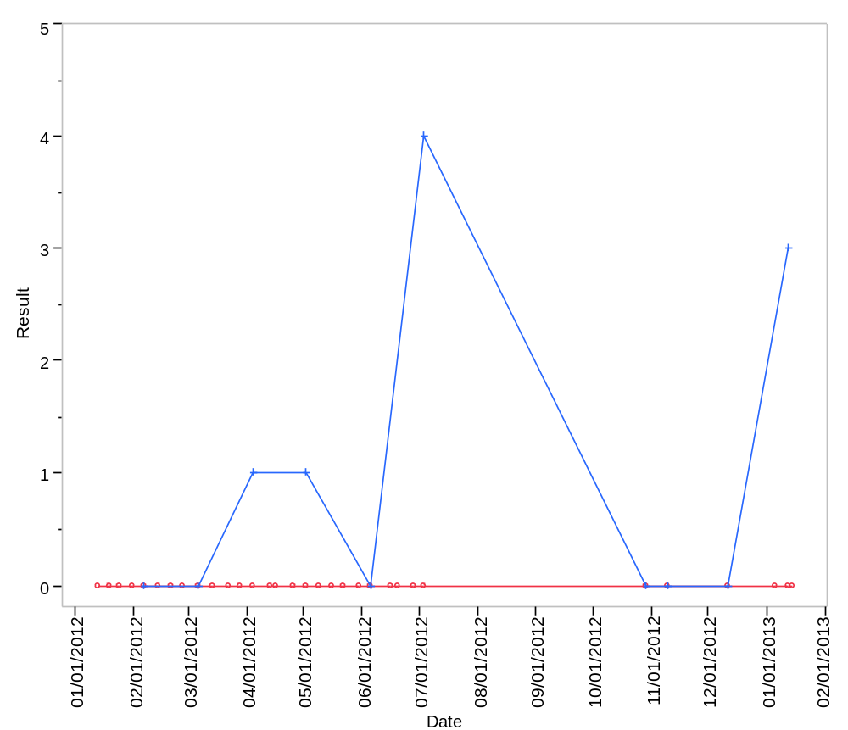

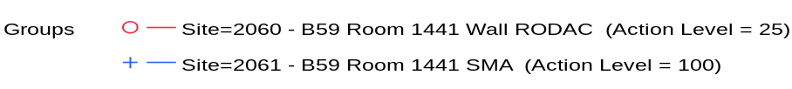

Overlay Plot Room=1600, Grade=Grade C, Frequency=Dynamic
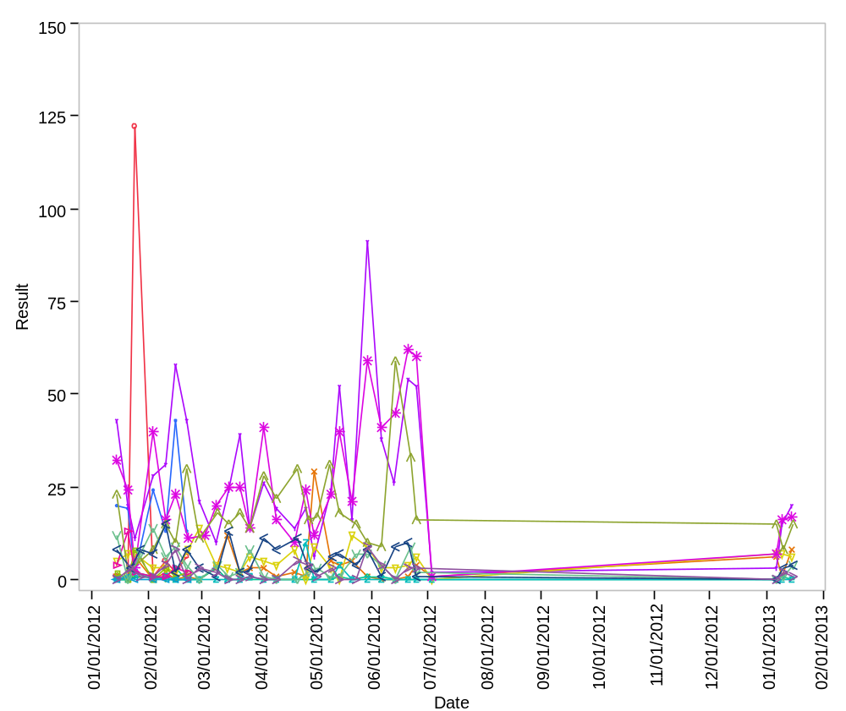

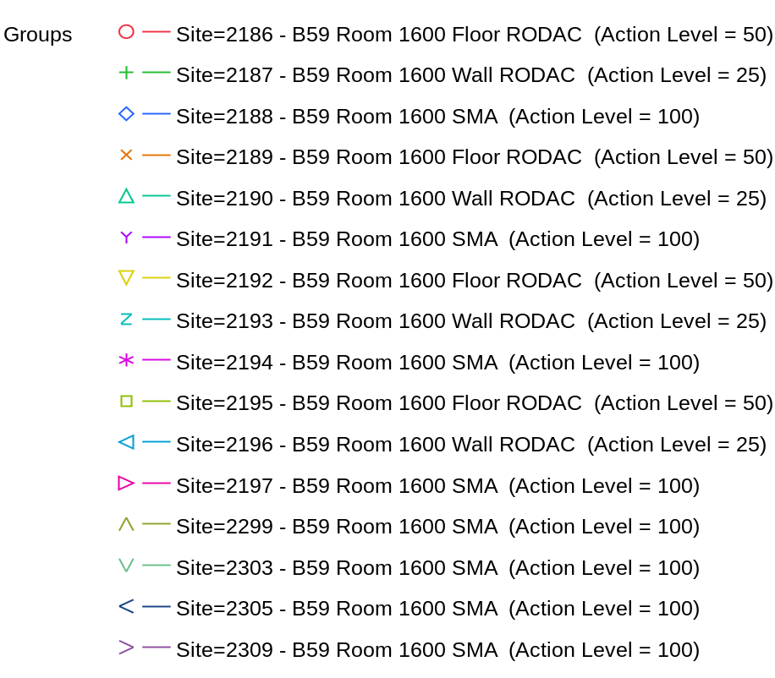

Overlay Plot Room=1600, Grade=Grade C, Frequency=Static
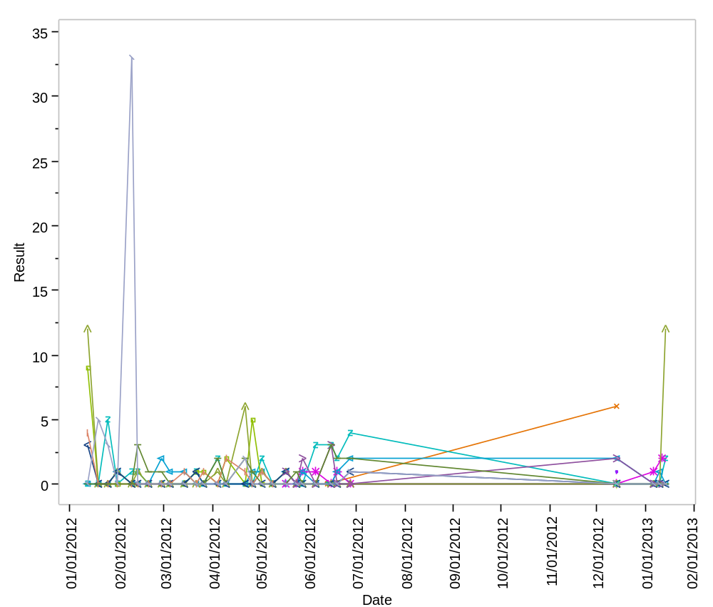

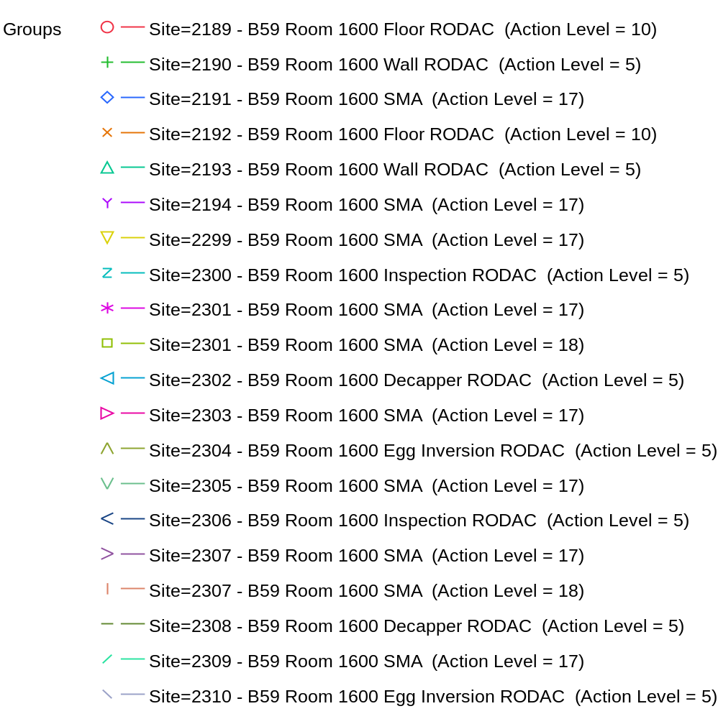

Overlay Plot Room=1601, Grade=Grade C, Frequency=Dynamic
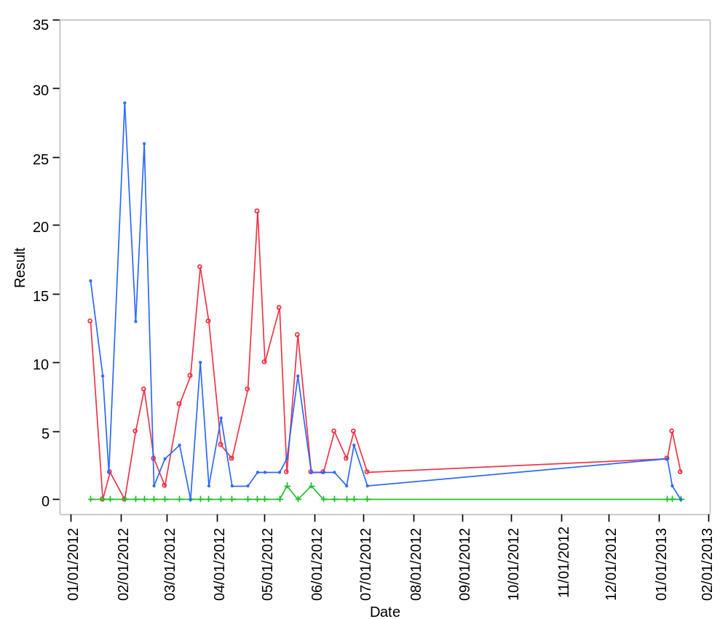

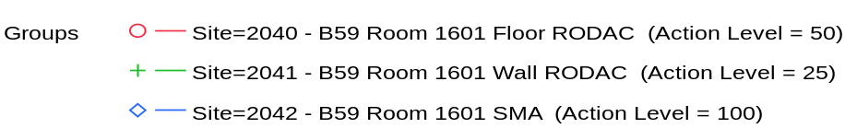

Overlay Plot Room=1601, Grade=Grade C, Frequency=Static
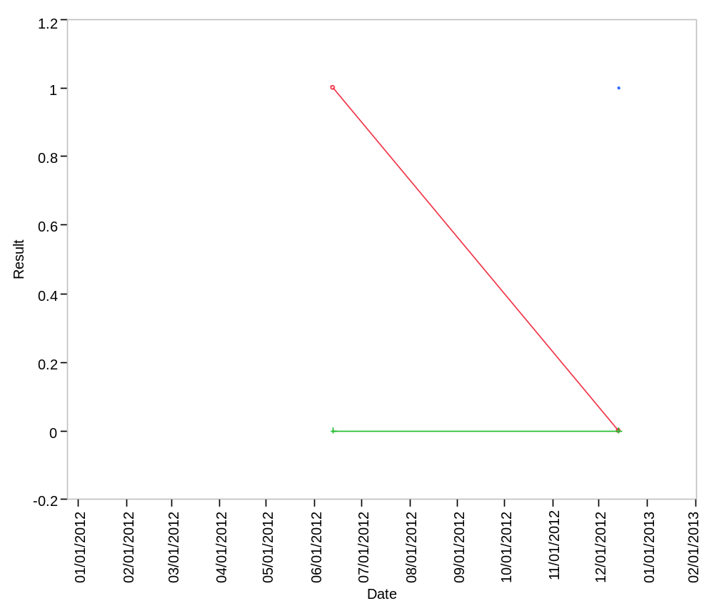

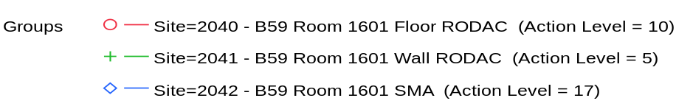

Overlay Plot Room=1602, Grade=Grade C, Frequency=Dynamic
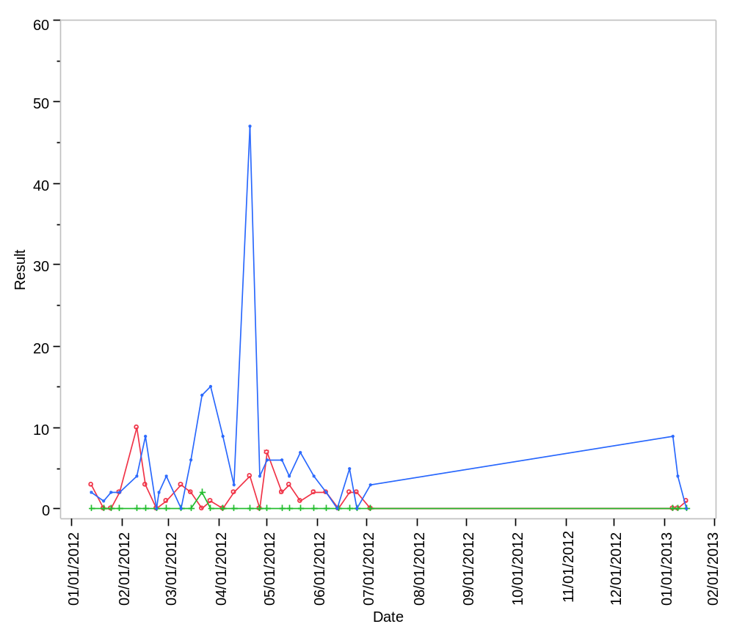

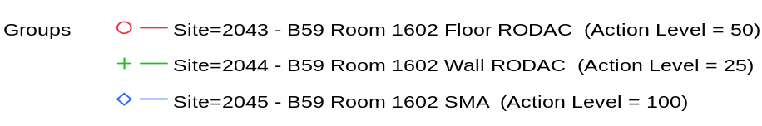

Overlay Plot Room=1602, Grade=Grade C, Frequency=Static
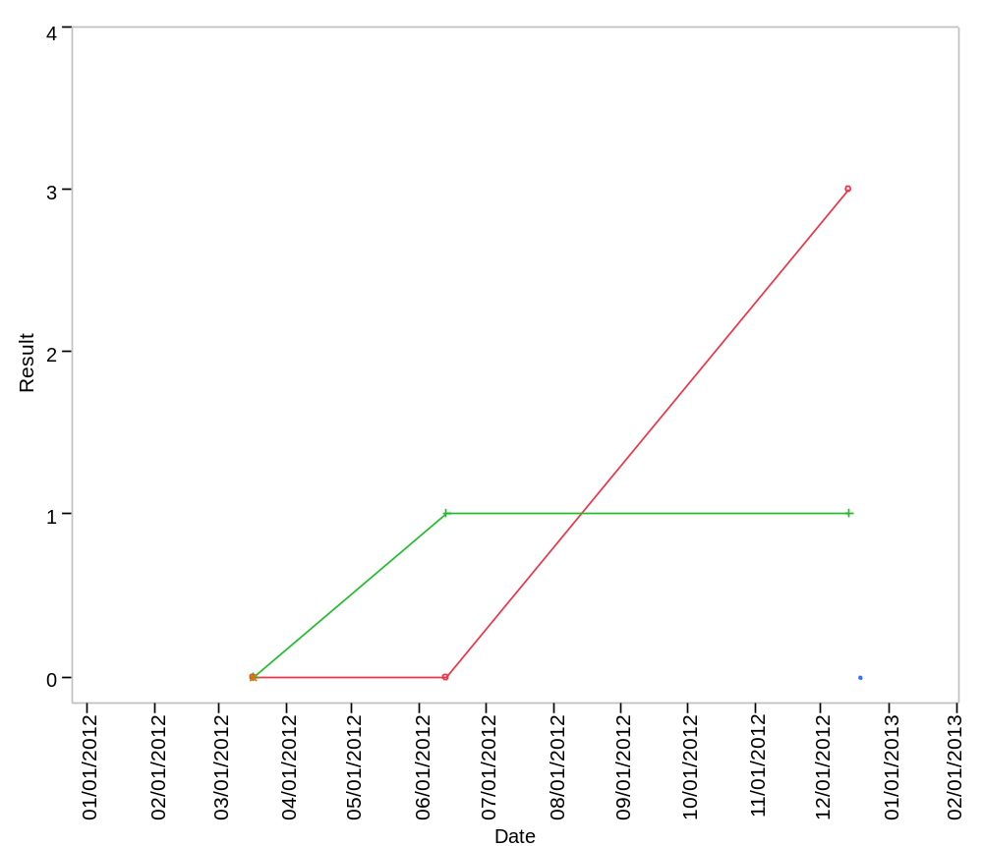

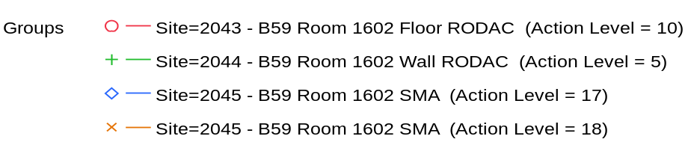

Overlay Plot Room=1603, Grade=Grade C, Frequency=Dynamic
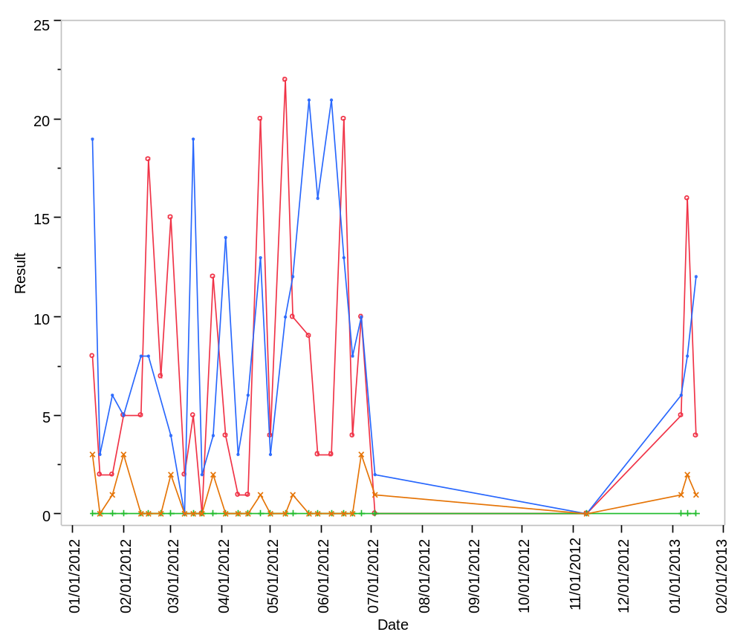

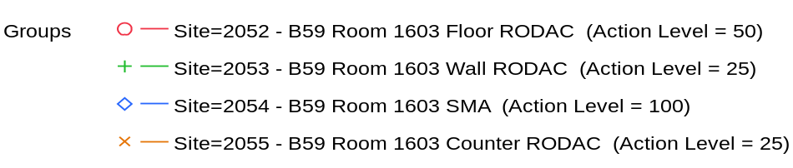

Overlay Plot Room=1603, Grade=Grade C, Frequency=Static
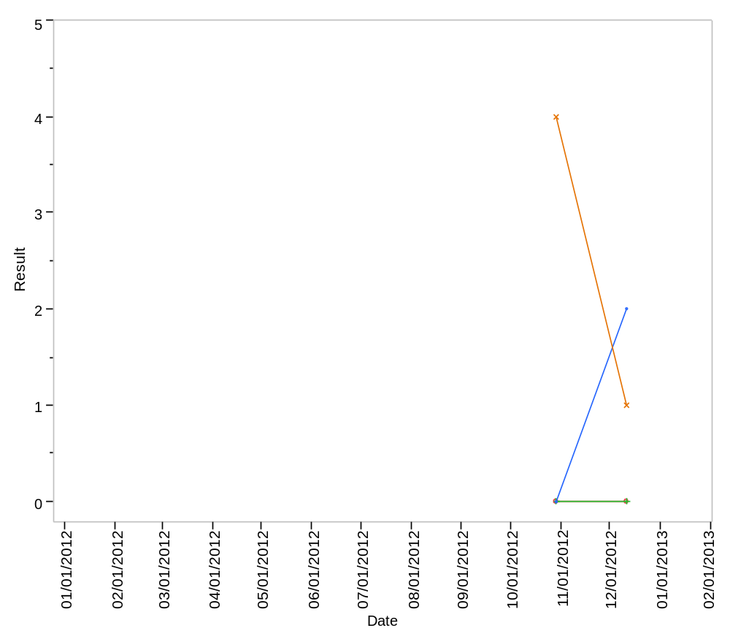

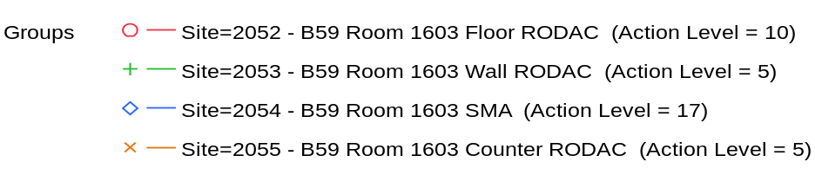

Overlay Plot Room=1605/, Grade=Grade C, Frequency=Dynamic
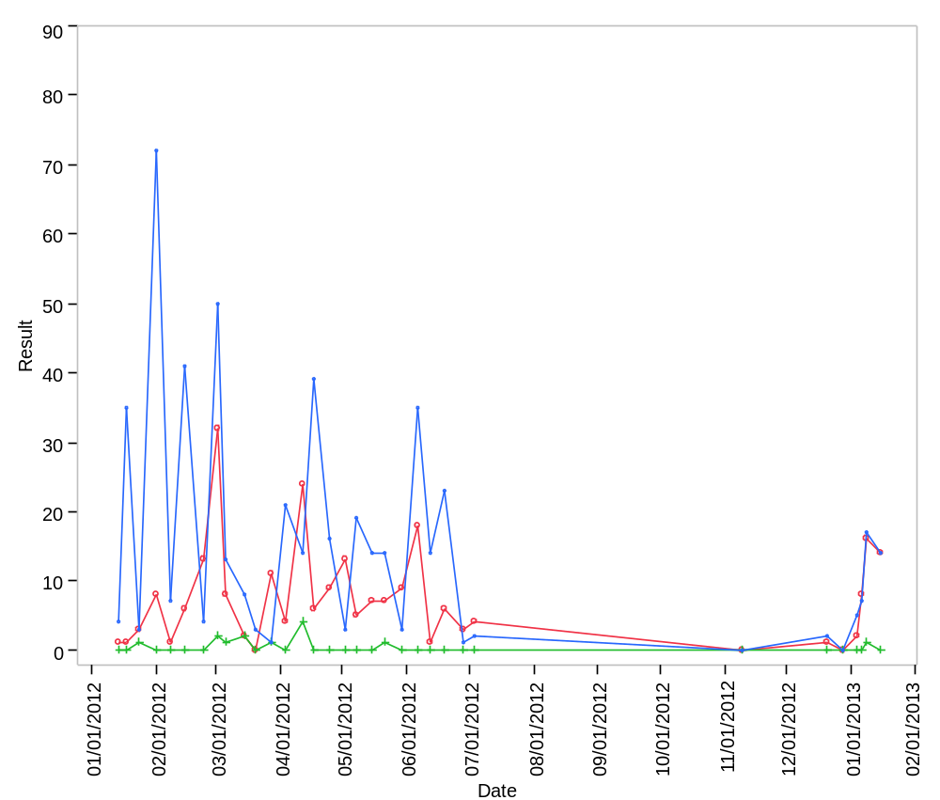

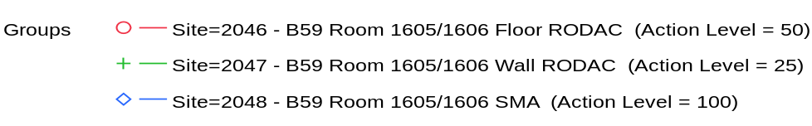

Overlay Plot Room=1605/, Grade=Grade C, Frequency=Static
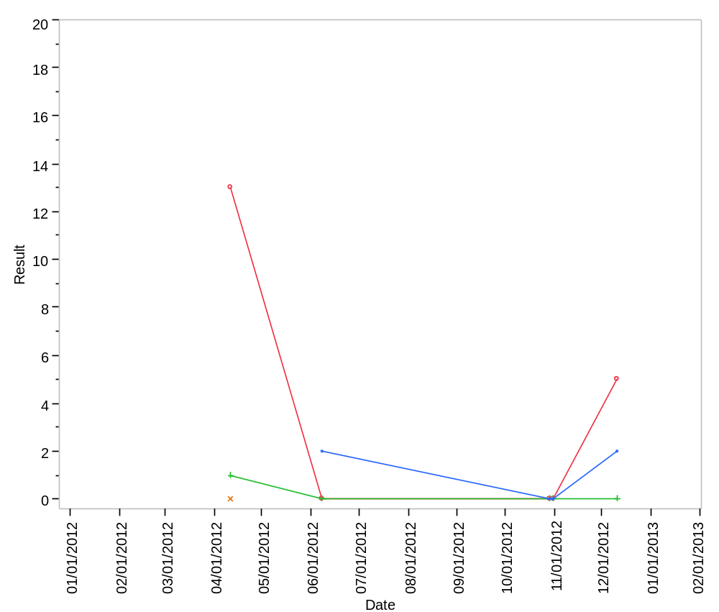

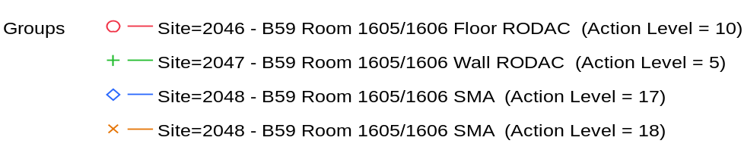

Overlay Plot Room=1609, Grade=Grade C, Frequency=Dynamic
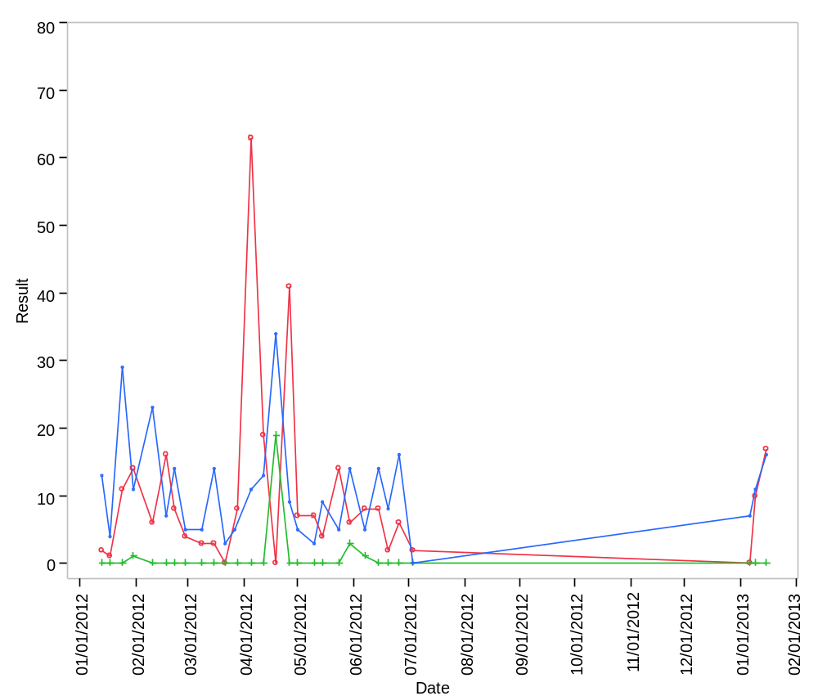

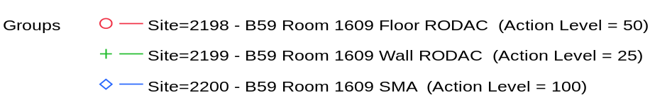

Overlay Plot Room=1609, Grade=Grade C, Frequency=Static
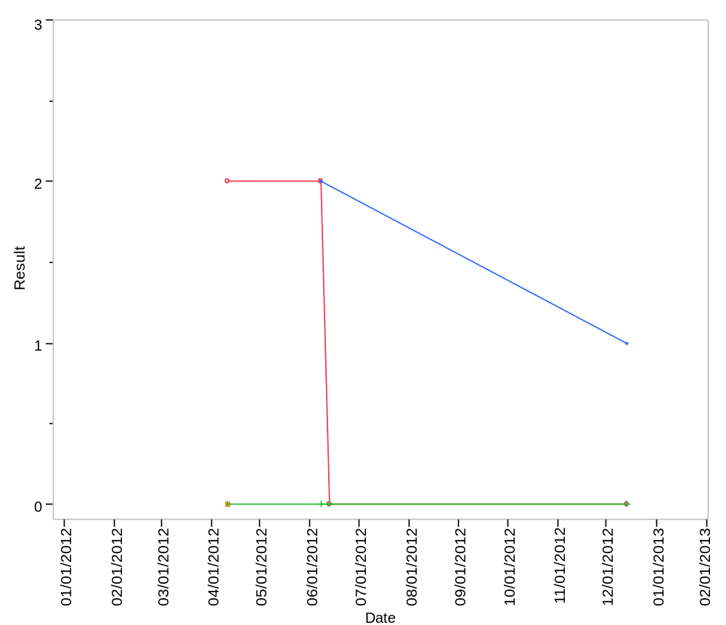

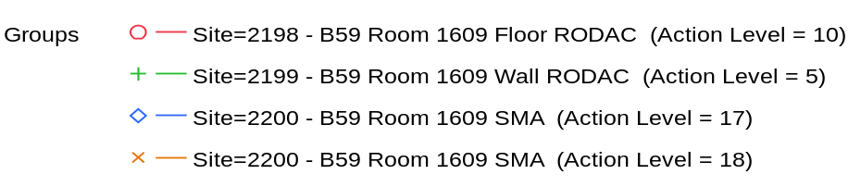

Overlay Plot Room=1610, Grade=Grade D, Frequency=Static
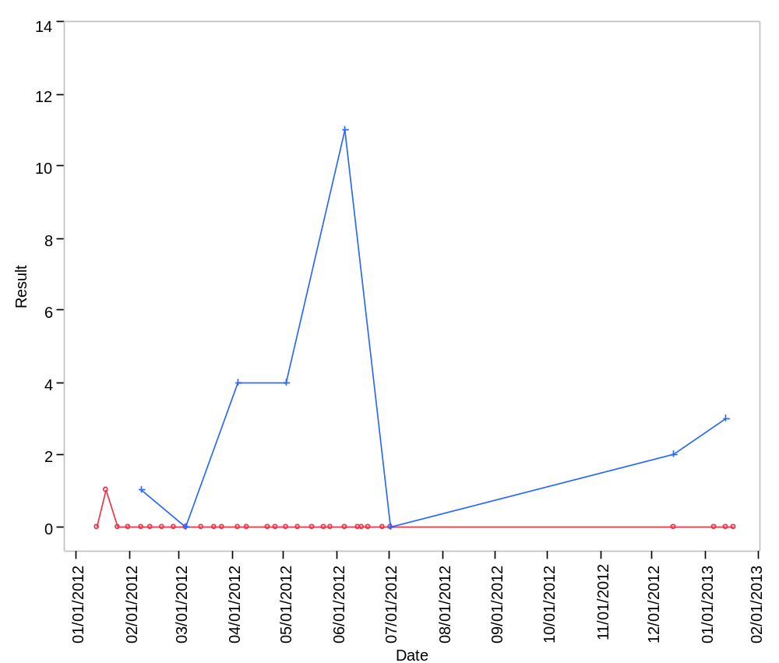

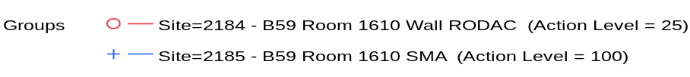

Overlay Plot Room=1614, Grade=Grade D, Frequency=Static
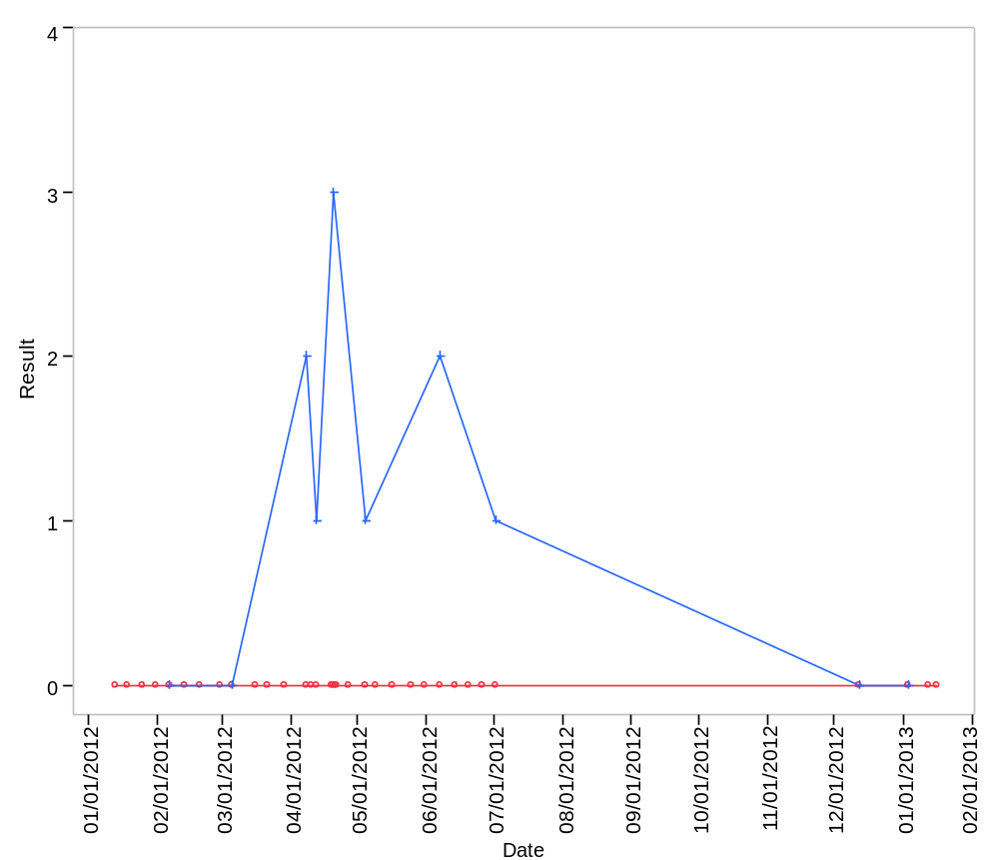

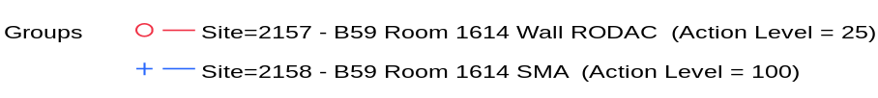

Overlay Plot Room=1615, Grade=Grade D, Frequency=Static
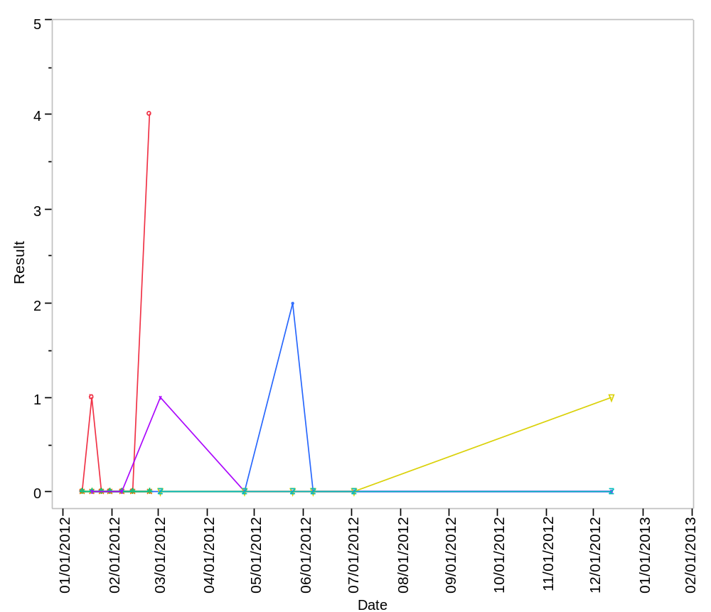

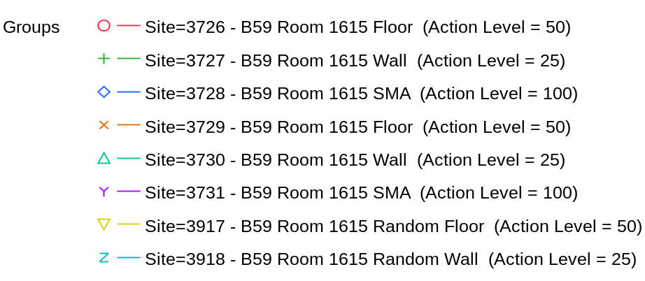

Overlay Plot Room=1616, Grade=Grade D, Frequency=Static
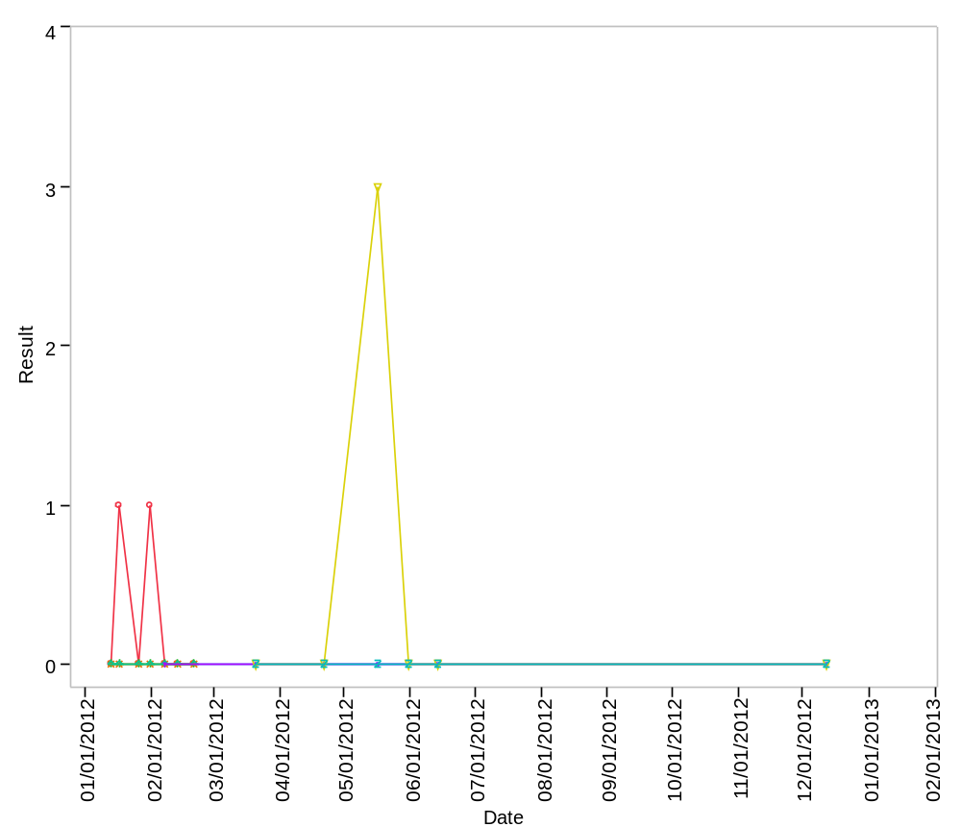

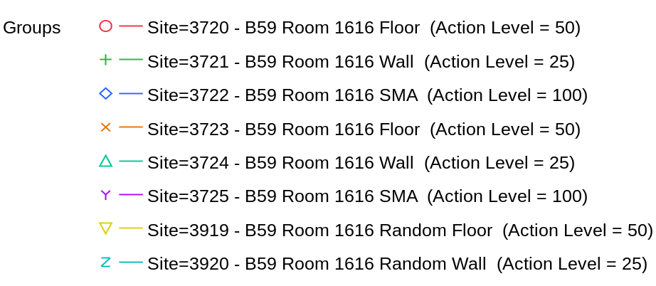

Overlay Plot Room=1617, Grade=Grade D, Frequency=Static
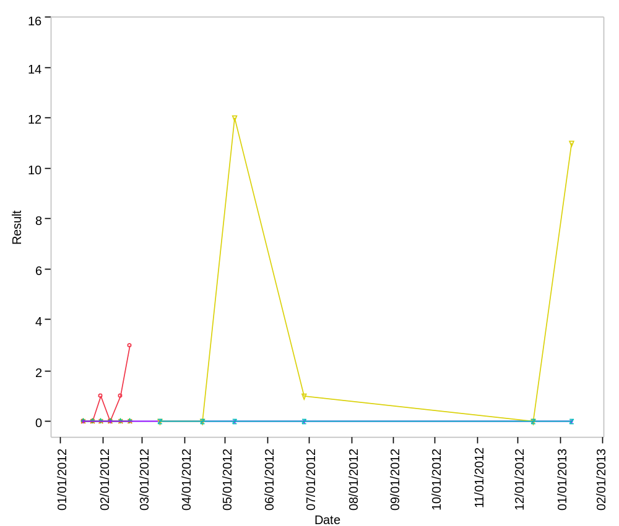

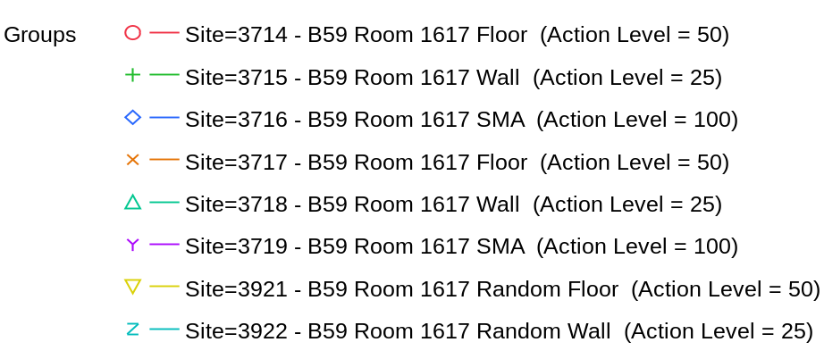

Overlay Plot Room=1618, Grade=Grade D, Frequency=Static
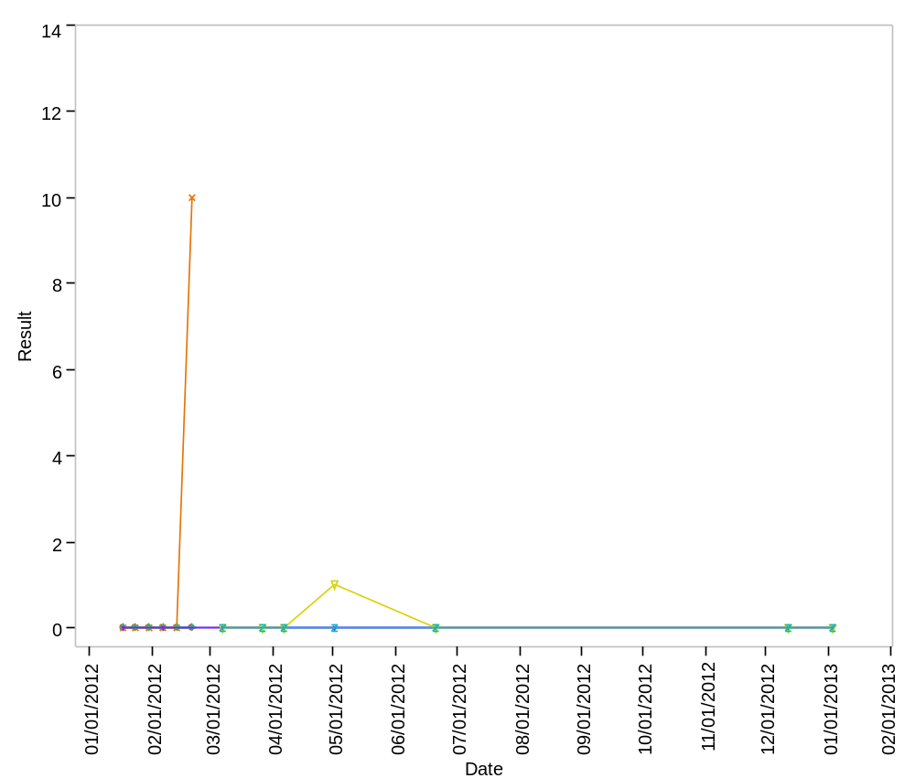

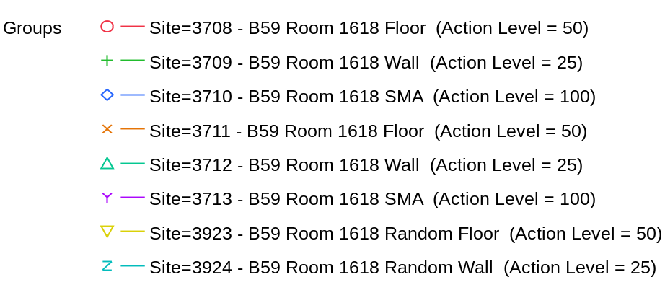

Overlay Plot Room=1620, Grade=Grade C, Frequency=Dynamic
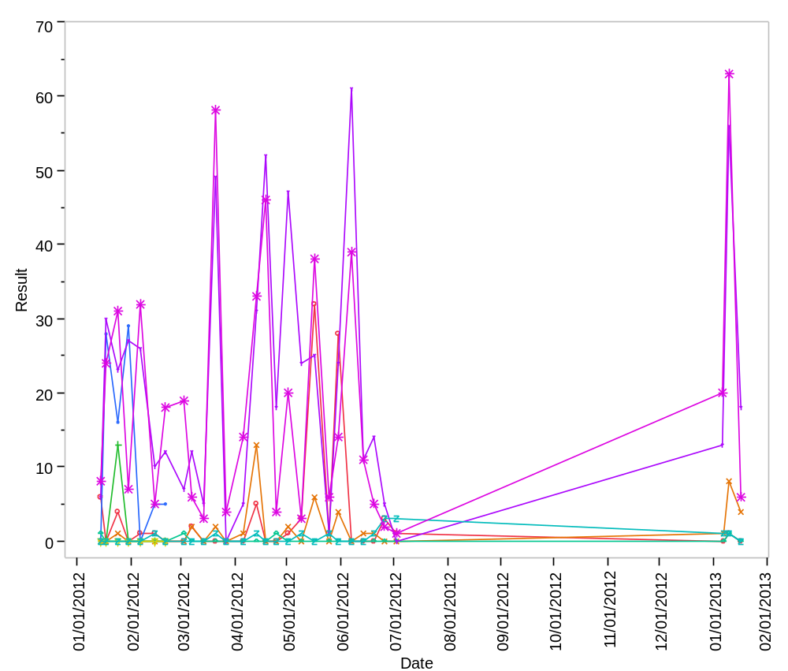

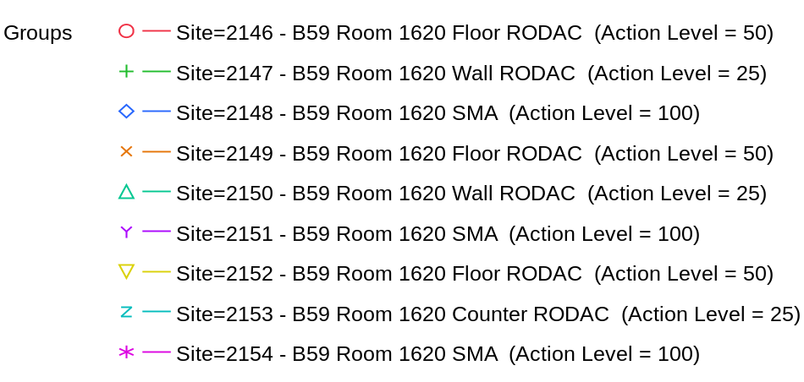

Overlay Plot Room=1620, Grade=Grade C, Frequency=Static
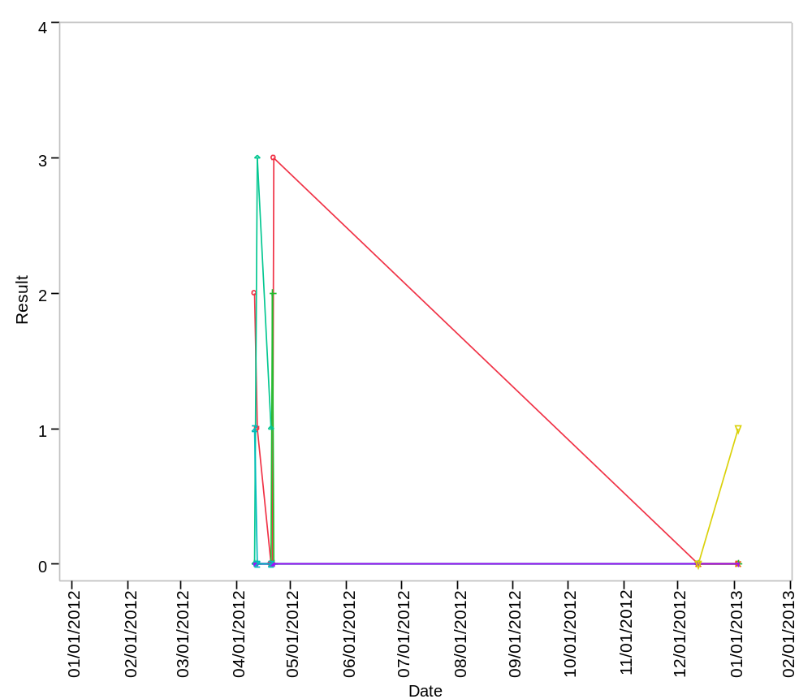

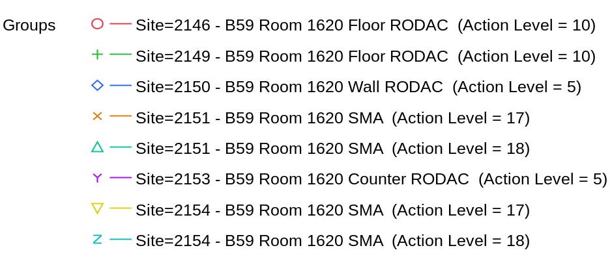

Overlay Plot Room=1621, Grade=Grade D, Frequency=Static
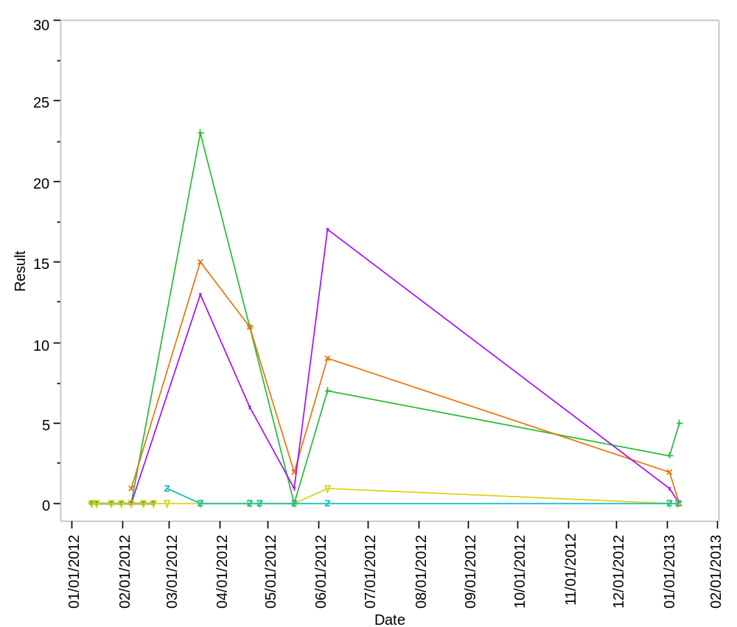

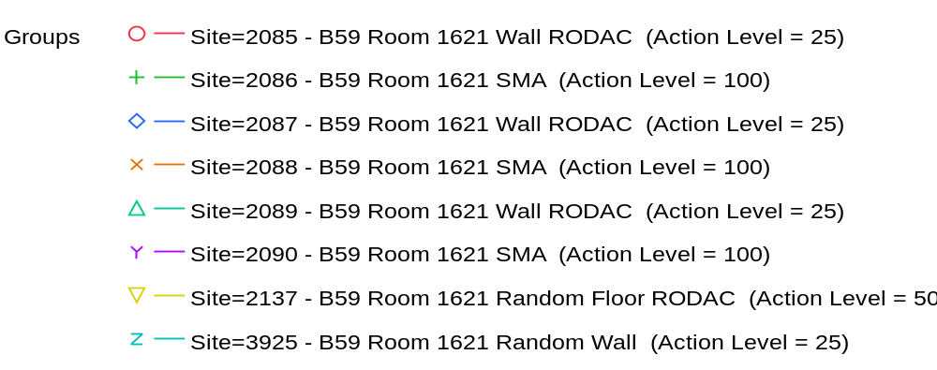

Overlay Plot Room=1622, Grade=Grade D, Frequency=Static
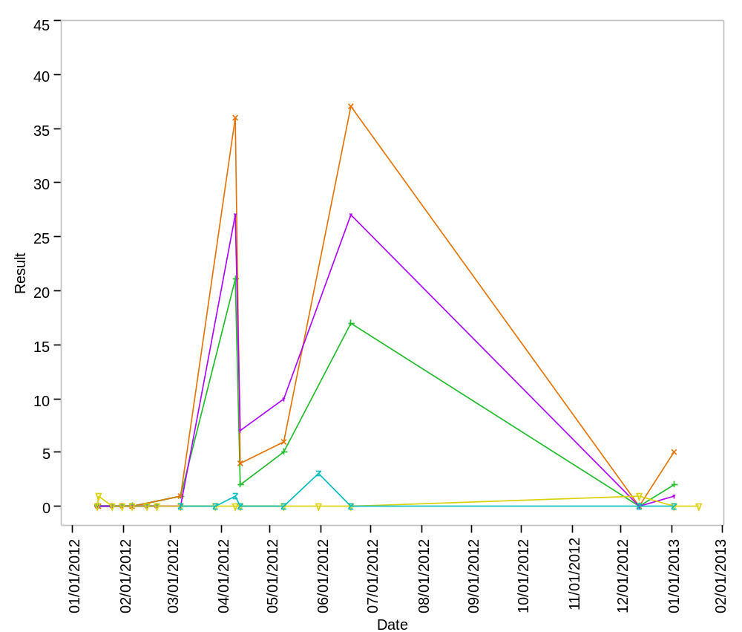

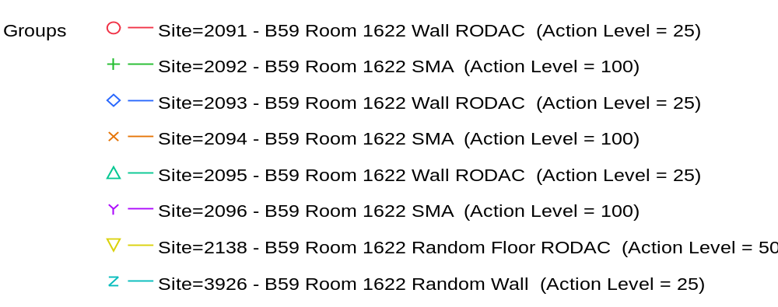

Overlay Plot Room=1623, Grade=Grade D, Frequency=Static
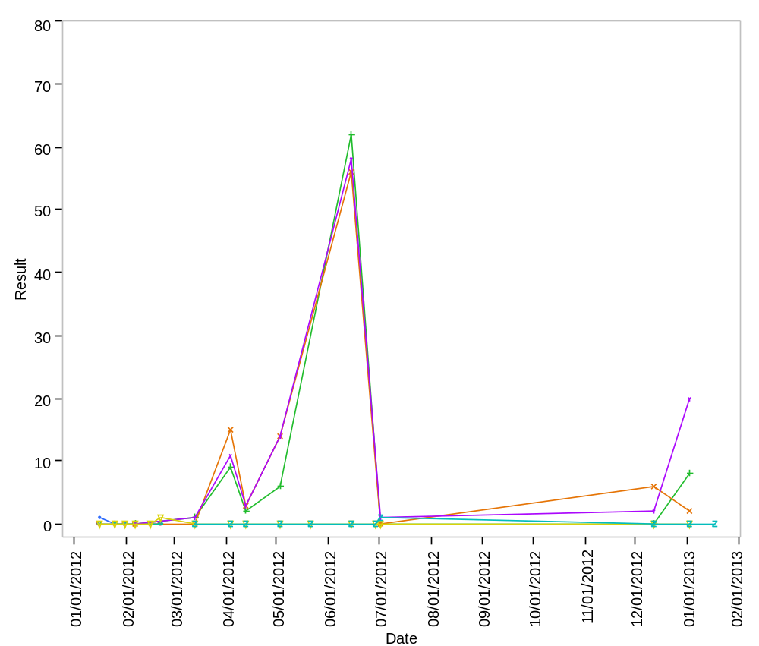

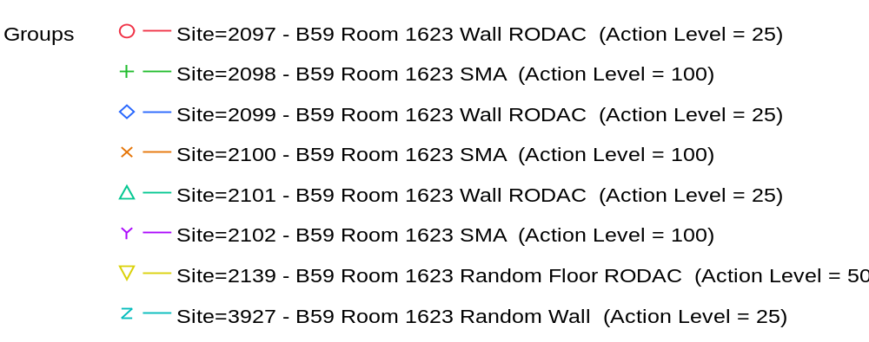

Overlay Plot Room=1624, Grade=Grade D, Frequency=Static
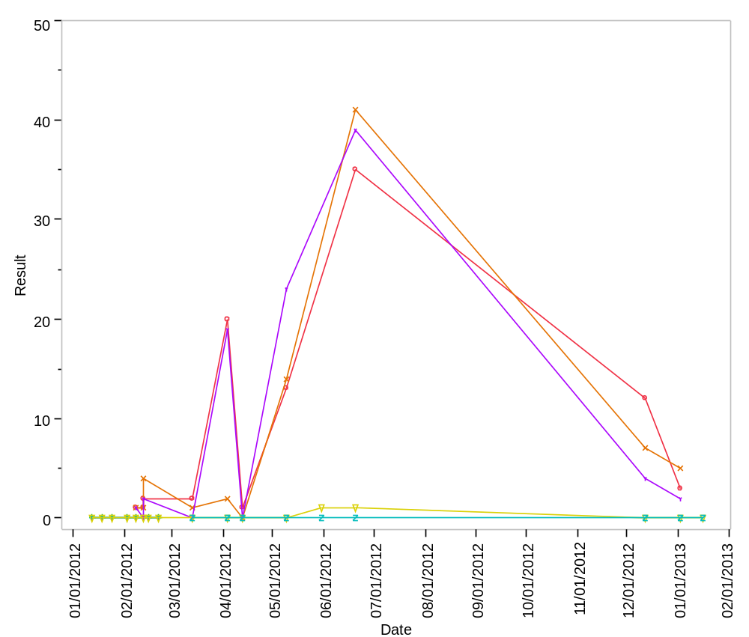

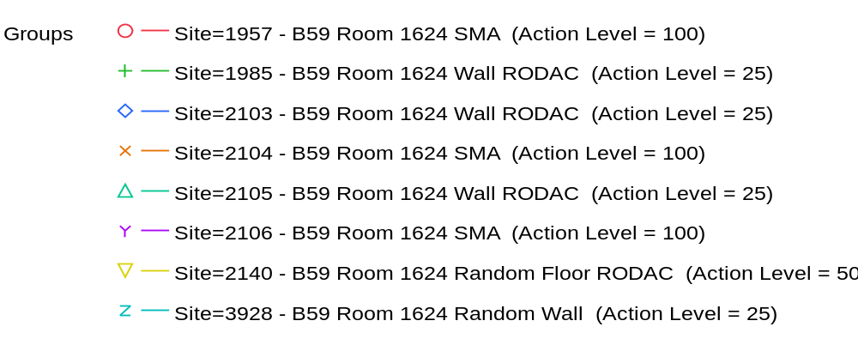

Overlay Plot Room=1625, Grade=Grade D, Frequency=Static
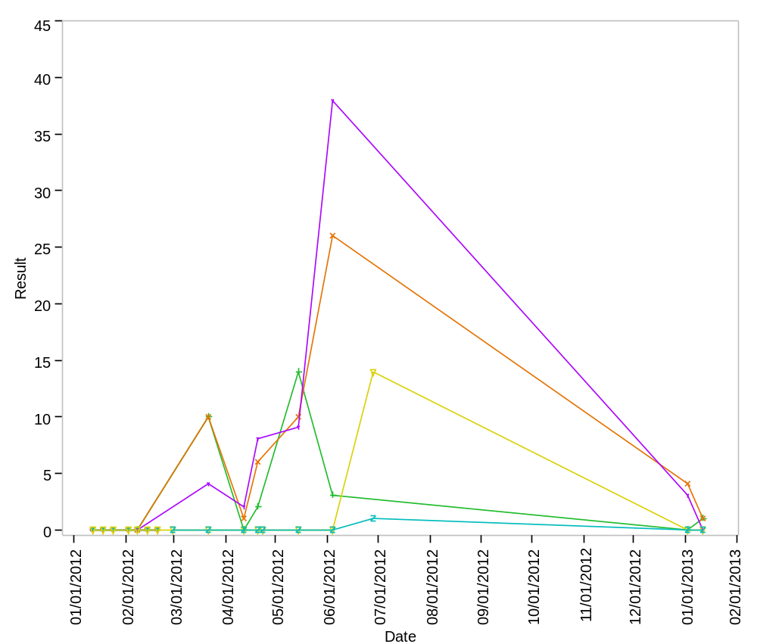

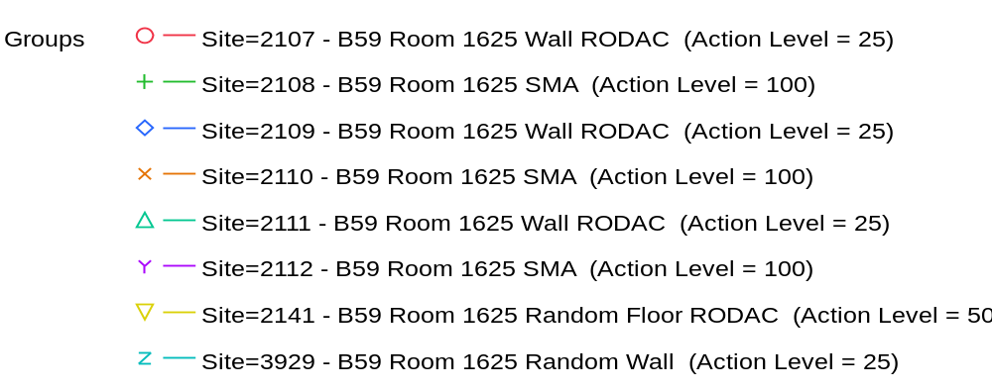

Overlay Plot Room=1626, Grade=Grade D, Frequency=Static
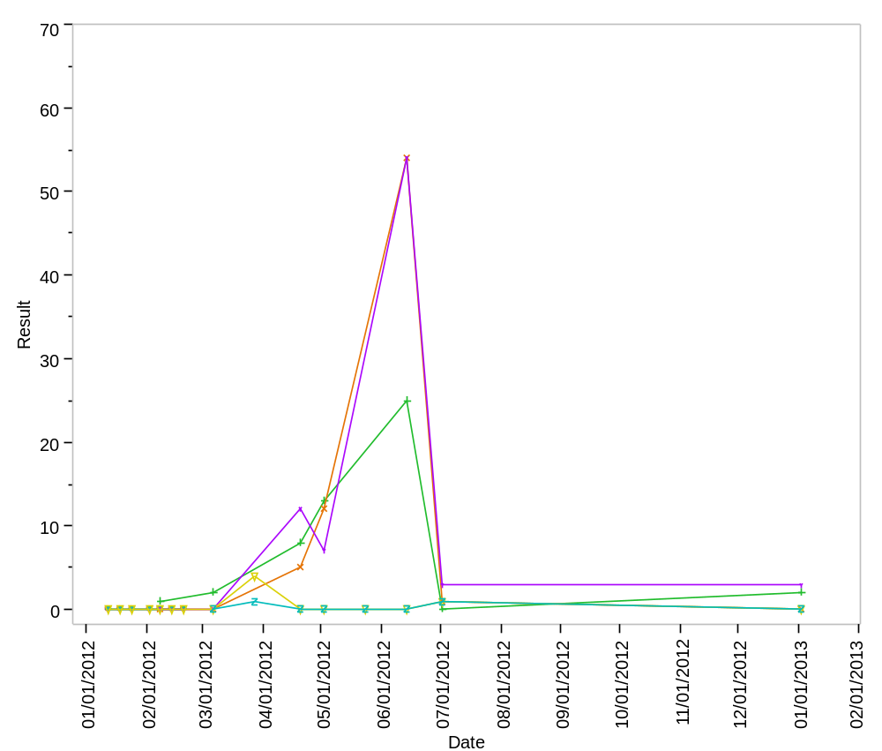

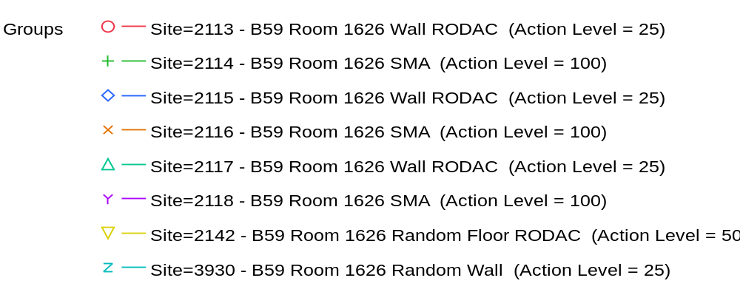

Overlay Plot Room=1627, Grade=Grade D, Frequency=Static
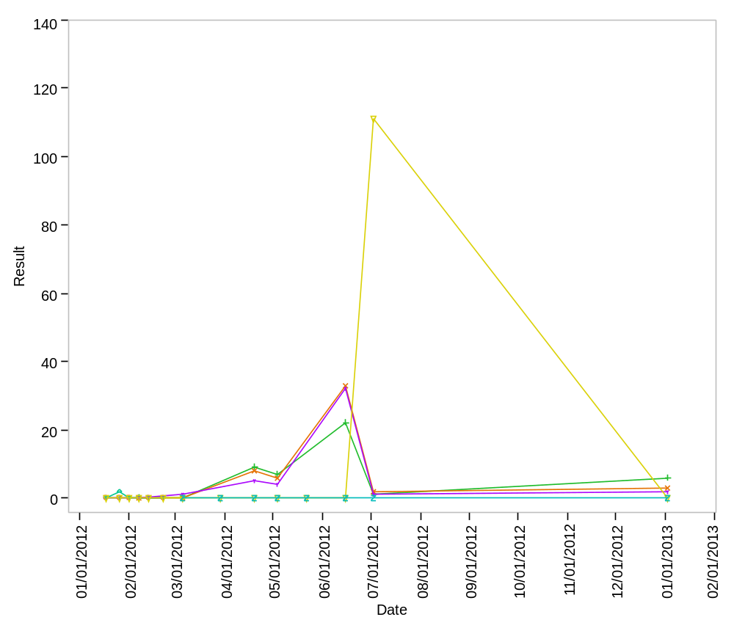

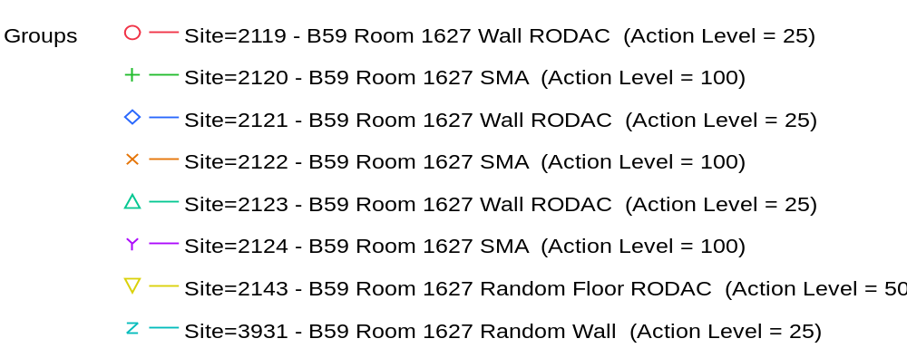

Overlay Plot Room=1628, Grade=Grade D, Frequency=Static
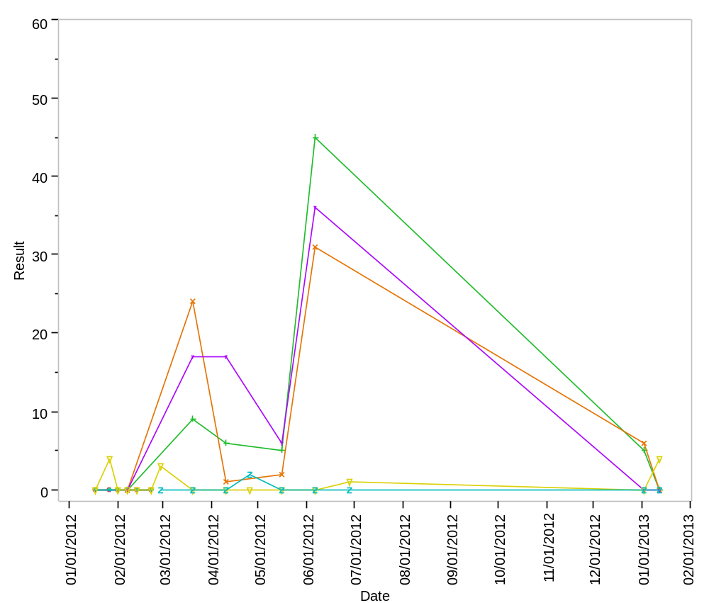

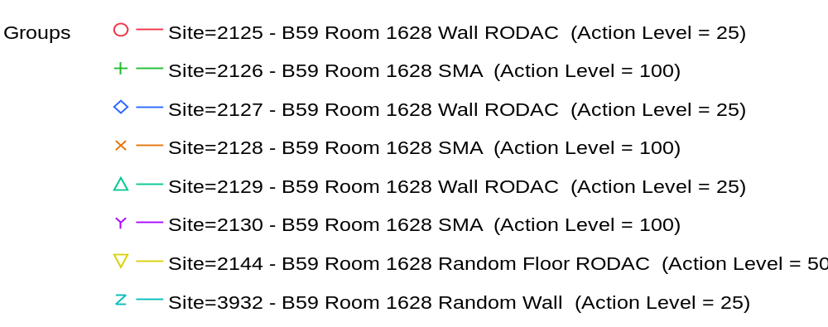

Overlay Plot Room=1629, Grade=Grade D, Frequency=Static
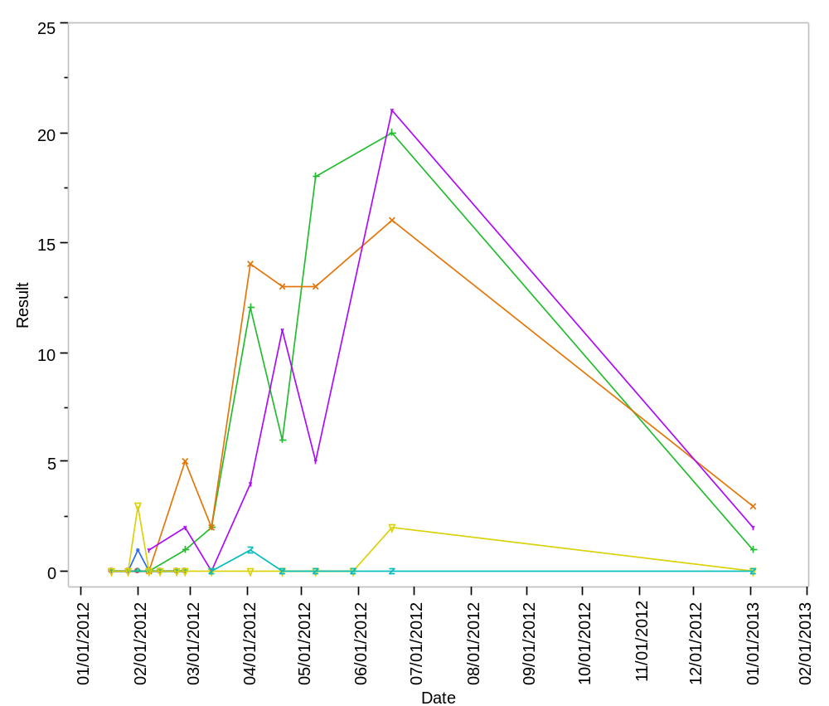

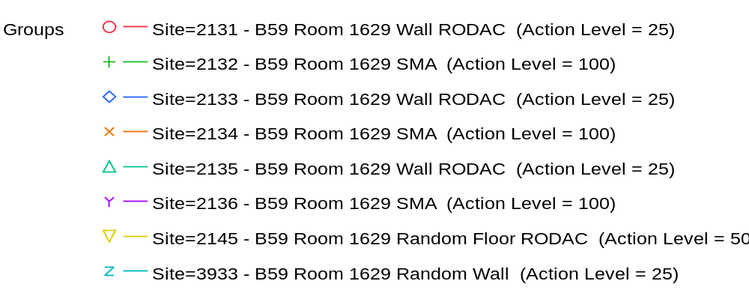

Overlay Plot Room=1630, Grade=Grade C, Frequency=Dynamic
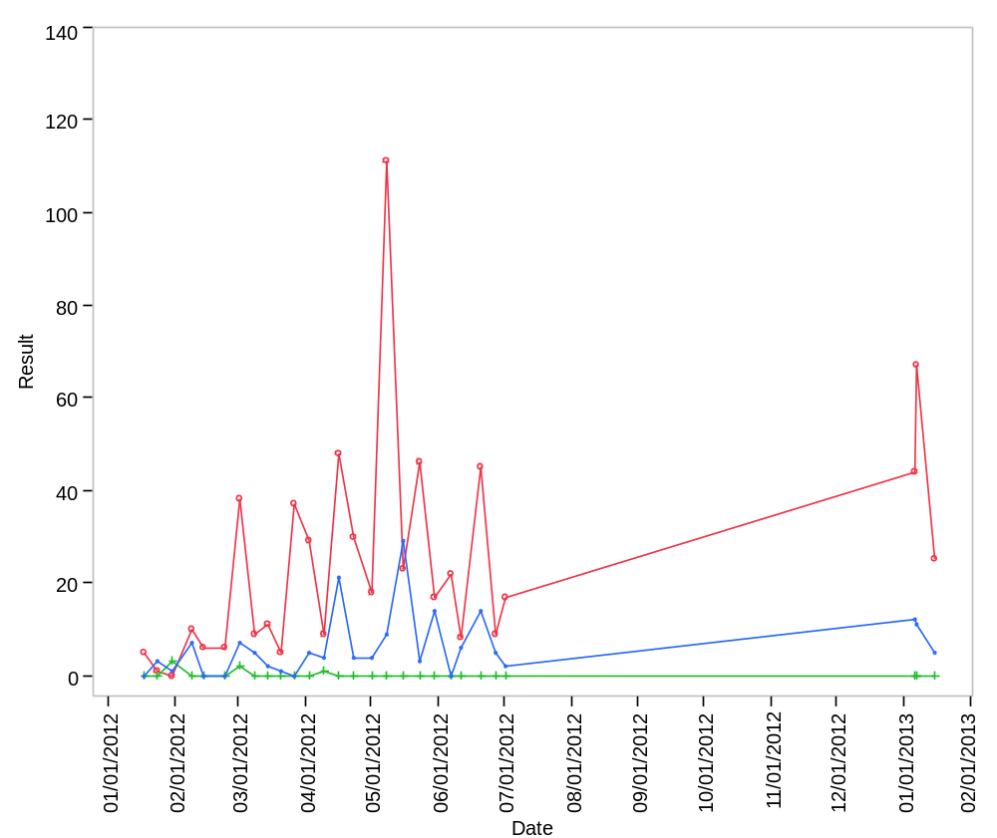

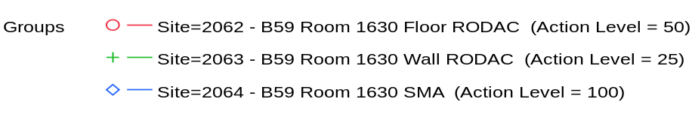

Overlay Plot Room=1630, Grade=Grade C, Frequency=Static
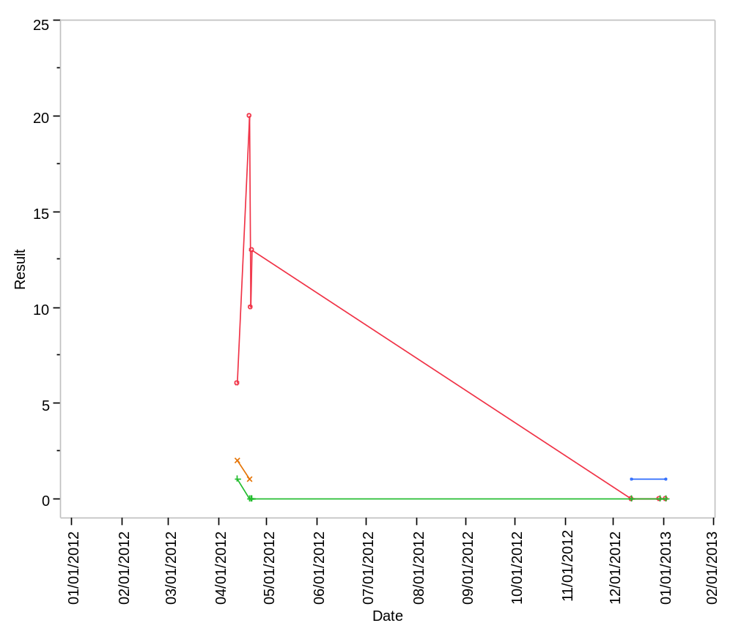

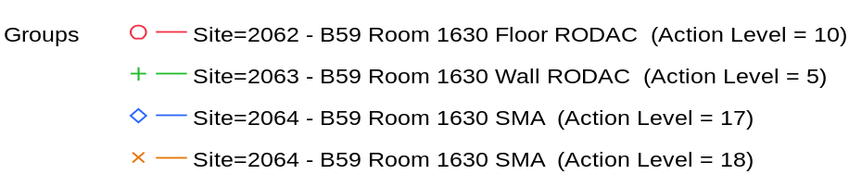

Overlay Plot Room=1631, Grade=Grade C, Frequency=Dynamic
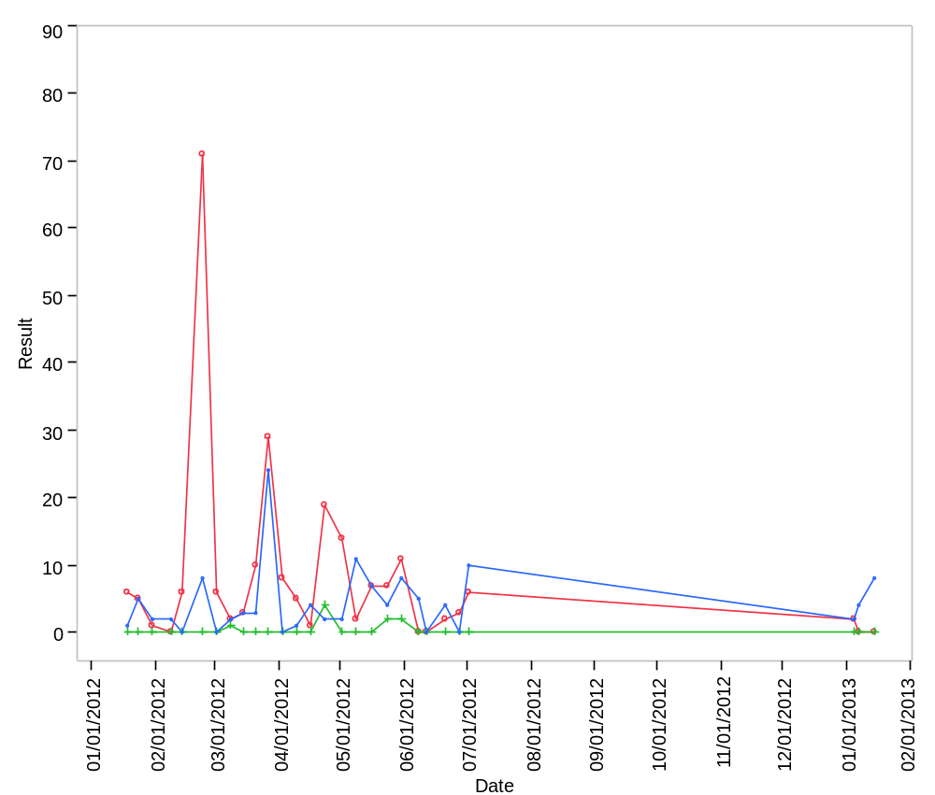

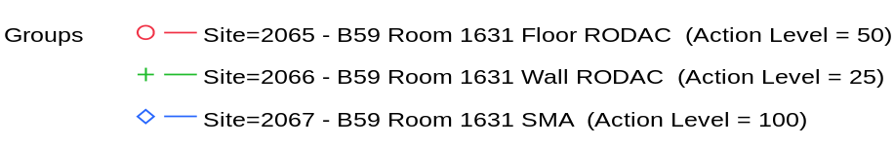

Overlay Plot Room=1631, Grade=Grade C, Frequency=Static
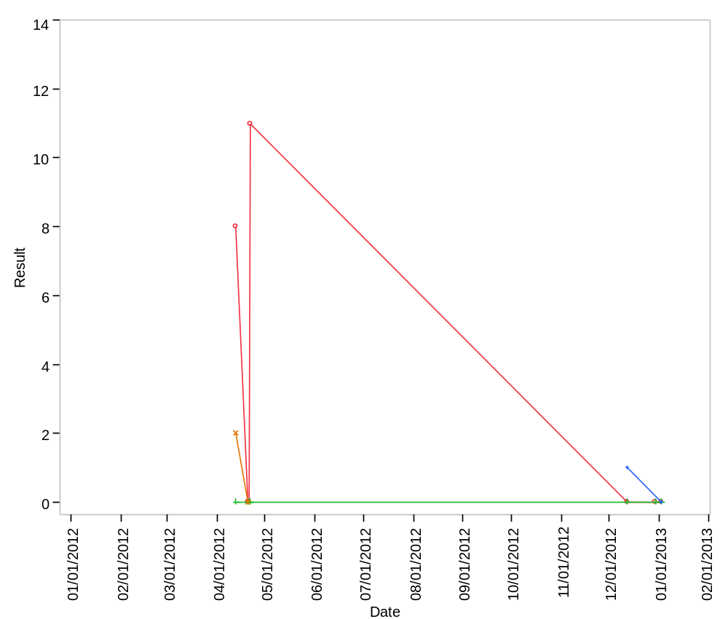

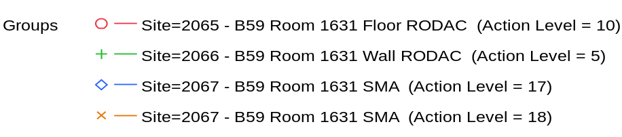

Overlay Plot Room=1632, Grade=Grade C, Frequency=Dynamic
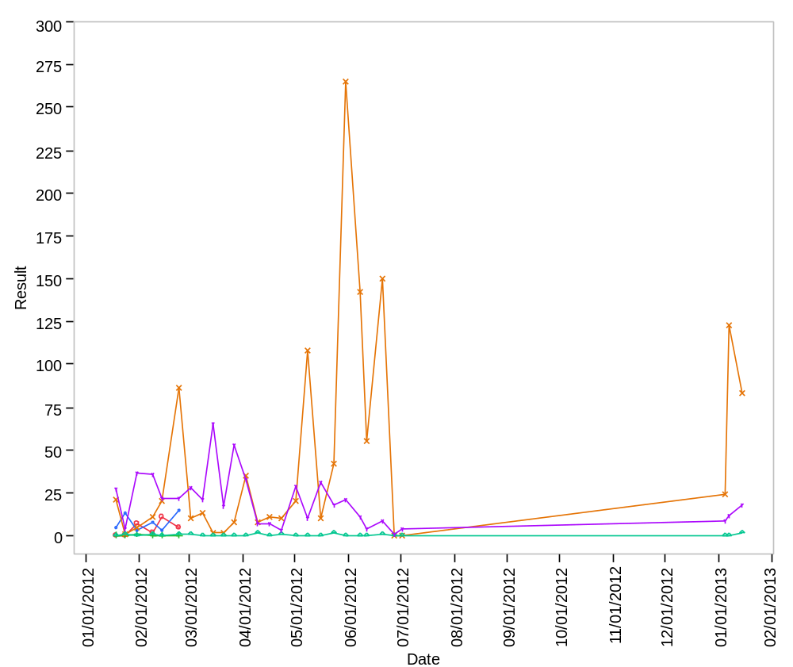

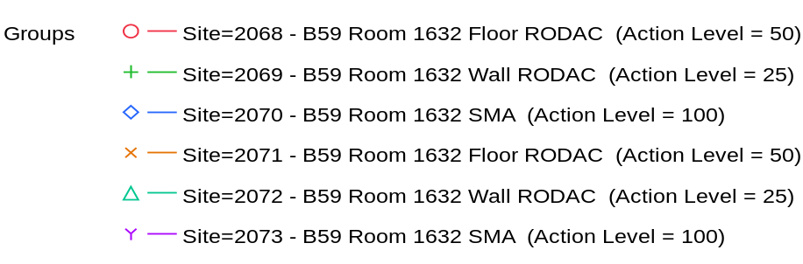

Overlay Plot Room=1632, Grade=Grade C, Frequency=Static
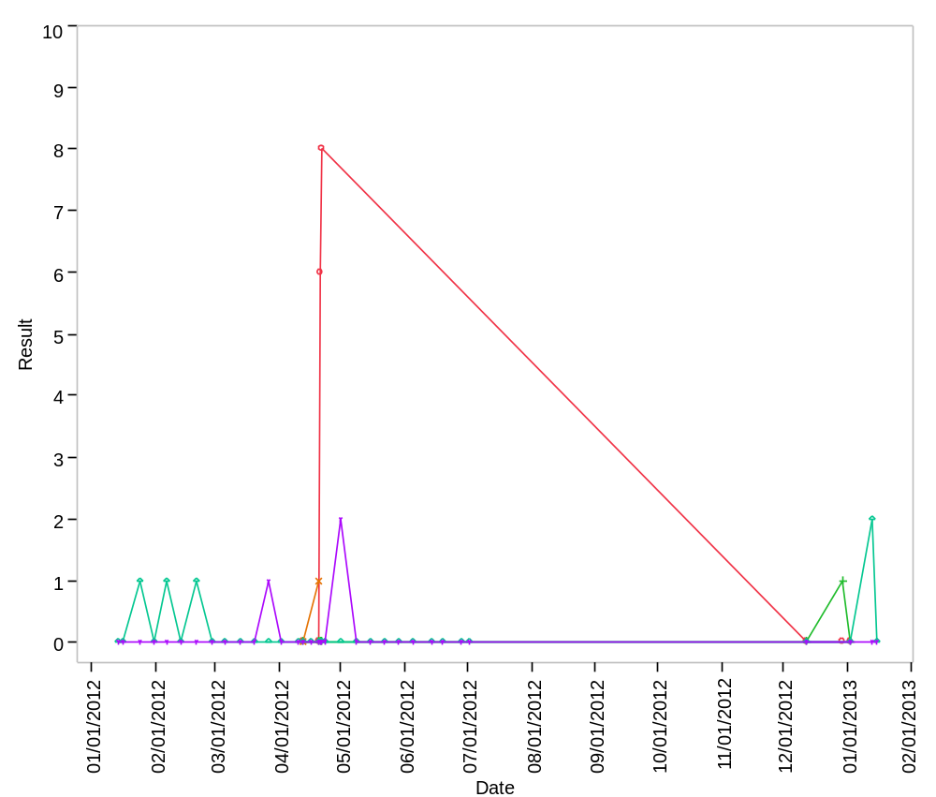

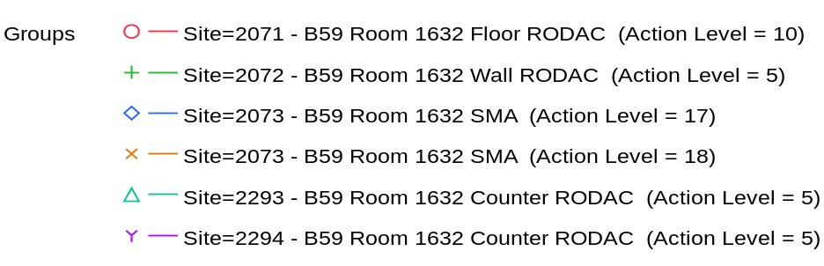

Overlay Plot Room=1632, Grade=Grade C - Laminar Flow, Frequency=Dynamic
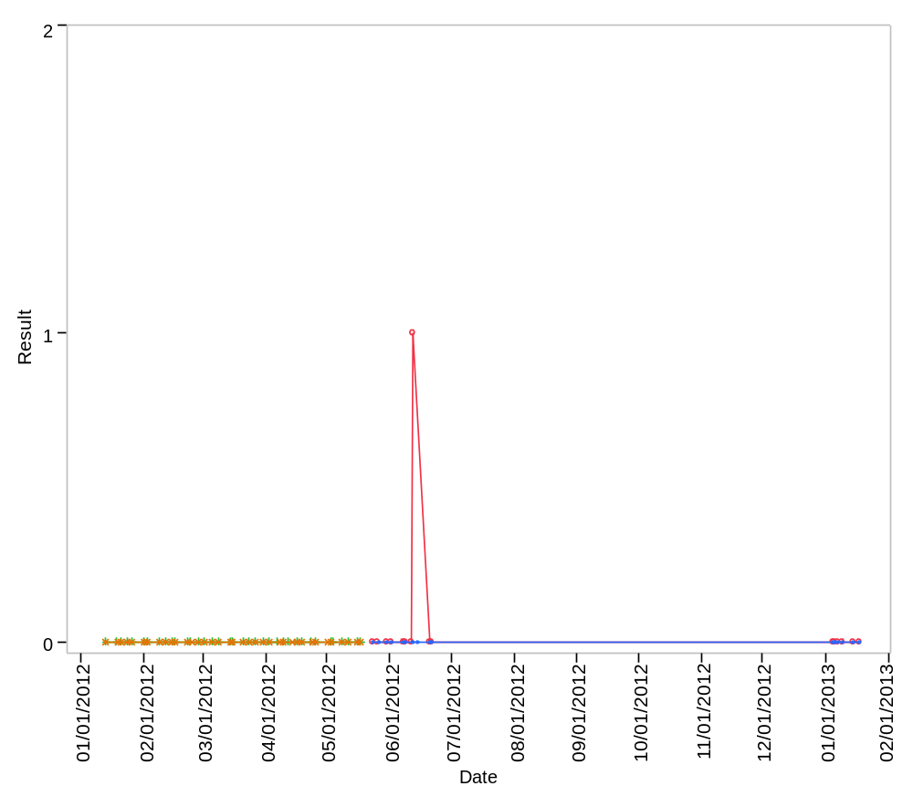

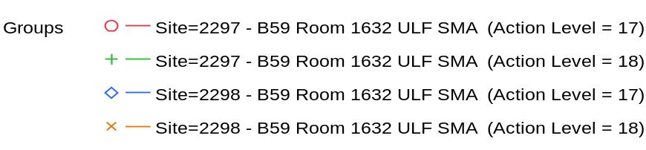

Overlay Plot Room=1632, Grade=Grade C - Laminar Flow, Frequency=Static
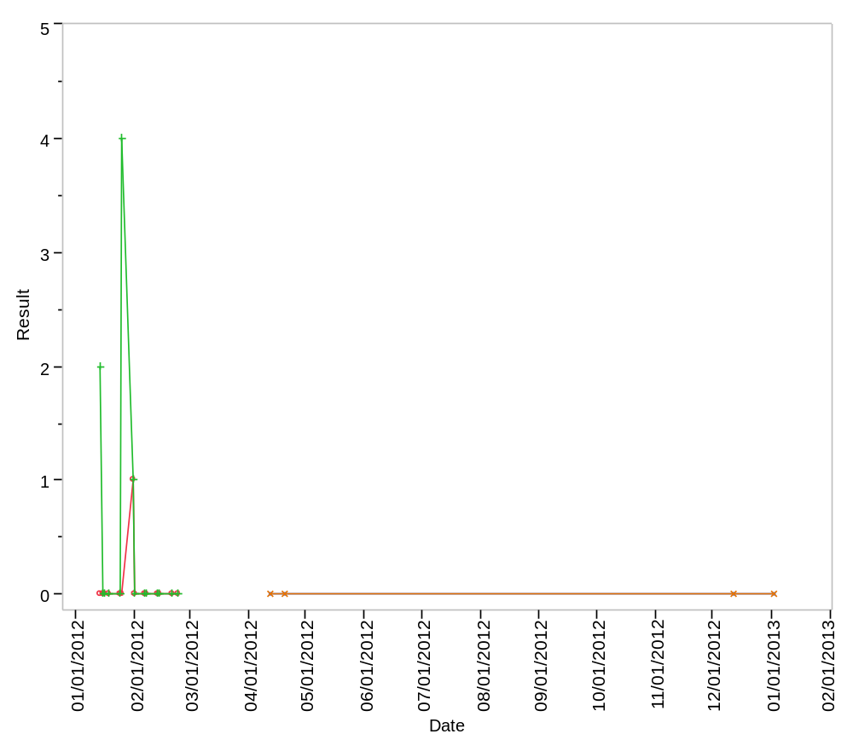

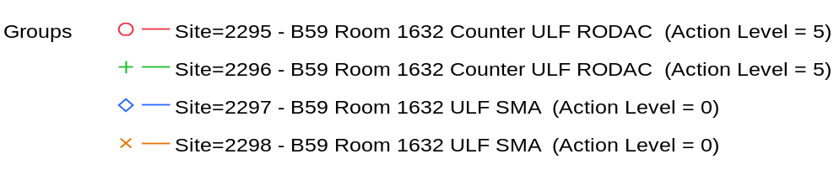

Overlay Plot Room=1633, Grade=Grade C, Frequency=Dynamic
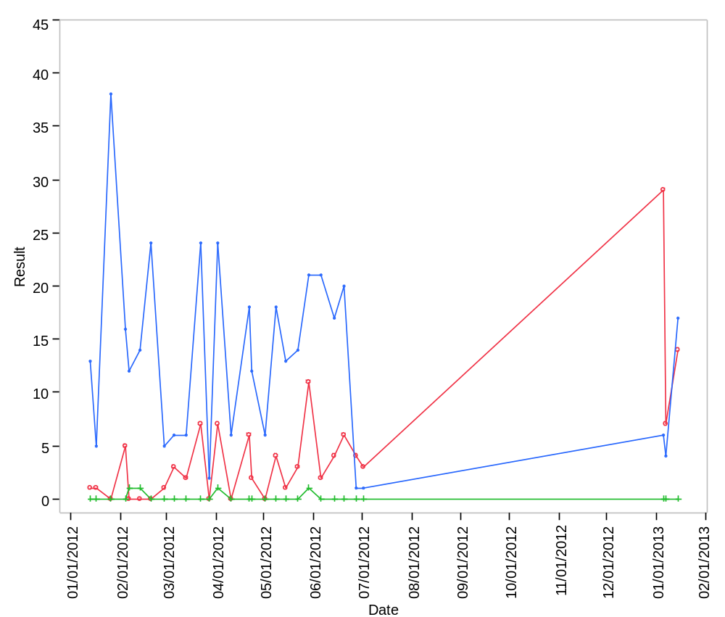

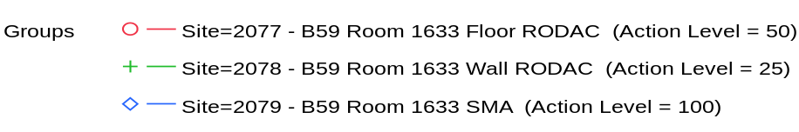

Overlay Plot Room=1633, Grade=Grade C, Frequency=Static
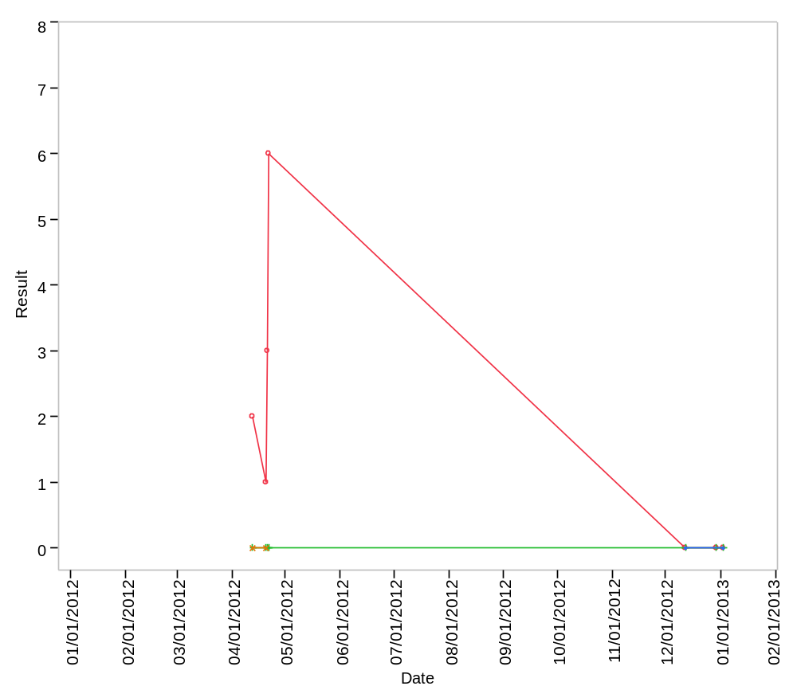

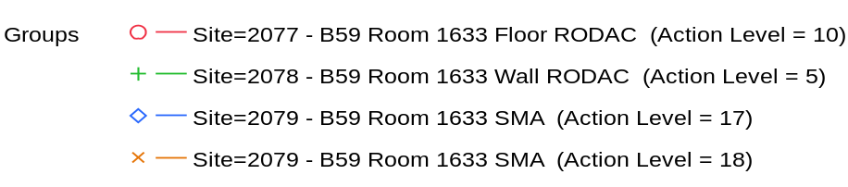

Overlay Plot Room=1633, Grade=Grade C - Laminar Flow, Frequency=Dynamic
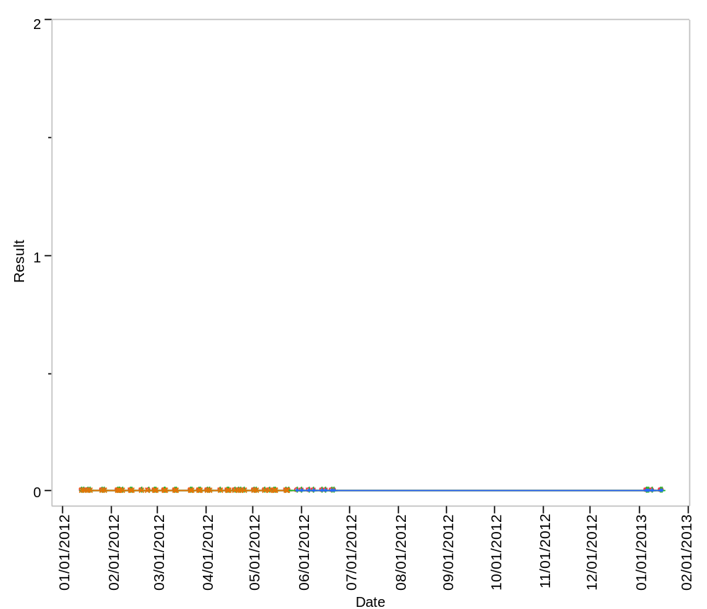

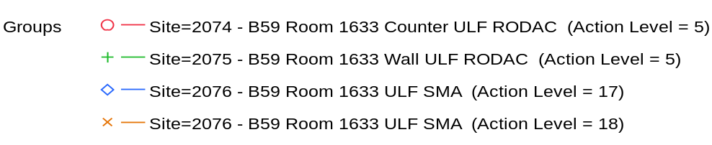

Overlay Plot Room=1633, Grade=Grade C - Laminar Flow, Frequency=Static
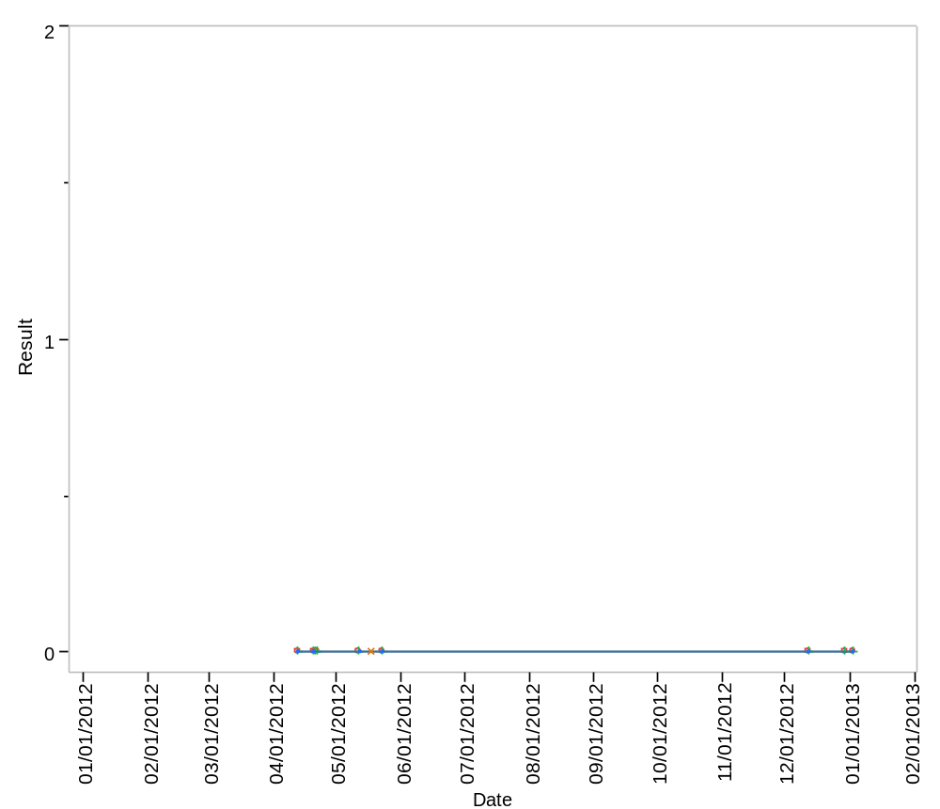

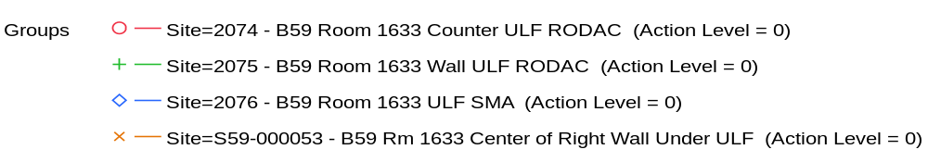

Overlay Plot Room=1634, Grade=Grade C, Frequency=Dynamic
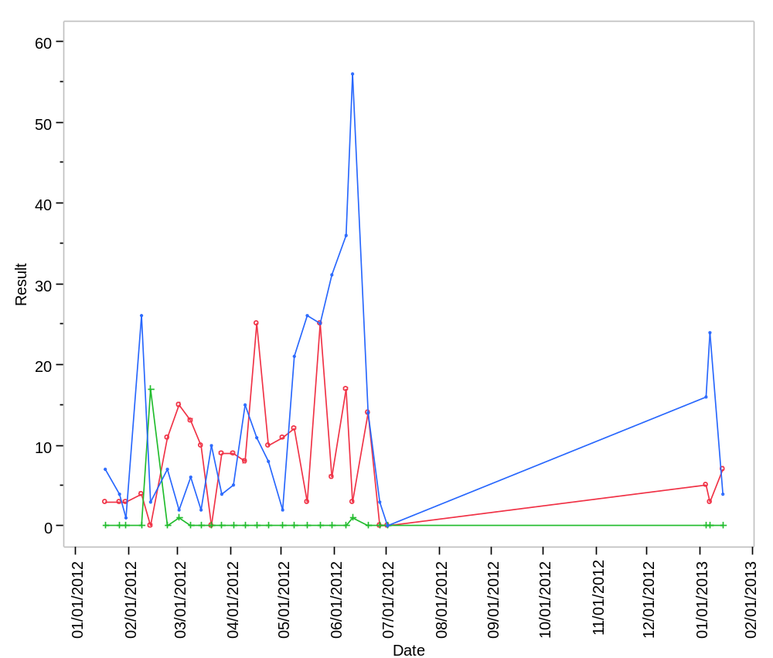

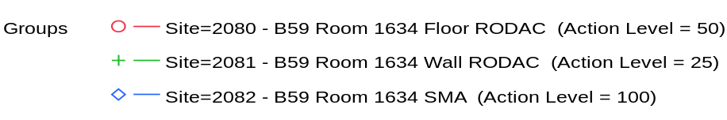

Overlay Plot Room=1634, Grade=Grade C, Frequency=Static
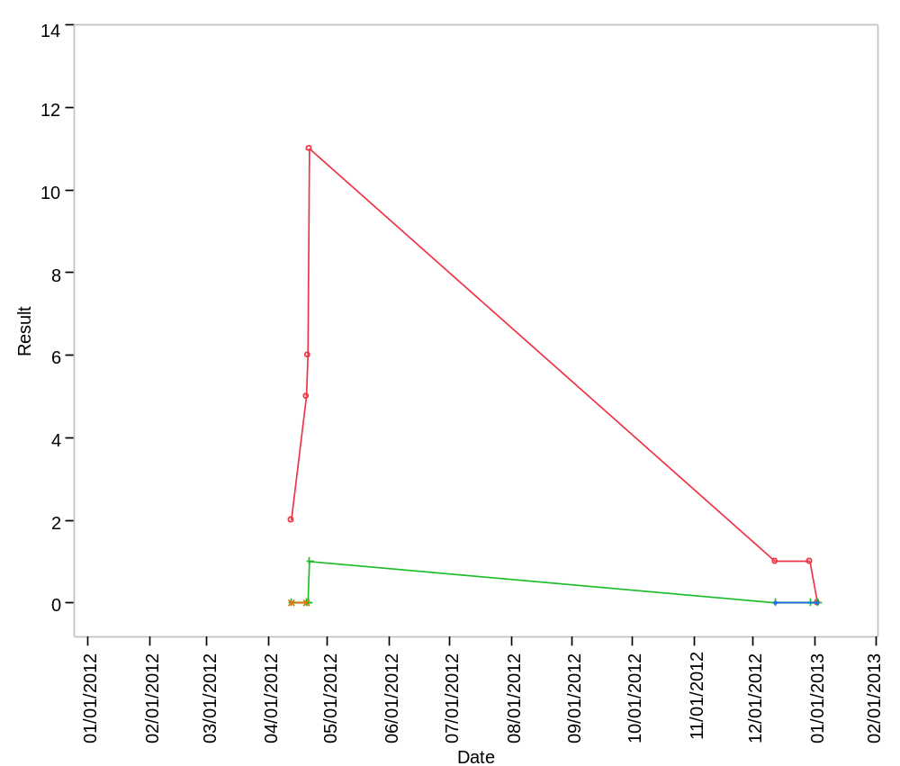

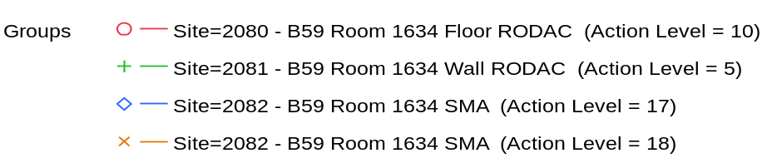

Overlay Plot Room=1637, Grade=Grade D, Frequency=Dynamic
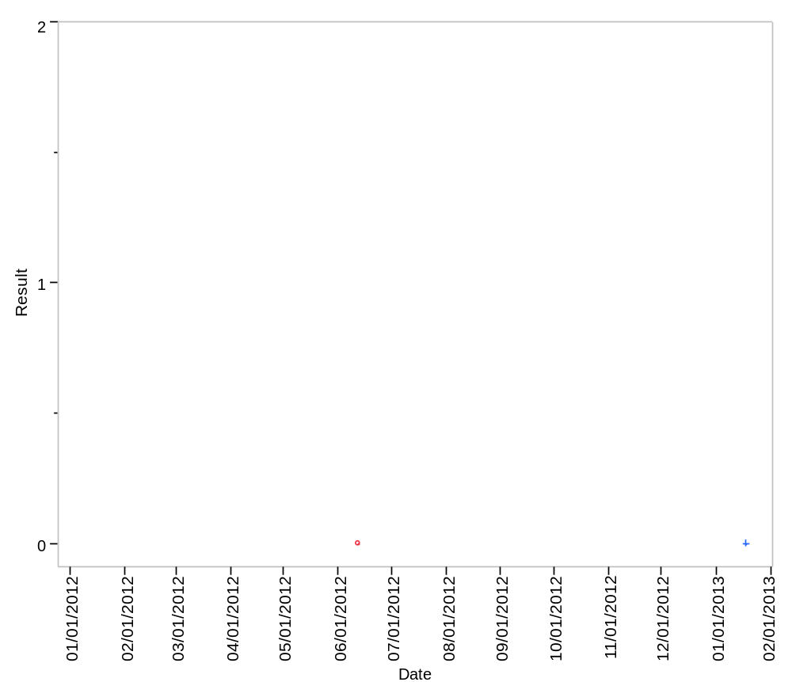

Overlay Plot Room=1637, Grade=Grade D, Frequency=Static
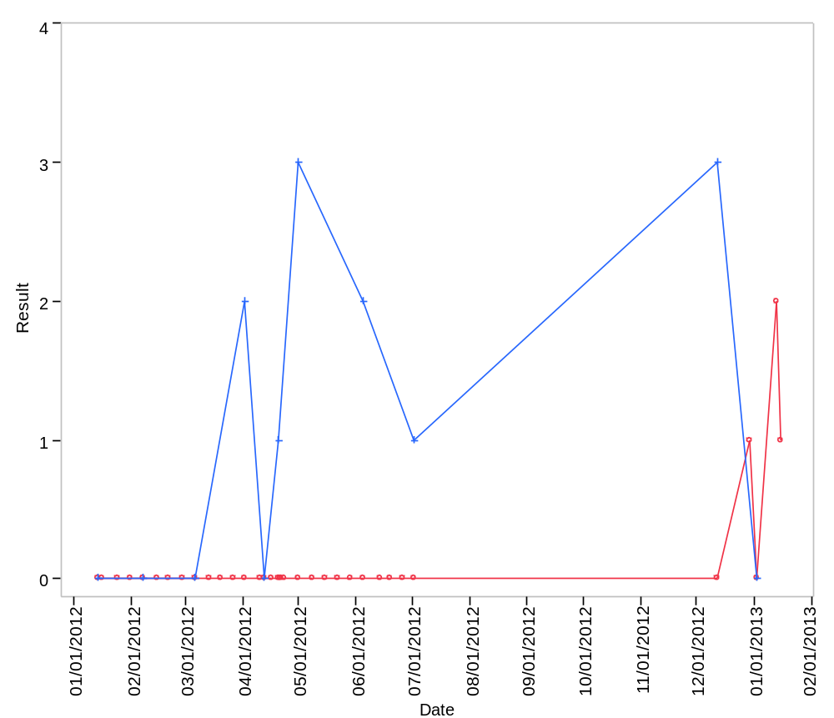

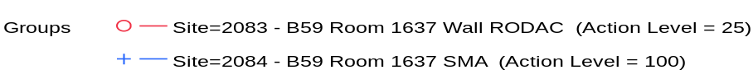

Overlay Plot Room=1700, Grade=Grade D, Frequency=Static
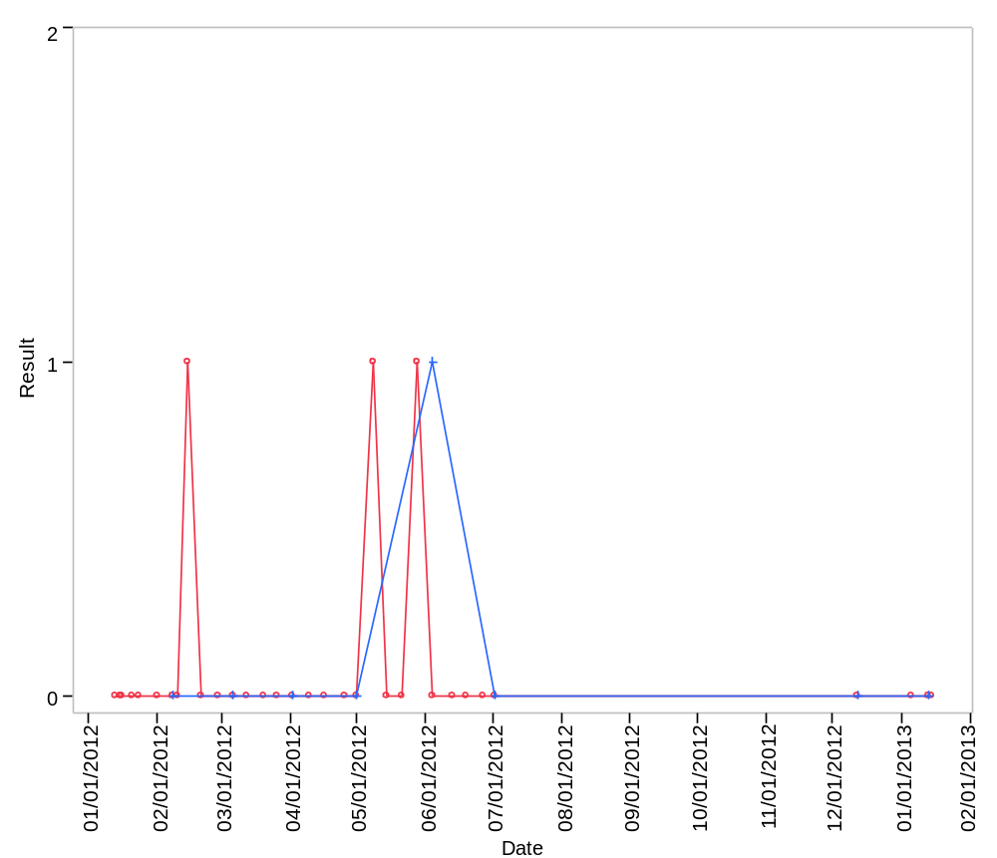

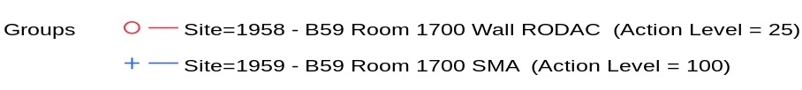

Overlay Plot Room=1702, Grade=Grade C, Frequency=Dynamic
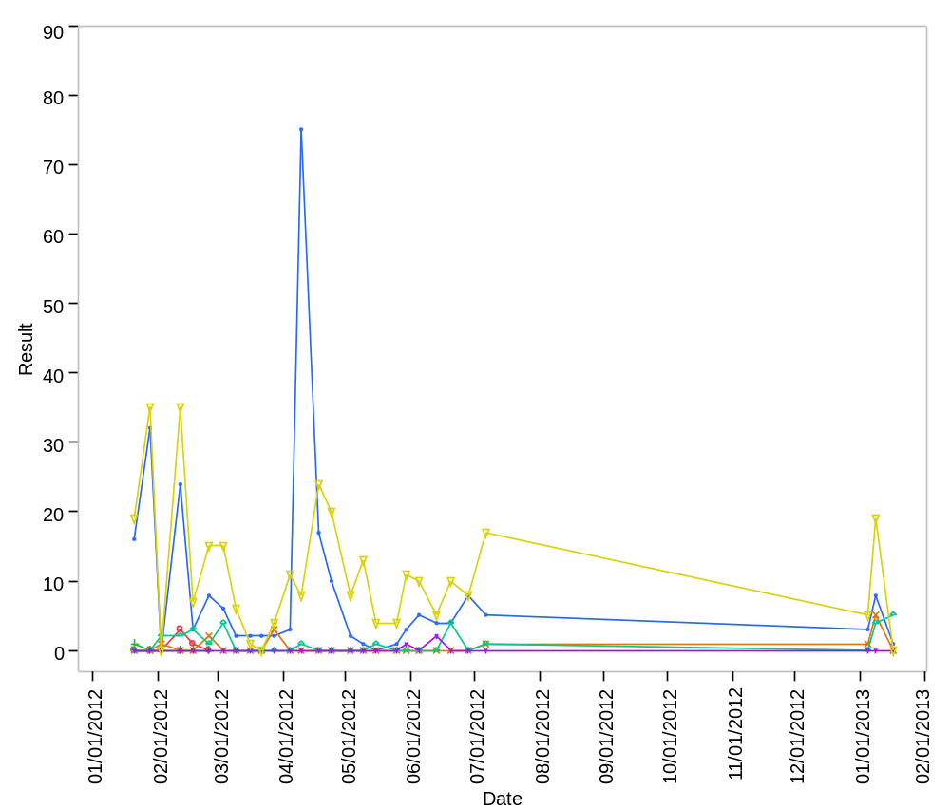

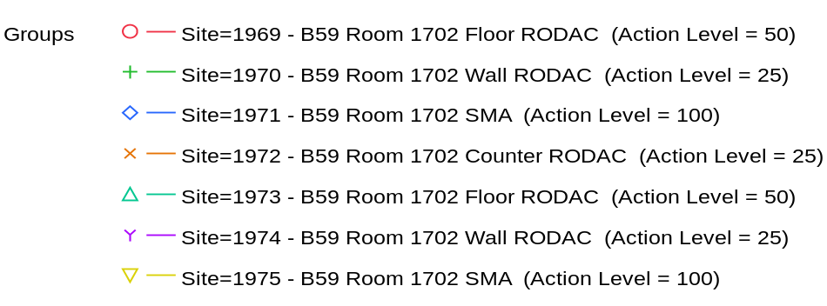

Overlay Plot Room=1702, Grade=Grade C, Frequency=Static
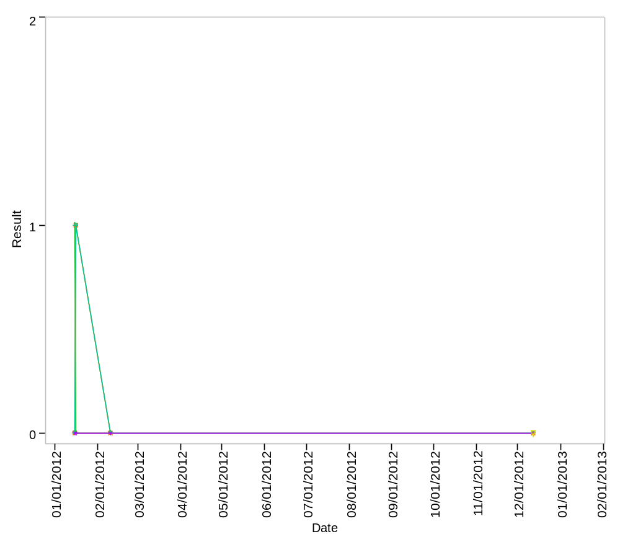

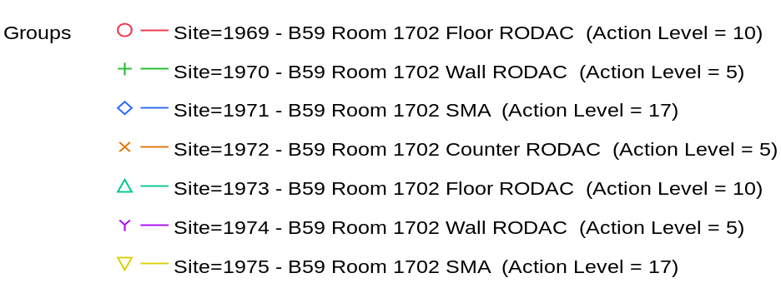

Overlay Plot Room=1703, Grade=Grade C, Frequency=Dynamic
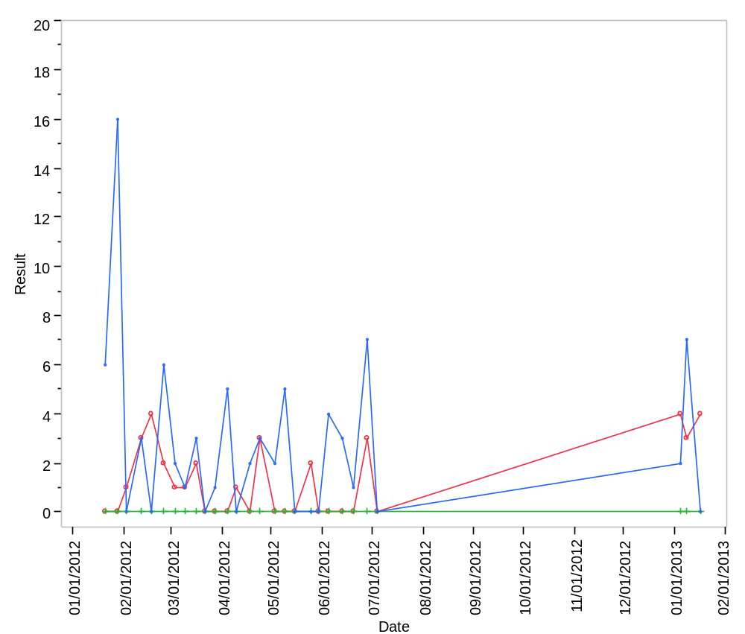

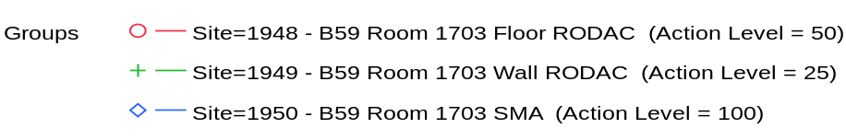

Overlay Plot Room=1703, Grade=Grade C, Frequency=Static
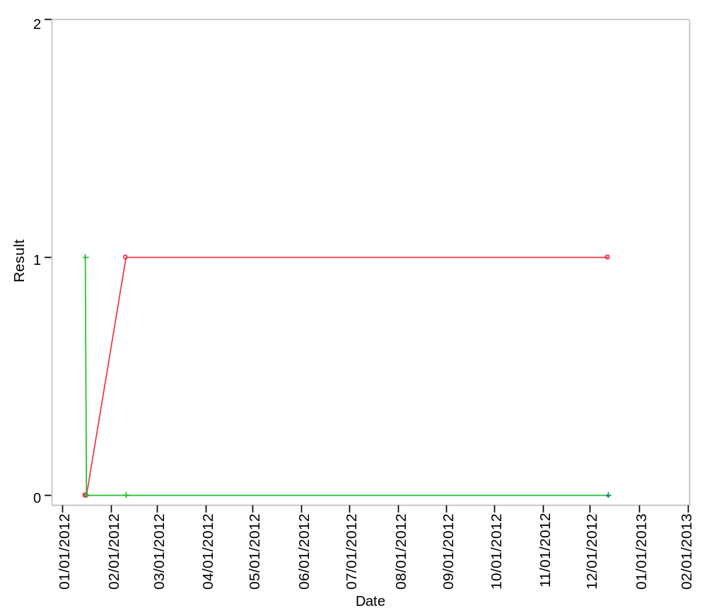

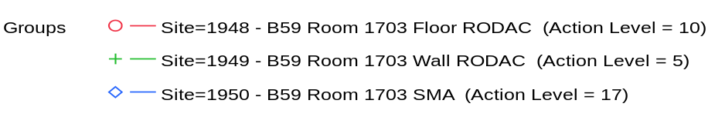

Overlay Plot Room=1704, Grade=Grade D, Frequency=Static
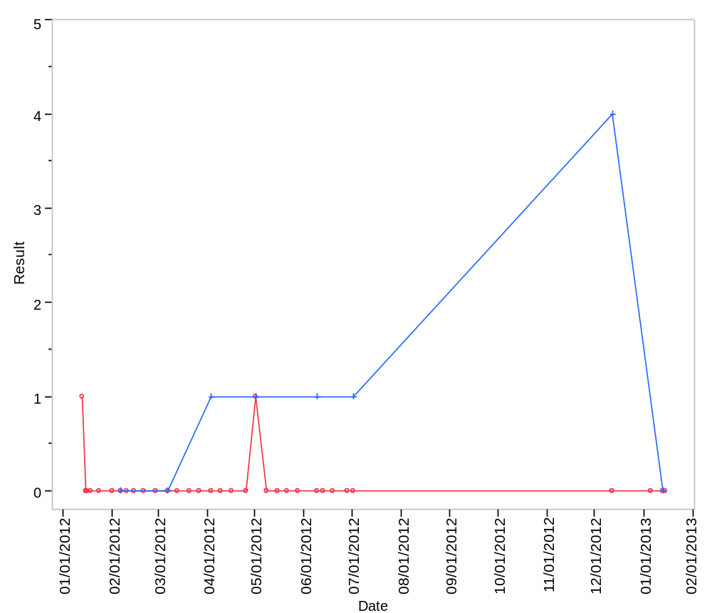

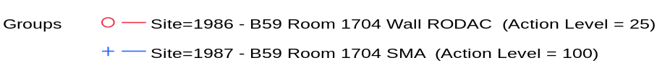

Overlay Plot Room=1706, Grade=Grade C, Frequency=Dynamic
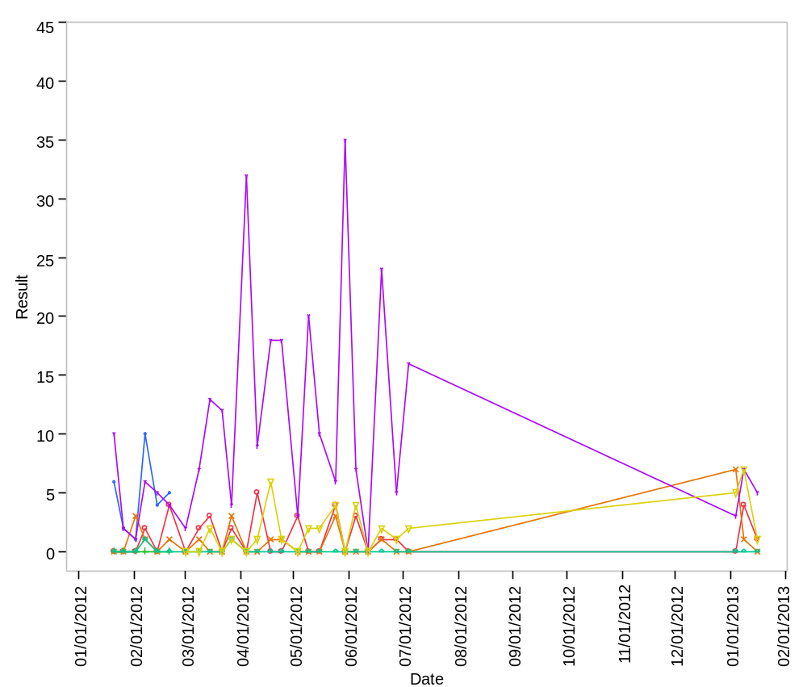

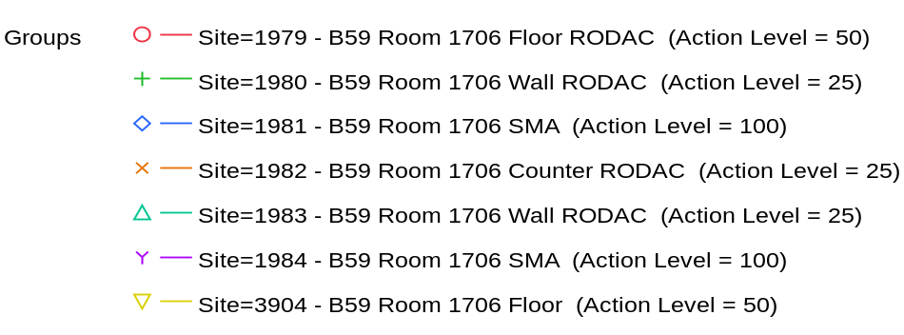

Overlay Plot Room=1706, Grade=Grade C, Frequency=Static
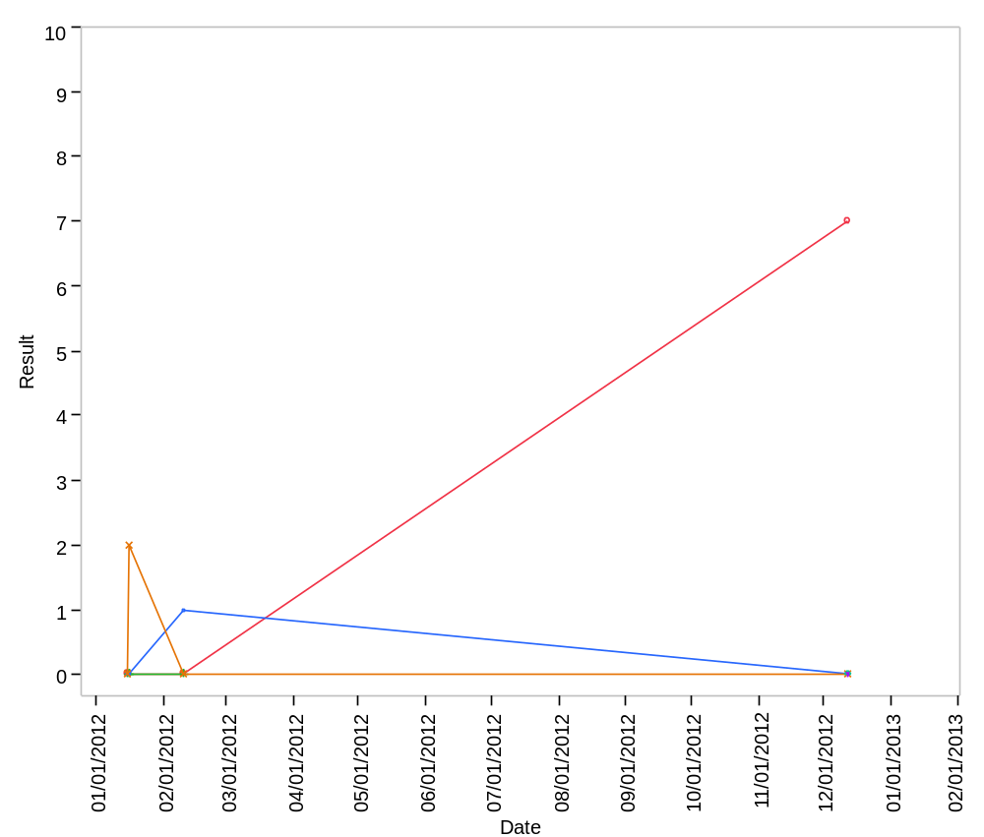

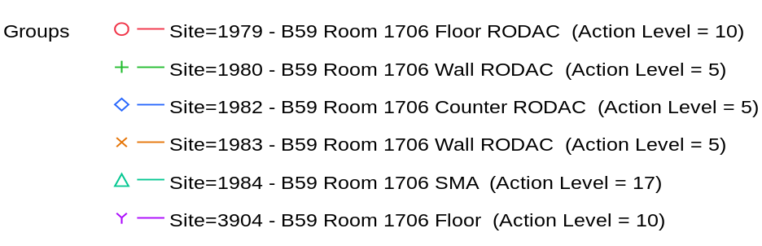

Overlay Plot Room=1708, Grade=Grade D, Frequency=Static
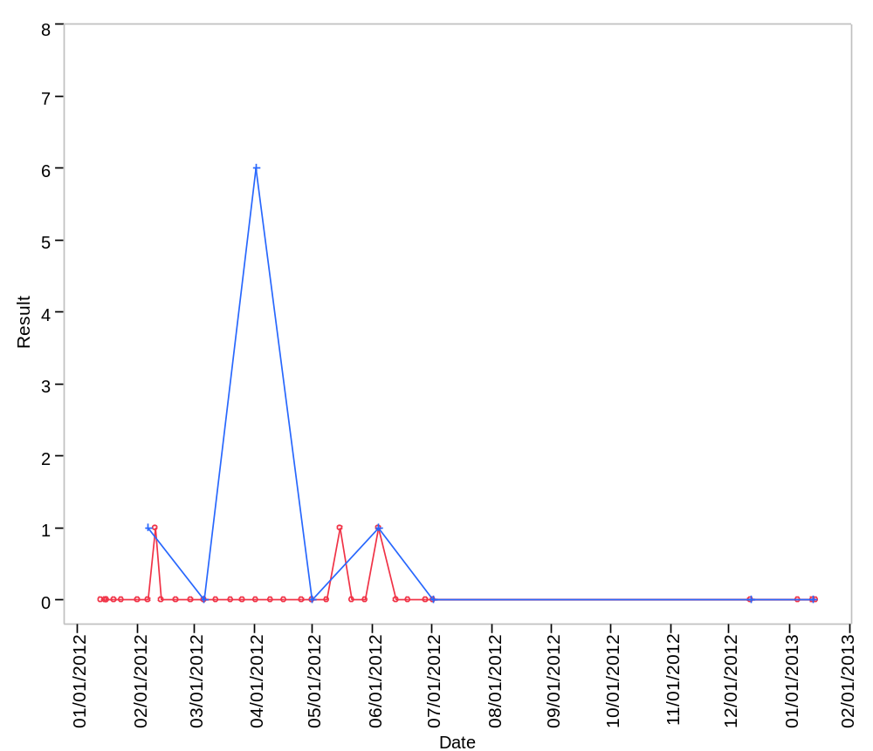

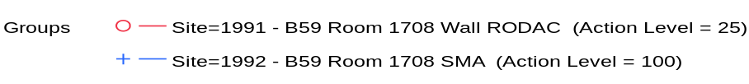

Overlay Plot Room=1709, Grade=Grade C, Frequency=Dynamic
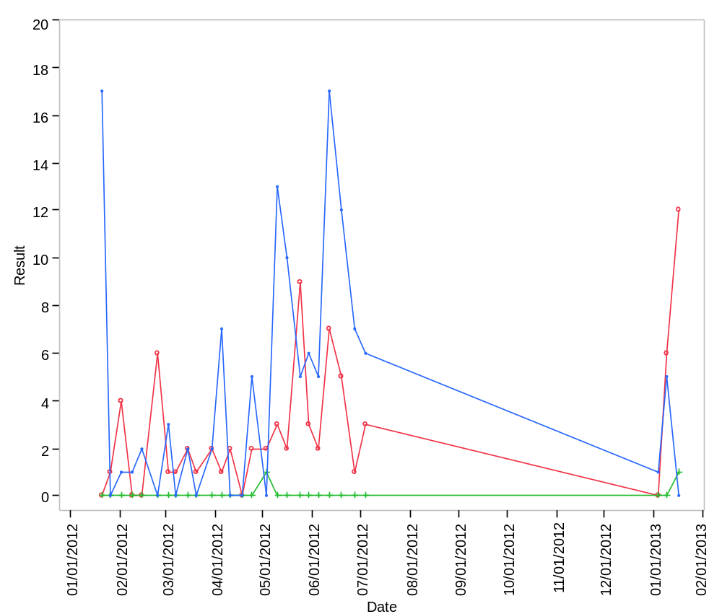

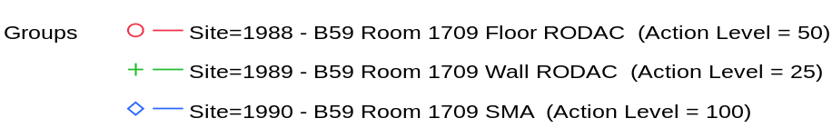

Overlay Plot Room=1709, Grade=Grade C, Frequency=Static
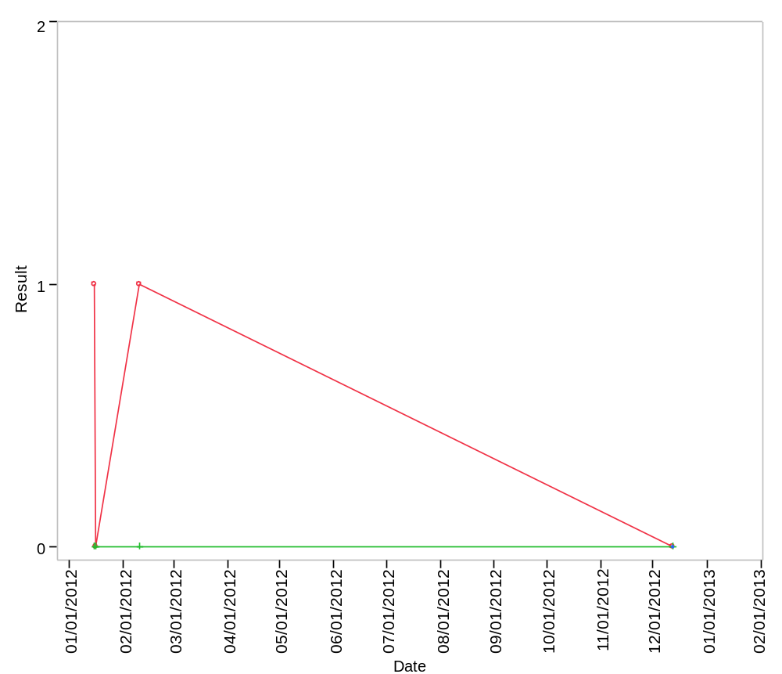

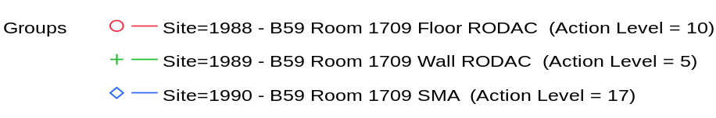

Overlay Plot Room=1710, Grade=Grade C, Frequency=Dynamic
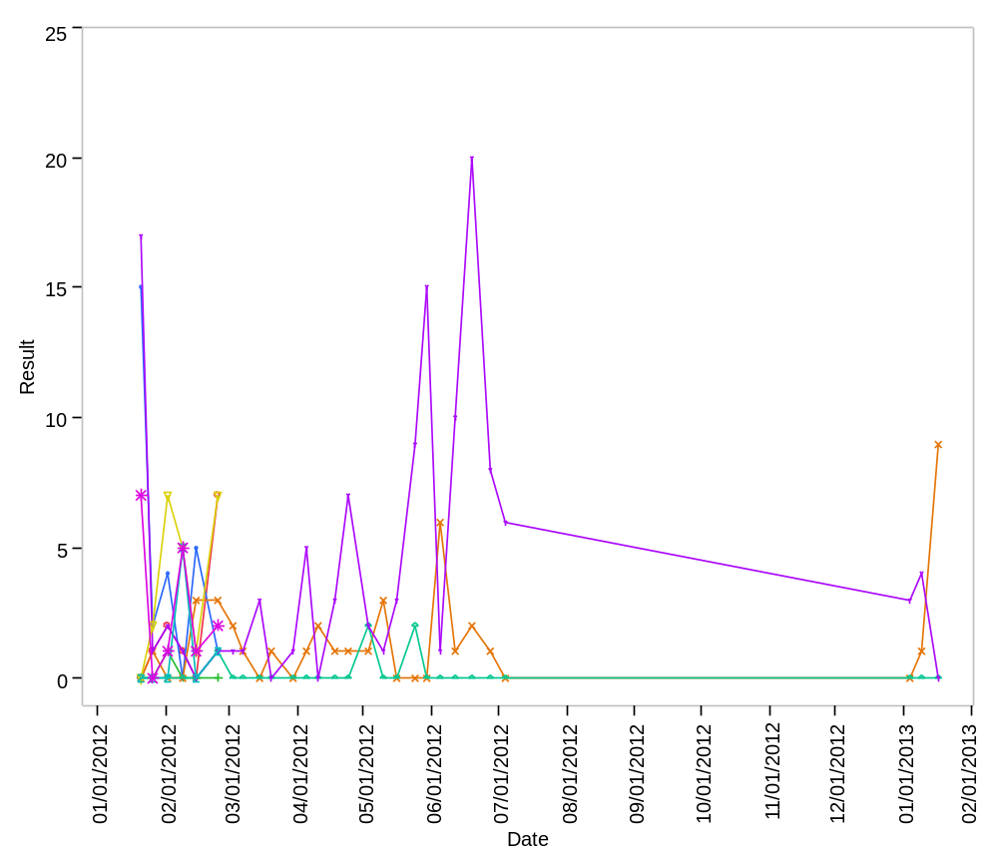

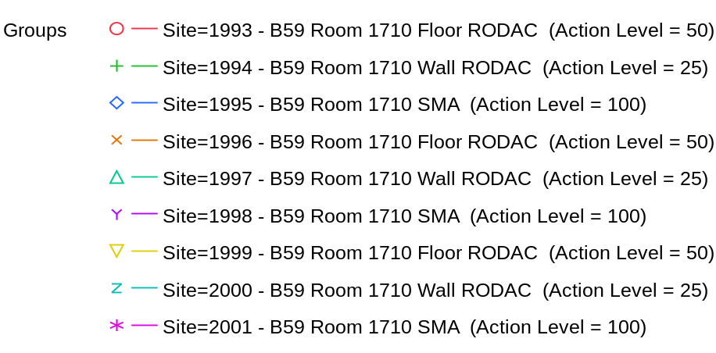

Overlay Plot Room=1710, Grade=Grade C, Frequency=Static
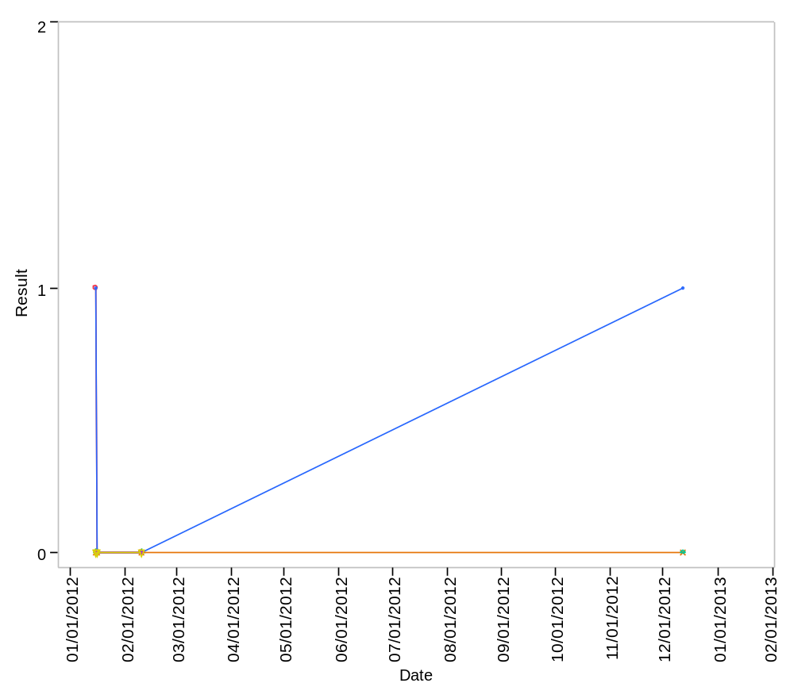

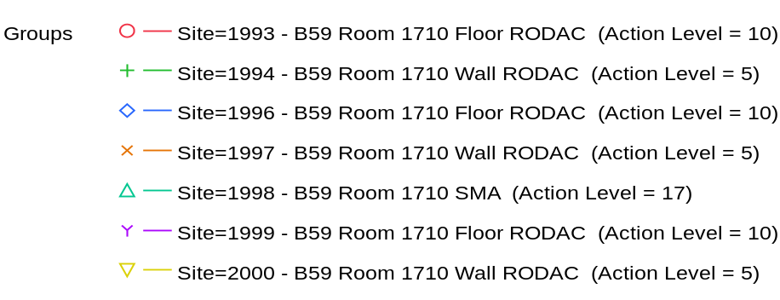

Overlay Plot Room=1711, Grade=Grade D, Frequency=Static
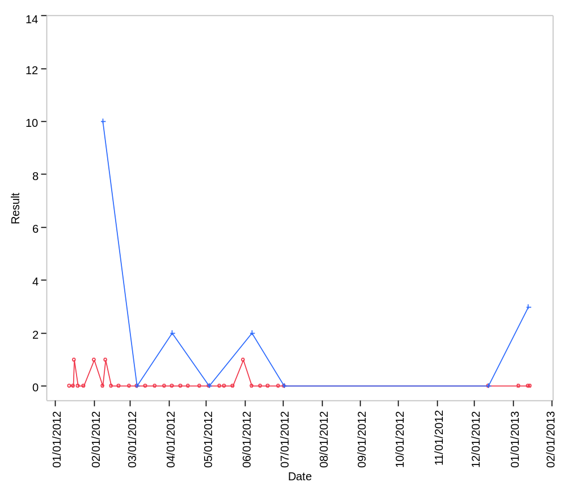

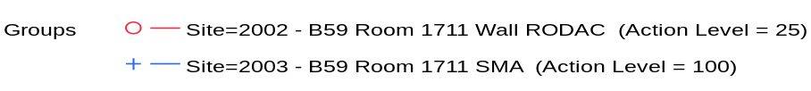

Overlay Plot Room=1713, Grade=Grade C, Frequency=Dynamic
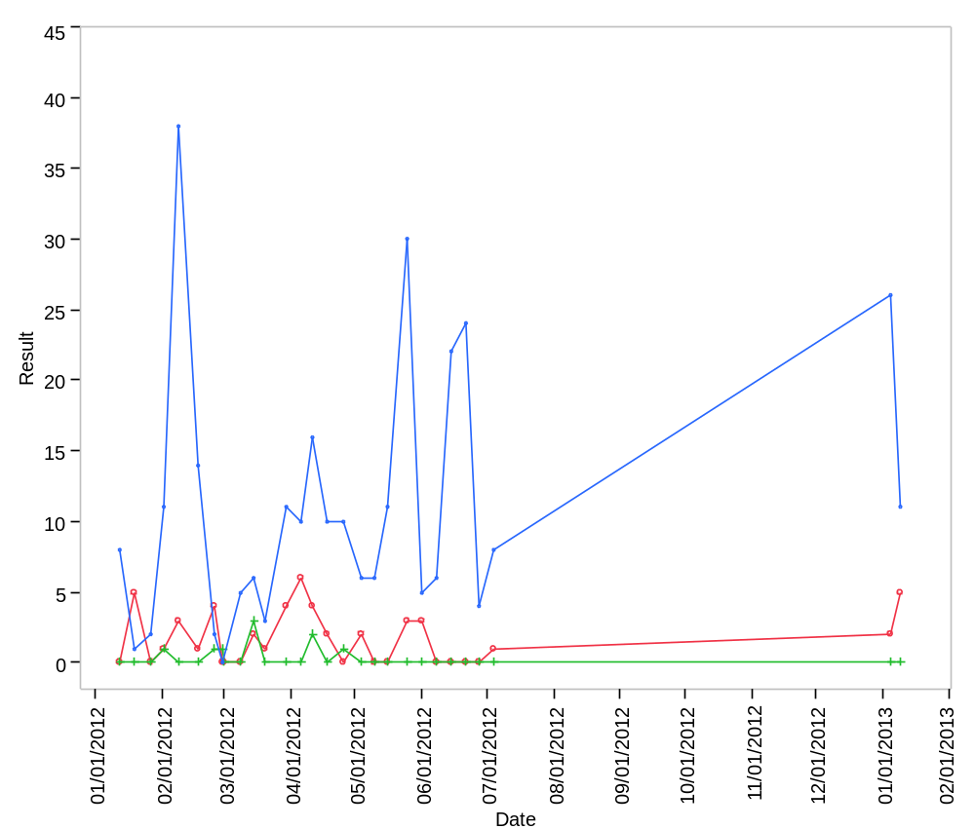

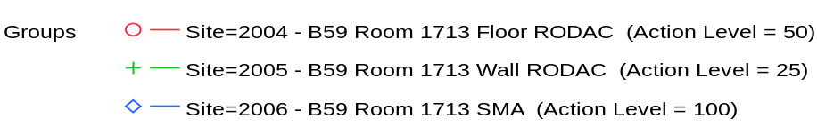

Overlay Plot Room=1713, Grade=Grade C, Frequency=Static
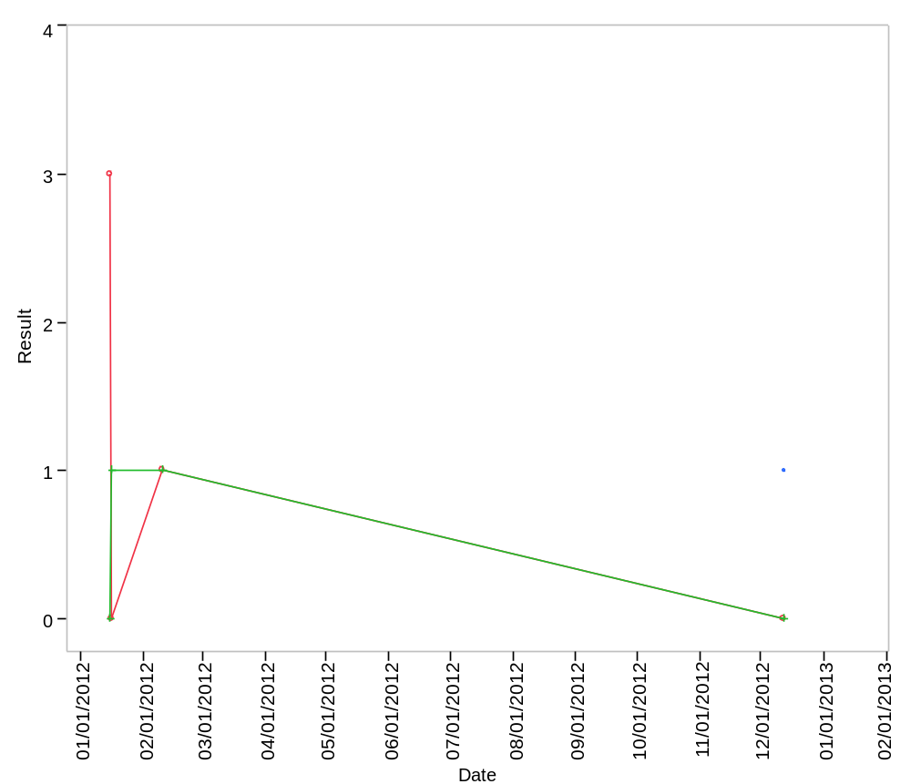

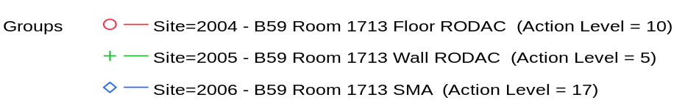

Overlay Plot Room=1714, Grade=Grade C, Frequency=Dynamic
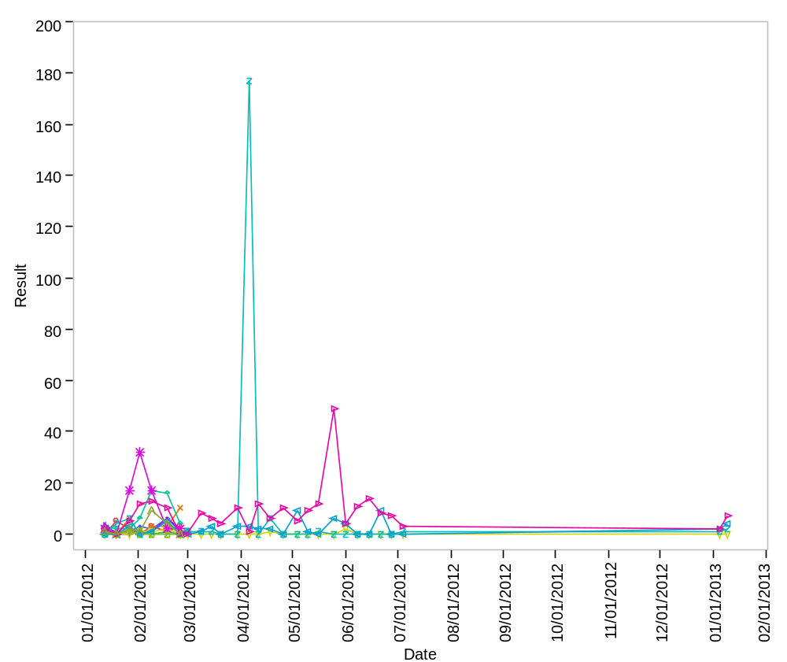

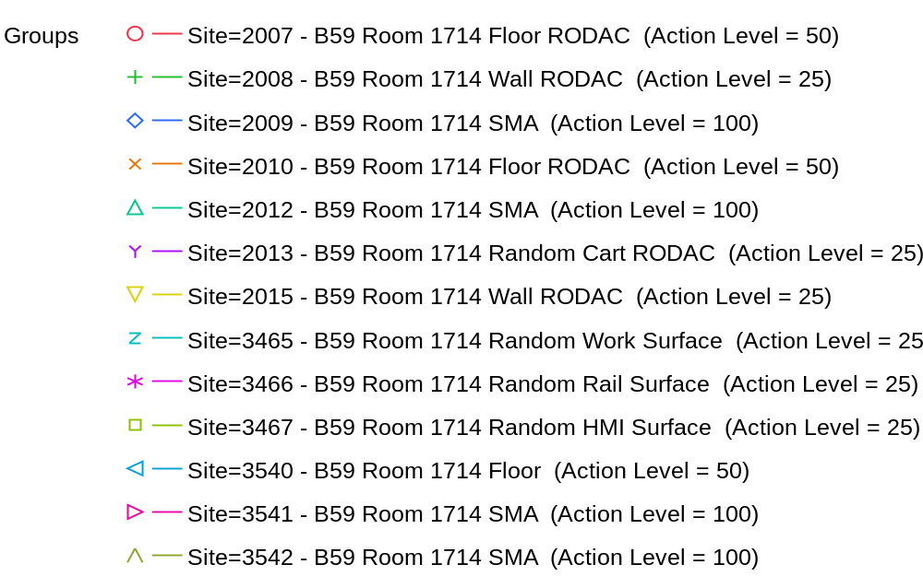

Overlay Plot Room=1714, Grade=Grade C, Frequency=Static
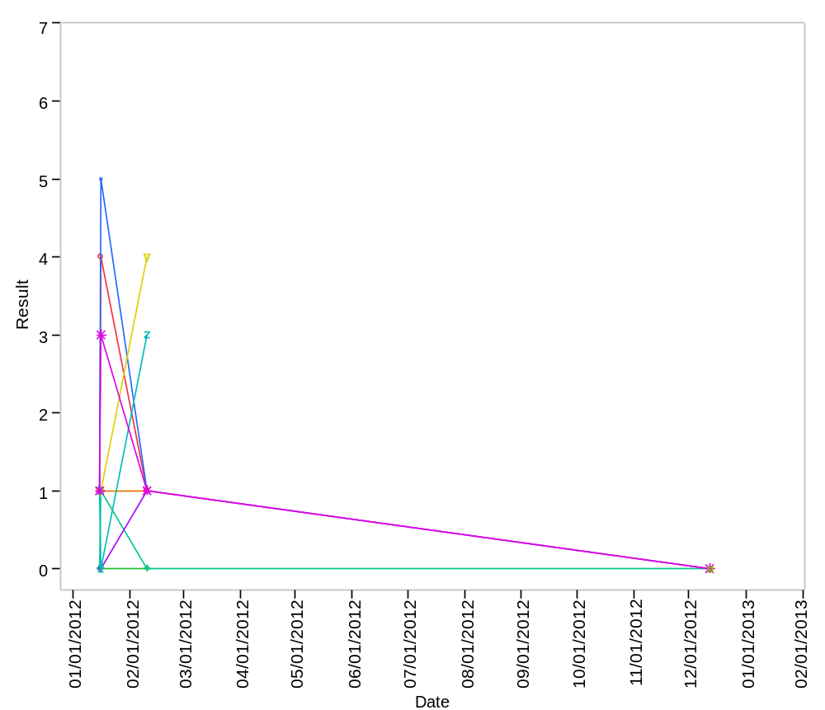

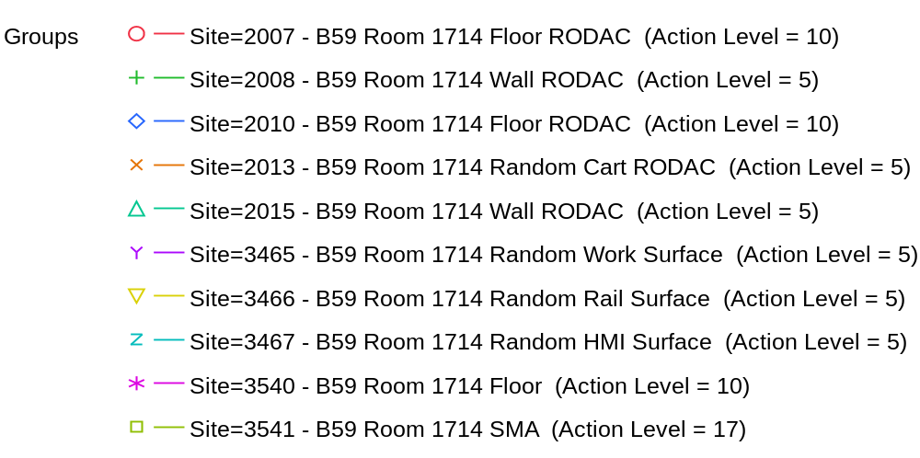

Overlay Plot Room=1715, Grade=Grade D, Frequency=Static
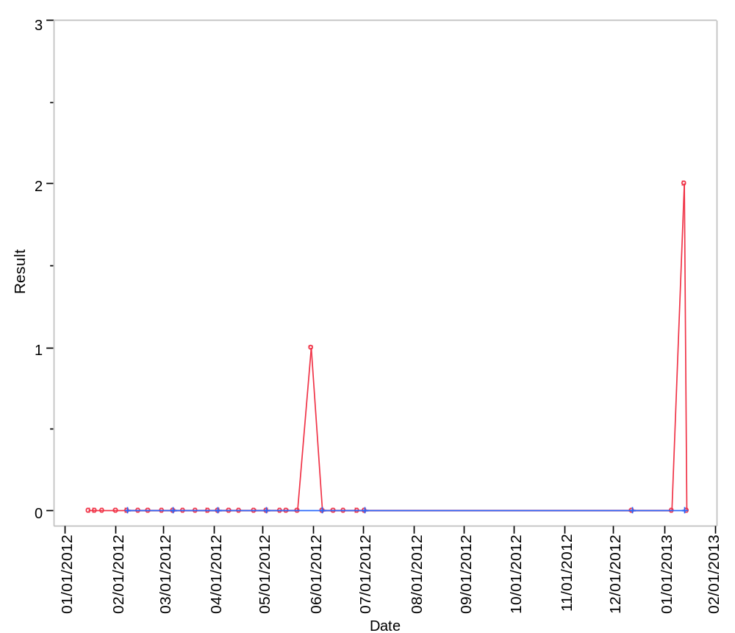

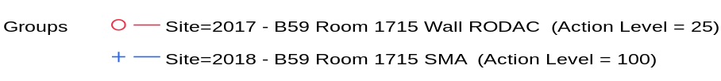

Overlay Plot Room=1717, Grade=Grade C, Frequency=Dynamic
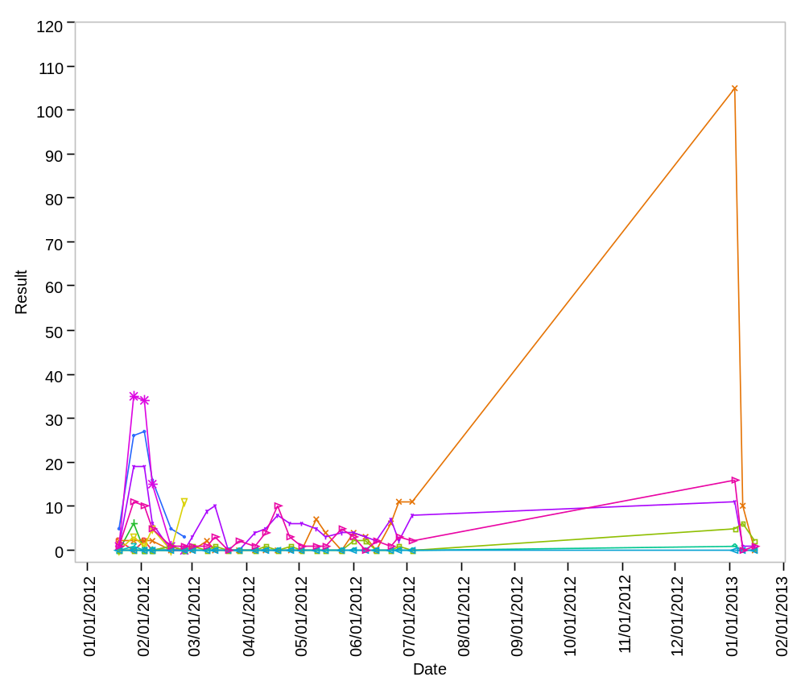

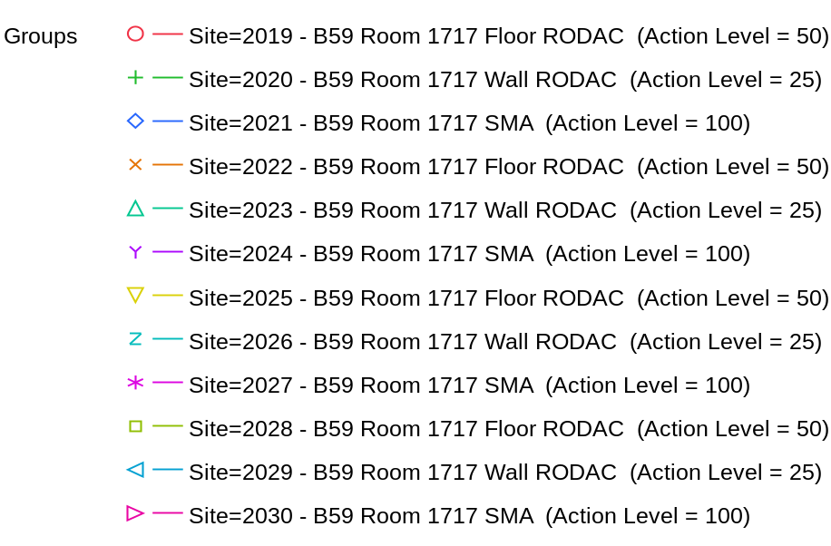

Overlay Plot Room=1717, Grade=Grade C, Frequency=Static
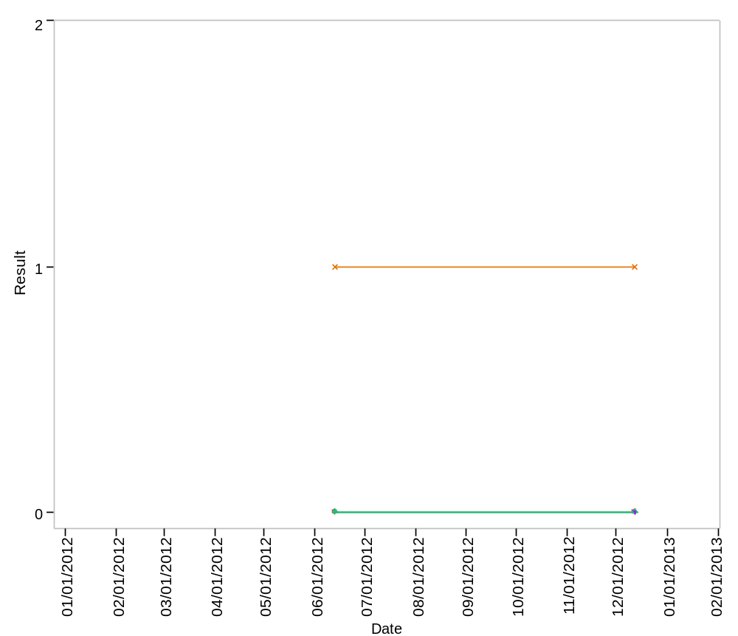

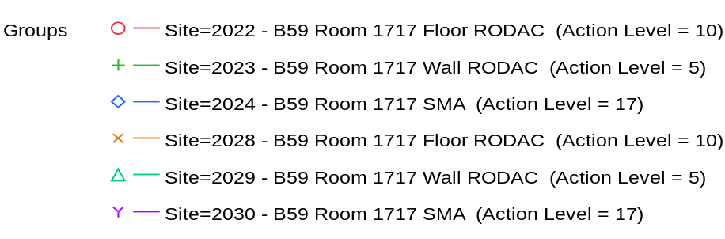

Overlay Plot Room=1718, Grade=Grade C, Frequency=Dynamic
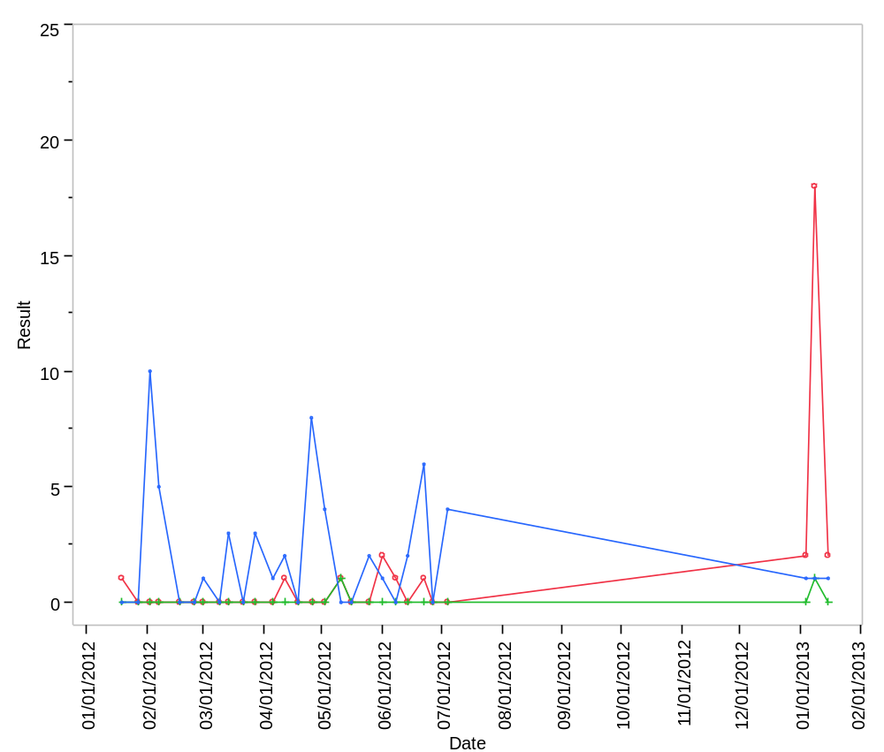

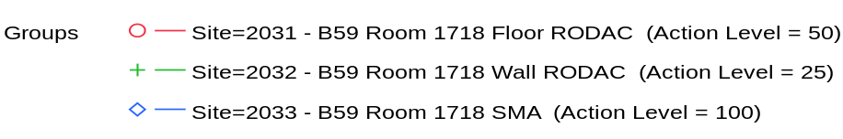

Overlay Plot Room=1718, Grade=Grade C, Frequency=Static
